Purpose, Coherence, Mattering, and Life Crafting: The Development and Validation of a Novel Meaning-Making Intervention

Jack Wells
N00191803
Research Supervisor: John Greaney



Thesis submitted 27/03/23 as a requirement for the BSc (Hons) Applied Psychology
Dún Laoghaire Institute of Art, Design and Technology
Declaration
I have read the IADT Plagiarism Policy and declare that this submission is my own original work. Where I have read, consulted, and used the work of others I have acknowledged in-text and in the References section.
Word count: 5000

Signed: __________________ Date: 27/03/23

Acknowledgements
To study meaning in life while surrounded by so many bright and inspiring people who have enriched the meaning of mine has been a privilege. I would like to give sincere thanks to my supervisor and positive psychology lecturer Dr John Greaney for his pivotal guidance and consistent encouragement. To my advanced research methods lecturer Dr Gráinne Kirwan for arming me with the right tools for the empirical job, and always doing so in such excellent humour. To my statistics lecturer Dr Christine Horn for her piercing analytical insight whenever the nitty got gritty. To my invaluable friends and colleagues who made sure I never left the library without a smile on my face. To Nick for more than a single sentence will ever do justice and to the rest of his fantastic family for inviting me into their home in Dún Laoghaire. To Graeme and Max for supporting and always bringing out the best in me. And to the wonderful Mago, who was and always will be one of life’s incredible whys that convince us we can bear with almost any how.

Contents
Abstract 1
Introduction 2
Meaning in Life: An Overview 2
The Benefits of Meaning 2
Measuring Meaning in Life 3
Meaning as Purpose, Coherence, and Mattering 3
Obstacles in Meaning Seeking 4
Meaning-Making and Life Crafting 5
Expressive Writing and Meaning in Life Crafting 5
The Present Study 6
Research Questions 7
Hypotheses 7
Hypotheses Related to Meaning in Life 7
Hypotheses Related to Year of Study and Life Crafting 7
Method 8
Design 8
Participants 8
Exclusion Criteria 9
Materials 9
Data Sheet 9
The Multidimensional Existential Meaning Scale 9
The Life Crafting Scale 10
Experimental Booklets 10
PowerPoint Presentation 10
Procedure 10
Results 12
Descriptive Statistics 12
Inferential Statistics 13
The Influence of Experimental Grouping on Purpose, Coherence, and Mattering 13
The Influence of Experimental Grouping and Year of Study on Life Crafting 14
Exploratory Analysis 15
Life Domains in Students’ Writing About the Future 15
Discussion 17
Support for Hypotheses 17
Frequency of Life Domains Written about by the Experimental Group 17
Similarity to Other Works 17
Meaning-Focused Life Reframing 17
The Mechanics of Narrative Meaning-Making 18
Strengths, Limitations and Generalisability of Results 18
Strengths 18
Limitations 19
Generalisability of Results 19
Implications for future research 20
Conclusion 21
References 22
Appendix A 27
Excluded Outliers 27
Appendix B 28
Information Sheet 28
Appendix C 30
Debrief Sheet 30
Appendix D 31
PowerPoint Presentation Slides 31
Appendix E 36
Data Sheet 36
Appendix F 40
Booklet A 40
Appendix G 43
Booklet B 43
Appendix H 46
The Multidimensional Existential Meaning Scale 46
Appendix I 47
The Life Crafting Scale 47
Appendix J 48
Participant UU225’s Large Influence in the Two-Way ANOVA 48
Appendix K 49
MANOVA Assumptions Testing Report 49
Appendix L 53
ANOVA Assumptions Testing Report 53

Abstract
This study aimed to develop and validate a novel meaning-making intervention for young adults. These efforts were underpinned by recent developments in the conceptualisation and measurement of meaning-focused life crafting and multidimensional-existential meaning. It was hypothesised that a brief (16 min) intervention prompting expressive writing about values, passions, and actions that might bring about an ideal and less ideal future would increase perceptions of meaning in life. A quantitative (2x2) experimental design examined the influence of this intervention versus a control measure on a sample of fourth- and second-year undergraduate students (N=74; mean age = 21.2, SD = 1.87). Results indicated a moderate increase in purpose (p=.003), coherence (p=.006), and mattering (p=.027) scores, as well as life crafting scores (p=.030) for students who took part in the intervention. Furthermore, second-year students scored moderately lower in global life crafting (p=.002), suggesting that students might benefit more from such interventions earlier in their studies. Lacking a longitudinal analysis of how observed increases persisted over time limits the implications of these findings. The remarkable effect size of the intervention despite its brevity highlights two promising directions for further research. Possible explanations for the success of the intervention are also discussed.
Keywords: positive psychology, intervention, meaning in life, purpose, coherence, mattering, multidimensional-existential meaning, meaning-focused life crafting.

Introduction

Meaning in Life: An Overview
The question of what precisely makes life meaningful often challenges us. Conceptions of meaning in life (MIL) have been discussed and debated deeply in religion, philosophy, and literature for millennia (King & Hicks, 2021). Furthermore, empirical efforts have produced varying perspectives on what constitutes a psychologically meaningful life. MIL has been described as an experience and a state (Klinger, 1977, p. 10), a subjective quality of an individual’s inner world (Frankl, 2020), and even a pedestalised goal more desirable than happiness (Huta & Waterman, 2013). Steger (2018) suggests that perceiving MIL enables us to organise our experience, achieve a sense of individual worth and place, and direct our attention and energy more effectively. These diverse perspectives converge on the existential-positivist proposition that meaning is something that gives our lives structure and empowers us to endure hardship (Wong, 2020). In the words of Frankl (2020) - founder of meaning-focused existential therapy - paraphrasing Nietzsche (1889): “He who has a why to live for, can bear with almost any how.” But what is the precise function of meaning and is it something that we can actively create?

The Benefits of Meaning
Meaning as a subjective, intuitive experience has been associated with functional benefits across a variety of life domains. Steger et al. (2009) associate MIL with increased life-satisfaction and reduced depression. The crafting of meaning in workplaces has been suggested to significantly improve employee motivation and productivity (Steger et al., 2012). MIL has been suggested to buffer against mortality risk across adult populations (Hill & Turiano, 2014). Kang et al. (2019) even attribute MIL to positive engagement in health-related behaviours, including greater acceptance of conflicting but beneficial public health messages.
Furthermore, MIL could be particularly beneficial for younger populations. In adolescents, MIL has been associated with healthier eating and increased physical activity (Brassai et al., 2015). Supported searching for MIL might increase subjective well-being (Doğan et al., 2012) and be protective against suicidal behaviours in university students (Lew et al., 2020). Students who discuss the personal meaningfulness of goals have reported significantly increased life-satisfaction and goal-directedness nine months later (Bundick, 2011). Perceiving MIL seems central to the formation of well-being as young people construct overarching life aims (Krok, 2017). Such wide-ranging positive associations incentivise the development of interventions, validated by reliable measures, that support young people in their search for MIL.

Measuring Meaning in Life
Definitional ambiguities and reliance on individuals’ intuitive sense of MIL have traditionally limited MIL measurement (King & Hicks, 2021). Informed by foundational work by Frankl (2020), Crumbaugh and Maholick’s (1964) Purpose-in-Life test and complimentary Seeking-of-Noetic-Goals scale (Crumbaugh, 1977) conceive of MIL as inextricably linked to an individual’s sense of purpose. These measures made considerable progress towards a useful conception of MIL despite their permeation with positive mood. Steger et al.’s (2006) Meaning-in-Life Questionnaire (MLQ) made further progress, including face-valid items without referring to enjoyment or pleasure e.g., “I understand my life’s meaning”. However, the MLQ relies on a unidimensional conception of MIL, making measurements difficult to integrate with broader literature.
George and Park (2016) tackle this one-dimensionality head-on, proposing a tripartite conceptualisation consisting of purpose, coherence, and mattering subconstructs. This multidimensionality facilitates the integration of meaning measurements with broader meaning literature by offering flexibility and precision. Moreover, George and Park (2017) develop and validate a scale based on this conceptualisation known as the Multidimensional-Existential-Meaning Scale (MEMS). Park et al. (2020) assert that the MEMS reflects the distinct subconstructs of George and Park’s conception with good factor structure, reliability, and other psychometric properties, and has been validated with non-English-speaking samples (Marco et al., 2022). The MEMS enables researchers to address meaning-specific research questions more directly and comprehensively than ever before through self-report measurement methods.

Meaning as Purpose, Coherence, and Mattering
Purpose as defined by George and Park (2016) is the extent to which we perceive our lives as directed by valued goals. Thus, purpose is central to our sense of engagement with, and direction in, life. Coherence is more cognitive, referring to our perception of the degree to which life makes sense. In that sense, coherence is a product of consistent noncontradictory observations and beliefs about our lives that enable us to make meaningful connections between events (Heine et al., 2006). Mattering refers to our experience of individual existential significance (Becker, 1973). Thus, mattering is the product of perceptions that we are valuable and consequential, either in our immediate environments or on a cosmic scale (Costin & Vignoles, 2020).
Combined, these subconstructs offer a depth and flexibility that unidimensional conceptions of MIL have not. However, purpose, coherence, and mattering must be understood as interconnected in complex ways. For instance, struggling to understand one’s life might make it more difficult to find direction or feel significant. Similarly, feeling insignificant could undermine one’s sense of purpose or obstruct sense-making. George and Park hypothesise a logical synergy between these subconstructs, such that experiencing all three simultaneously intensifies the relative experience of each one.

Obstacles in Meaning Seeking
Confoundingly, searching for meaning might be something that we struggle to do effectively. Steger et al. (2008) suggest that individuals are unlikely to search for meaning in a planned or organised manner. Prolonged searching for meaning could also be problematic; relating to a lower presence of MIL, reduced life-satisfaction, and reduced well-being (Cohen & Cairns, 2011). Steger et al. (2009) suggest that a relationship between searching for meaning and negative well-being develops into later life stages. Cohen and Cairns hypothesise that such negative outcomes arise when individuals believe their search is prolonged or unlikely to succeed. Thus, searching alone might not effectively lead to finding MIL (Chu & Fung, 2020).
Individuals might therefore benefit from support to search for meaning in an organised manner. If as suggested by Krok (2017) and Bronk (2011) the establishment of a sense of MIL is a critical factor in the transition from emerging adulthood to adulthood, an empirically grounded and validated meaning-making intervention could be particularly valuable to young adults. Dekker et al. (2020) suggest that such assistance could enhance goal-pursuit, academic performance, and mental health. Thus, individuals might benefit from support to find meaning while still in school or college. However, Chen et al. (2022) draw attention to the dearth of literature on the development of effective meaning-making interventions.

Meaning-Making and Life Crafting
Jacob and Steger (2021) propose that individuals create meaning in two ways: through (1) actively identifying and pursuing sources of MIL or (2) being aided to craft MIL. The latter (strategic and supported crafting of MIL) is the concern of an emerging concept referred to as life crafting (LC). However, remarkably few papers explicitly refer to LC as a meaning-making strategy and fewer test such strategies empirically (Chen et al., 2022). Schippers and Ziegler (2019) outline a theoretical meaning-making life-crafting intervention and advocate its far-reaching potential benefits for individuals and society. Reflecting on competencies, habits, careers, social life, and the future are theorised as pragmatic actions that enrich our experience of MIL. de Jong et al. (2020) expound these conceptions, theorising a four-stage LC intervention involving discovering values and passions, reflecting on the ideal future, creating goals, and publicly committing to those goals.
These works outline considerable foundations for the development of meaning-focused LC but reserve the validation of their hypotheses for future research. Encouragingly, Chen et al. (2022) report promising results in an explorative investigation of LC as an effective meaning-making strategy. The team validate a reliable instrument referred to as the Life-Crafting Scale (LCS), developed to measure the effectiveness of LC interventions, which remains to be utilised in meaning-focused LC research. Strong theoretical foundations clearly exist upon which to develop and validate a novel meaning-making intervention.

Expressive Writing and Meaning in Life Crafting
Schippers and Ziegler (2019) and de Jong et al. (2020) converge on the suggestion that expressive writing prompts could effectively encourage and guide meaning-focused life-crafting efforts. Expressive writing requires executive control and prompts an evaluative mode of thinking which is leveraged in narrative therapy (Frank, 2018). Narrative therapy posits that individuals can be assisted to give meaning to their lives by constructing coherent narratives about themselves using written and spoken language (Ghavibazou et al., 2022). Frank (2018) emphasises the critical importance of reflecting on pragmatic actions in narrative therapy endeavours. The consideration of action through writing encourages individuals to think about how to better organise their experience. This could serve as a therapeutic substitute for what Steger (2018) suggests is the function of MIL: to give our lives structure and guide the direction of our attention and energy.
An effective meaning-making intervention might therefore resemble a narrative therapy exercise, prompting expressive writing about pragmatic actions that could actualise an idealised future. Positive future-orientation in conjunction with reflection on values and passions could help young adults to reframe their lives as being more purposeful, coherent, and mattering. The Future Authoring Program (FAP) is one intervention that leverages the benefits of expressive writing in such a manner to great effect (Finnie et al., 2017). The FAP focuses on organisational-goal setting and has been demonstrated to facilitate a variety of positive student outcomes including academic retention and performance.

The Present Study
Understanding the benefits and hurdles associated with MIL, individuals should be supported to search for meaning in a structured and systematic way, especially in early life stages. Strong theoretical foundations supporting the development of meaning-focused life-crafting interventions exist, yet only four academic papers refer explicitly to LC as a meaning-making strategy. Furthermore, these papers fail to address recent and considerable developments in the conception and measurement of MIL and LC. Namely, George and Park’s (2016, 2017) tripartite conceptualisation of MIL and Chen et al.’s (2022) life-crafting scale. The present study aims to operationalise these developments, adopting an experimental approach to validating a meaning-focused life-crafting intervention for young adults.
The influence of expressive writing prompts encouraging reflection on (1) values and passions, and (2) actions that might facilitate an ideal and less ideal future will be investigated quantitatively. It is hypothesised that students who write about values, passions, and appropriate actions they could take to bring about an ideal future will report higher purpose, coherence, and mattering scores than a control group. Life-crafting scores for students between experimental and year of study groups will also be compared, and a possible interaction effect investigated.
Experimental groups will additionally indicate from a predetermined list of topics (e.g., career, relationships, mental health) what they wrote about when writing about the future. This exploratory addition aims to marginally compensate for a lack of qualitative analysis of students’ writing.

Research Questions
Will students who participate in a brief meaning-focused life-crafting intervention perceive greater meaning in life than a control group? Will writing about values, passions, and actions that might bring about an ideal and less ideal future influence students’ perceptions of purpose, coherence, and mattering?
Moreover, will life-crafting behaviours differ between year of study and experimental groups? Will year of study and experimental grouping interact to influence life-crafting outcomes?

Hypotheses

Hypotheses Related to Meaning in Life
H₁: Students in the experimental group will score significantly higher in purpose than those in the control group.
H₂: Students in the experimental group will score significantly higher in coherence than those in the control group.
H₃: Students in the experimental group will score significantly higher in mattering than those in the control group.

Hypotheses Related to Year of Study and Life Crafting
H₄: Students in the experimental group will score significantly higher in life crafting than those in the control group.
H₅: There will be a significant difference in life crafting between students in their second and fourth years of study.
H₆: There will be a significant interaction effect between year of study and experimental condition on life crafting scores.

Method

Design
A two-by-two between-groups experimental design was utilised to examine the influence of two independent factors; experimental condition with two levels (experimental and control) and year of study with two levels (second year and fourth year), on four dependent variables; purpose, coherence, and mattering (measured using the MEMS; George & Park, 2017), and life crafting (measured using the LCS; Chen et al., 2022).
Participants were divided into experimental groups randomly through the distribution of shuffled experimental booklets (A or B), and into self-reported year of study groups (second or fourth).

Participants
Participants (N=78) were undergraduate students purposively sampled from The Institute of Art Design & Technology Dun Laoghaire (IADT) between the 1st and 28th of February 2023. These samples were selected to investigate potential differences between students earlier and later in their undergraduate studies in an ecologically valid setting. Table 1 below illustrates relevant sociodemographic characteristics including gender and year of study by experimental group.
Table 1
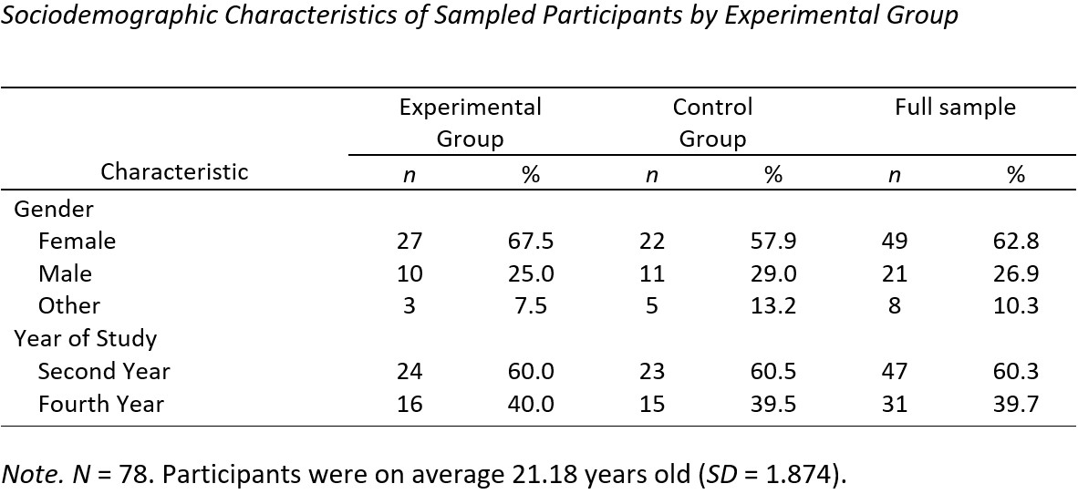
All materials and methods utilised in the study were approved by the Psychology Ethics Committee of IADT and in accordance with the Psychological Society of Ireland’s Code of Professional Ethics (2019).

Exclusion Criteria
Four (low scoring) outliers were identified (see Appendix A) and excluded from the study due to the MANOVA’s sensitivity to outliers (Tabachnick & Fidell, 2013, p. 253). The remaining participants (N=74) were included in statistical analyses.

Materials
The experiment utilised three printed booklets, a digital information (see Appendix B) and debrief (Appendix C) sheet, and a PowerPoint presentation (Appendix D). Each participant was provided with one ‘Data Sheet’ (Appendix E) and either a ‘Booklet A’ (Appendix F) or ‘Booklet B’ (Appendix G). These materials were pilot tested on the 16th of January 2023.

Data Sheet
The Data Sheet was divided into two sections. Pages one and two were used to collect written consent and demographic information. Pages three and four were used to collect scale data. Page three presented the Multidimensional Existential Meaning Scale (George & Park, 2017). Page four presented the Life Crafting Scale (Chen et al., 2022) and a series of ten checkboxes enabling the experimental group to indicate what they reflected on when writing about the future from a predetermined list e.g., family, career, money.

The Multidimensional Existential Meaning Scale
This 15-item questionnaire (see Appendix H) adapted from George and Park (2017) used a seven-point Likert scale with responses ranging from very strongly disagree to very strongly agree (very strongly disagree = 1, very strongly agree = 7) and consisted of statements related to purpose, coherence and mattering e.g., “My life makes sense”, “My direction in life is motivating me”, “I am certain that my life is of importance”. Item two was reverse scored to help determine whether participants gave consistent responses. In this study, the reliability of the purpose subscale was very good (Cronbach’s alpha = .909), the reliability of the coherence subscale was good (.882), and the reliability of the mattering subscale was good (.836). The overall reliability of subscales combined was very good (.920).

The Life Crafting Scale
This measure (see Appendix I) adapted from Chen et al. (2022) consisted of nine questionnaire items relating to global (not related to specific life domains) life-crafting behaviours e.g., “I think about how my life helps others” and “I try to work hard on challenging activities”. This scale utilised a five-point Likert scale with responses ranging from never to always (never = 1, always = 5). In this study, this measure showed good reliability (Cronbach’s alpha = .819).

Experimental Booklets
Booklets A and B were similar, both containing two short and long writing prompts. Booklet A was the control measure, containing short prompts to write about modules and lectures from memory and long prompts to reflect on favourite and less favourite assignments. Booklet B was the experimental measure, consisting of prompts to write about values and passions and reflect on actions that might bring about an ideal and less ideal future.

PowerPoint Presentation
A PowerPoint presentation embedded with countdown timers for each booklet section guided participants through the intervention and ensured that students in all groups spent equal time completing each section.

Procedure
All experiments were conducted in structured classroom environments to simulate a controlled lab. Consenting participants were seated and given a Data Sheet and either a Booklet A or B from a shuffled pile. The PowerPoint presentation presented a QR code linked to a detailed information sheet. Participants were verbally briefed about the aims and design of the study and asked to complete the consent and demographic sections of the Data Sheet. Participants were informed that they could leave the study or ask questions at any time, and that only the Data Sheet would be collected.
Once participants provided consent and demographic information, the experiment began. Participants were given three minutes to respond to each short prompt and five minutes to respond to each long prompt for a total of 16 minutes of writing. As timers corresponding to each booklet section elapsed, participants were asked to move to the next section and a new timer was started. Once all four sections were completed, participants were asked to complete the second section of the Data Sheet. Participants were then thanked, the experiment was closed, and Data Sheets were collected. Participants were debriefed verbally, and digitally using a QR code at the end of the presentation. Participants were invited to ask questions which usually prompted a brief group discussion.

Results

Descriptive Statistics
Means and standard deviations for purpose, coherence, mattering and life-crafting scores for the experimental (n = 37) and control (n = 37) groups are displayed in Table 2 below.
Table 2
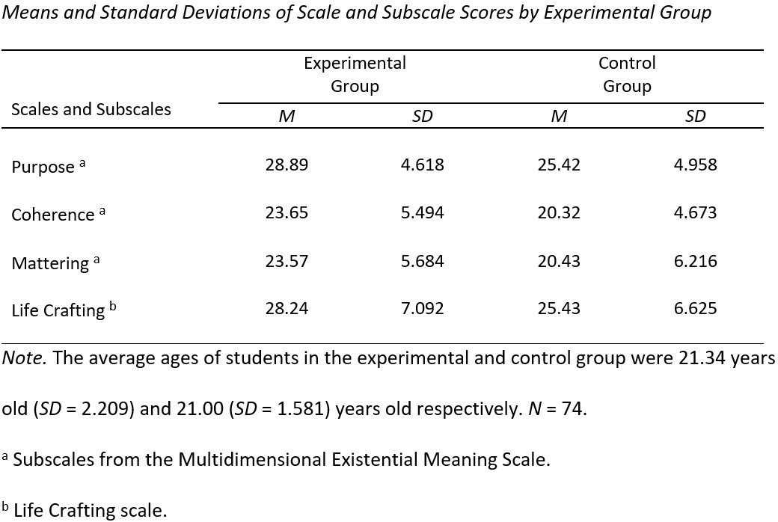
Means and standard deviations for purpose, coherence, mattering and life crafting scores for the second (n = 45) and fourth (n = 29) year of study groups are displayed overleaf in Table 3.

Table 3
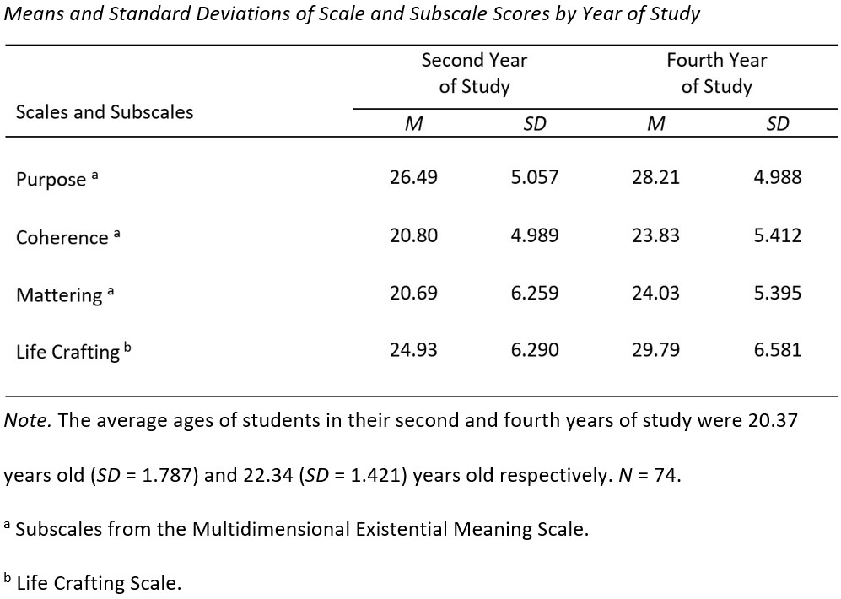

Inferential Statistics

The Influence of Experimental Grouping on Purpose, Coherence, and Mattering
A one-way (1x3) between-groups multivariate analysis of variance was conducted in SPSS 28.0.1 to test hypotheses one to three: whether participants in the experimental group scored significantly higher in purpose, coherence and mattering than the control group.
A Shapiro-Wilk test showed a significant departure from normality for purpose scores in the experimental group, W(37)=.936, p=.035. This group’s scores were moderately negatively skewed (skewness=-.408, p=.388). However, the MANOVA is moderately robust to violations of normality when the violation is not severe, the group sizes are balanced, and contain greater than 20 participants (Tabachnick & Fidell, 2013, p. 253). As such, the present analysis was deemed valid despite this violation. A detailed report on all assumptions testing for this analysis can be found in Appendix K.
Students in the experimental group scored significantly higher in purpose than those in the control group, F(1,72)=9.646, p=.003. The effect size was medium (partial η²=.118). Students in the experimental group also scored significantly higher in coherence than those in the control group, F(1,72)=7.861, p=.006. The effect size was again medium (partial η²=.098). Finally, students in the experimental group scored significantly higher in mattering than those in the control group F(1,72)=5.126, p=.027. The effect size was medium (partial η²=.066). Table 4 below displays the MANOVA output.
Table 4
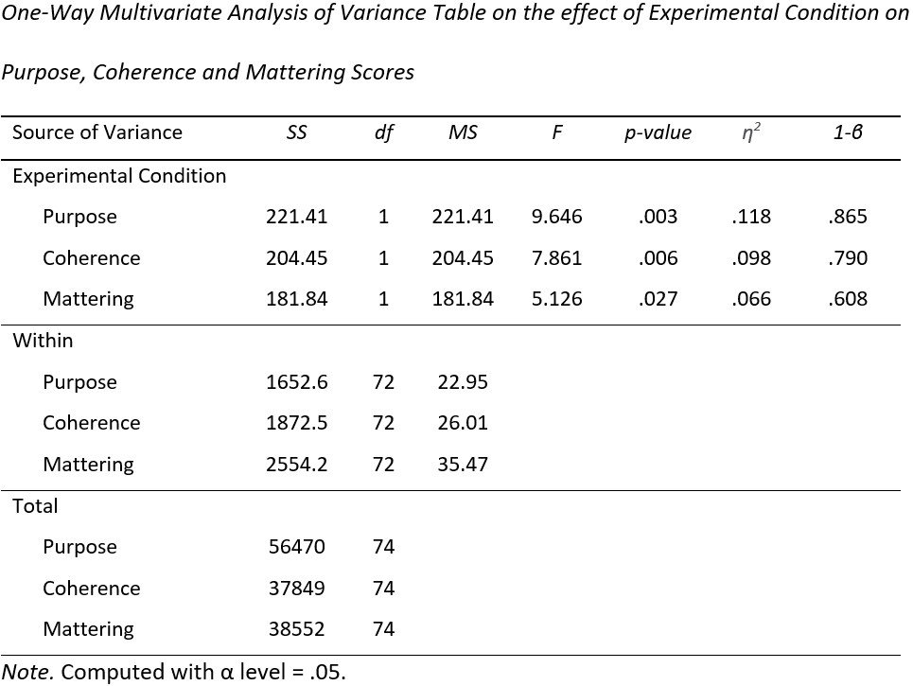

The Influence of Experimental Grouping and Year of Study on Life Crafting
An additional two-way between-groups analysis of variance was conducted to test hypotheses four to six; whether students in the experimental group scored higher in life crafting than the control group, whether there was a significant difference in life crafting scores between students in second and fourth year, and whether there was a significant interaction between year of study and experimental condition on life-crafting scores. No assumptions of this test were violated and a detailed report on all assumptions testing for this analysis can be found in Appendix L.
There was no significant interaction between year of study and experimental group on life crafting scores, F(1,70)=3.310, p=.073, 1-β=.434. Students in the experimental group scored significantly higher in life crafting than the control group, F(1,70)=4.878, p=.030. The effect size was moderate (partial η²=.065). Students in their fourth year of study also scored significantly higher in life crafting than students in second year, F(1,70)=10.335, p=.002. The effect size was moderate (partial η²=.129). Table 5 below displays the ANOVA output.
Table 5
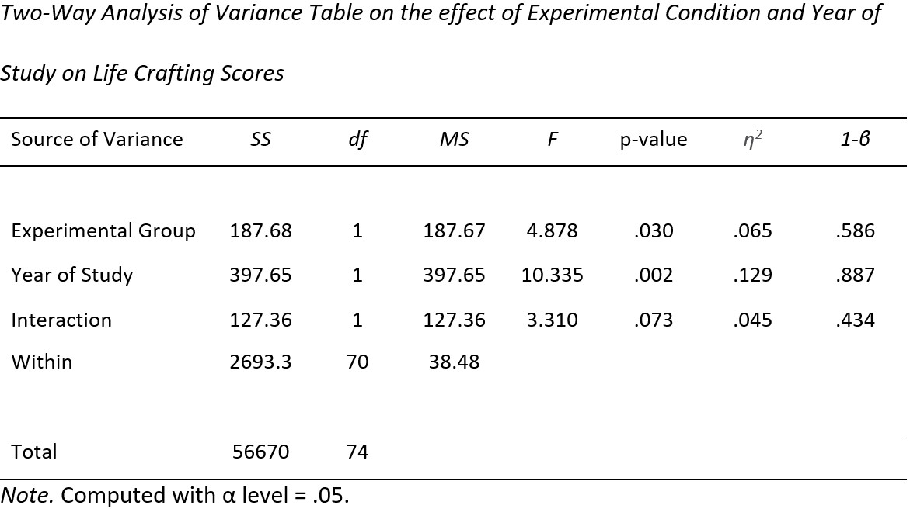

Exploratory Analysis

Life Domains in Students’ Writing About the Future
A frequency analysis of broad life domains students in the experimental group chose to write about was conducted. The proportion of students who wrote about each predetermined life domain is illustrated in Figure 1 overleaf.

Figure 1
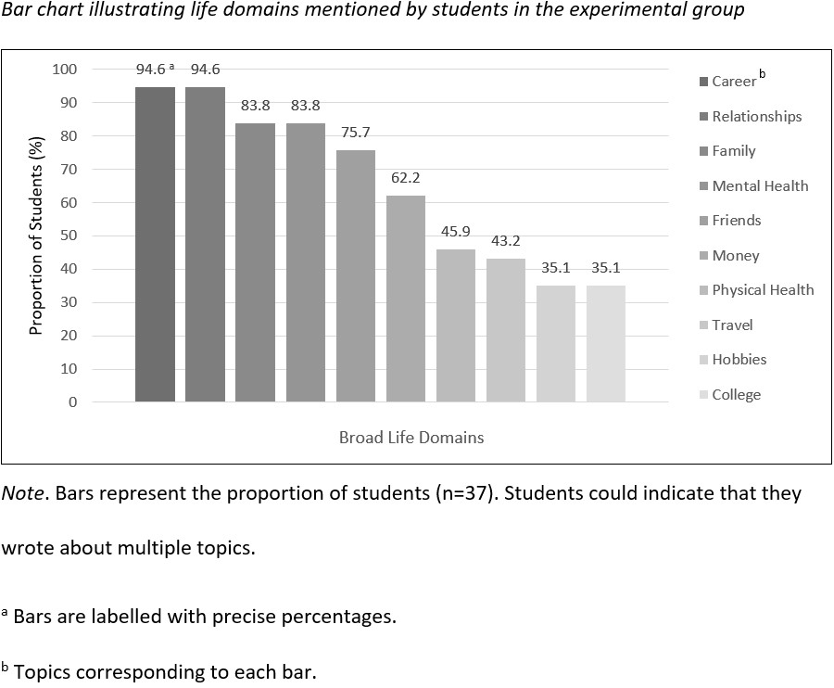

Discussion

Support for Hypotheses
The present study suggests that a brief meaning-focused writing intervention moderately increased students’ perceptions of meaning in life (MIL). As hypothesised, students who wrote expressively about values, passions, and actions that might lead to an ideal and less ideal future reported higher purpose, coherence, and mattering scores than the control group.
Additionally, students in the intervention group reported significantly higher life-crafting scores than those in the control group, supporting the use of expressive writing to promote life-crafting behaviours. Fourth-year students also scored significantly higher in life crafting than second-year students, suggesting those later in their studies engage more in global life-crafting behaviours irrespective of experimental grouping. No significant interaction between year of study and experimental grouping was observed, although the interaction approached statistical significance.

Frequency of Life Domains Written about by the Experimental Group
Almost all students (94.6%) in the experimental group wrote about careers and relationships when prompted to write about the future. A significant majority (83.8%) wrote about family and mental health. A majority wrote about friends (75.7%) and money (62.2%). Almost half (45.9%) wrote about physical health. A minority wrote about travel (43.2%), hobbies (35.1%), and college (35.1%). These results provide a limited insight into the life domains most central to students’ visions of the future.

Similarity to Other Works

Meaning-Focused Life Reframing
Chen et al. (2022) identify three key life-crafting behaviours: cognitively reframing one’s life, seeking social support, and actively pursuing challenges. The present study promoted meaning-focused life-crafting primarily through cognitive reframing. In this sense, individuals were not necessarily empowered to create or pursue new meaning sources, but instead to reframe their current lives as more purposeful, coherent, mattering, and therefore meaningful. The present intervention might therefore be more accurately regarded as meaning-focused life-reframing than life-crafting. The structure and positive future-orientated thinking afforded by this intervention might function analogously to Steger’s (2018) conceived function of meaning: to give our lives structure and guide the direction of our attention and energy. The success of the present intervention could therefore be due to its prompting patterns of thoughts and behaviour that would otherwise occur as a natural function of perceived MIL. In such a case, resultant increases in perceived meaning could have a ‘knock-on’ effect, motivating further thoughts and behaviours that actualise perceptions of MIL.

The Mechanics of Narrative Meaning-Making
Schippers and Ziegler (2019) and de Jong et al. (2020) theorise a structured way of finding meaning that among other activities involves discovering values and passions and writing about the ideal future. The results of the present study validate some of these suggestions, with important distinctions.
Firstly, students were prompted only to reflect on existing values and passions. Secondly, informed by insights from narrative therapy about the therapeutic utility of writing about actions (Frank, 2018), the present study prompted writing about appropriate actions that might lead to an ideal and less ideal future rather than about such futures in isolation. This critical distinction aimed to support students to cognitively reframe their ideal future more as a coherent product of appropriate action in the present than an uncertainty to be passively desired. Narratively reframing the future this way (as a coherent product of actions) might not only offer a clear purpose in life - to bring about such a future through actions - but also reinforce the sense that one’s actions matter considering their propagative consequence on the future. Additionally, uniform increases in purpose, coherence and mattering observed in the experimental group reinforce George and Park’s (2016) view that these constructs are interconnected in complex ways.

Strengths, Limitations and Generalisability of Results

Strengths
A major strength of utilising expressive writing prompts was that students were supported to craft meaning with minimal external guidance. Aside from the regulation of timers for each booklet section as a control measure, students’ life-crafting efforts were virtually self-directed. Thus, considering potential benefits, real-world implementation of this intervention would require relatively low cost and administrative work. Furthermore, it was deemed essential to the success of participant recruitment to design an intervention that was relatively brief and strictly time constrained. The success of the intervention, despite this brevity (only 16mins), also broadens the scope of its practical application. These factors encourage the implementation of such interventions going forward in schools and universities as suggested by Schippers and Ziegler (2019). Moderately effective meaning-focused life crafting appears possible without the costly one-to-one guidance that is indispensable in narrative therapy (Frank, 2018).

Limitations
Four key factors limit the present study. Firstly, to facilitate the successful recruitment of an adequate number of participants, the intervention was designed to be brief and strictly time limited. This resulted in a narrowing of the number of distinct stages theorised in the literature that could be incorporated. Secondly, sample size was a critical limitation in the testing of hypothesis six: the interaction between year of study and experimental grouping on life crafting. One second-year student in the control group, with a high life-crafting score (just below the outlier threshold) had a large influence on the significance of the result. The removal of this single participant would have produced a significant result (see Appendix J). Considering these aspects of the data, it is expected that with a larger sample size, a significant interaction between year of study and experimental grouping would be identified. Thirdly, lacking longitudinal investigation of how MIL increases persisted over time limits the validity of the results of the present study. MIL is an important factor both across a wide variety of life domains and at various life stages (Steger, 2018). The ideal meaning-making intervention should therefore produce increases that persist across long timescales. Lastly, the recruited sample was predominantly female narrowing result generalisability.

Generalisability of Results
Purposive sampling methods reinforce the validity and generalisability of the results of the present study. The targeted recruitment of university students (21.2 years old on average) and random allocation of experimental groups supports the generalisability of results to other young-adult populations. However, an approximately 2:1 ratio of female to male participants limits generalisability to male populations. Nonetheless, experiments were conducted in highly controlled environments: silent classrooms that were familiar to, and regularly occupied by, participants. Thus, the present study benefits from ecological validity. Furthermore, time spent completing each section between groups was strictly controlled, reinforcing observed differences.

Implications for future research
Further studies investigating the longitudinal persistence of MIL increases following similar interventions are necessary before valid conclusions about their practical utility can be made. However, the remarkable effect size of the intervention despite its brevity highlights two future directions for further meaning-focused life-crafting research. Firstly, it is possible that longer, more complex interventions could produce greater increases. Such interventions could involve additional non-written activities, such as making if-then plans and publicly proclaiming goals as suggested by Schippers and Ziegler (2019) and de Jong et al. (2020). Such long-form interventions could take the form of workshops or focused modules (Schippers & Ziegler). Secondly, an alternative shorter intervention - as examined in the present study - could be more widely accessible. Such an intervention, perhaps repeated at regular intervals like once a week, could be a practical strategy for implementing moderately effective meaning-making while requiring minimal time-investment and external direction. The possible advantages of these avenues warrant further investigation.
Careful consideration of the present study’s data suggests that a significant interaction between year of study and experimental grouping would have been identified with greater sample size. Future research should therefore explore the possibility of interactions between year of study and other factors on life-crafting outcomes. Furthermore, second-year students scored lower in life-crafting, suggesting that younger populations might have more to gain from similar interventions. These results encourage supporting undergraduate students as early as possible, such as at the start of their first year of study. Future research should therefore carefully consider implementing validated meaning-focused interventions into school and college curriculums. Dekker et al. (2020) theorise benefits of integrating AI-enhanced chatbots with meaning-focused life-crafting interventions to produce online platforms that optimise mental health and academic performance. Future studies should explore how technological advances and developments in meaning conceptualisation may be integrated to support individuals to find MIL.

Conclusion
A brief intervention prompting written reflection on values, passions, and ideal and less ideal futures was suggested to moderately increased perceptions of purpose, coherence, and mattering for students versus a control measure. Significant increases in life-crafting behaviours following the intervention were also observed. Observed differences between two distinct years of study suggest that those in earlier years might have more to gain from such interventions. George and Park’s (2016, 2017) multidimensional synergistic conception of MIL and Chen et al.’s (2022) life crafting scale undoubtedly underpin these findings. Operationalising these developments, aspects of Schippers and Ziegler (2019) and de Jong et al.’s (2020) theorised meaning-focused life crafting interventions are validated with important distinctions. Embracing insight from narrative therapy (Frank, 2018), students were prompted to write about appropriate actions that might bring about those futures, rather than about such futures in isolation.
However, lacking longitudinal investigation of how these increases persisted over time and the recruitment of a predominantly female sample of undergraduate students limits the implications of these findings. A variety of suggestions for future research are provided including two main avenues for the continued development and validation of meaning-focused life-crafting interventions. Longer and more complex interventions, for instance in the form of workshops or classes, could produce more profound increases in MIL. Shorter interventions, however, might be more accessible and easier to implement in schools or colleges, requiring minimal time investment and external guidance while remaining moderately effective. Future studies should explore these avenues and continue to conceptualise, develop, and validate diverse and multidimensional strategies for supporting individuals in their search for, and actualisation of, MIL.

References
Becker, E. (1973). The Denial of Death. Free Press.
Brassai, L., Piko, B. F., & Steger, M. F. (2015). A reason to stay healthy: The role of meaning in life in relation to physical activity and healthy eating among adolescents. Journal of Health Psychology, 20(5), 473–482. https://doi.org/10.1177/1359105315576604
Bronk, K. C. (2011). The role of purpose in life in Healthy Identity Formation: A grounded model. New Directions for Youth Development, 2011(132), 31–44. https://doi.org/10.1002/yd.426
Bundick, M. J. (2011). The benefits of reflecting on and discussing purpose in life in emerging adulthood. New Directions for Youth Development, 2011(132), 89–103. https://doi.org/10.1002/yd.430
Chen, S., van der Meij, L., van Zyl, L. E., & Demerouti, E. (2022). The Life Crafting Scale: Development and validation of a multi-dimensional meaning-making measure. Frontiers in Psychology, 13. https://doi.org/10.3389/fpsyg.2022.795686
Chu, S. T.-W., & Fung, H. H.-L. (2020). Is the search for meaning related to the presence of meaning? moderators of the longitudinal relationship. Journal of Happiness Studies, 22(1), 127–145. https://doi.org/10.1007/s10902-020-00222-y
Code of Professional Ethics 4th Edition. (2019). The Psychological Society of Ireland. Retrieved 2023, from https://psychologicalsociety.ie/source/Code%20of%20Pro fessional%20Ethics%20(Oct%202019).pdf
Cohen, K., & Cairns, D. (2011). Is searching for meaning in life associated with reduced subjective well-being? confirmation and possible moderators. Journal of Happiness Studies, 13(2), 313–331. https://doi.org/10.1007/s10902-011-9265-7

Costin, V., & Vignoles, V. L. (2020). Meaning is about mattering: Evaluating coherence, purpose, and existential mattering as precursors of meaning in life judgments. Journal of Personality and Social Psychology, 118(4), 864–884. https://doi.org/10.1037/pspp0000225
Crumbaugh, J. C. (1977). The seeking of Noetic Goals Test (song): A complementary scale to the purpose in life test (PIL). Journal of Clinical Psychology, 33(3), 900–907. https://doi.org/10.1002/1097-4679(197707)33:3<900::aid-jclp2270330362>3.0.co;2-8
Crumbaugh, J. C., & Maholick, L. T. (1964). An experimental study in existentialism: The psychometric approach to Frankl's concept of noogenic neurosis. Journal of Clinical Psychology, 20(2), 200–207. https://doi.org/10.1002/1097-4679(196404)20:2<200::aid-jclp2270200203>3.0.co;2-u
de Jong, E. M., Ziegler, N., & Schippers, M. C. (2020). From shattered goals to meaning in life: Life crafting in times of the COVID-19 pandemic. Frontiers in Psychology, 11. https://doi.org/10.3389/fpsyg.2020.577708
Dekker, I., De Jong, E. M., Schippers, M. C., De Bruijn-Smolders, M., Alexiou, A., & Giesbers, B. (2020). Optimizing students’ mental health and academic performance: AI-Enhanced Life Crafting. Frontiers in Psychology, 11. https://doi.org/10.3389/fpsyg.2020.01063
Doğan, T., Sapmaz, F., Tel, F. D., Sapmaz, S., & Temizel, S. (2012). Meaning in life and subjective well-being among Turkish University students. Procedia - Social and Behavioral Sciences, 55, 612–617. https://doi.org/10.1016/j.sbspro.2012.09.543
Finnie, R., Poirier, W., Bozkurt, E., Peterson, J. B., Fricker, T., & Pratt, M. (2017). Using Future Authoring to Improve Student Outcomes. Higher Education Quality Council of Ontario, 10–25. Retrieved March 16, 2023, from https://heqco.ca/wp-content/uploads/2020/03/HEQCO-Formatted_EPRI-Mohawk.pdf.
Frank, A. W. (2018). What is narrative therapy and how can it Help Health Humanities? Journal of Medical Humanities, 39(4), 553–563. https://doi.org/10.1007/s10912-018-9507-3
Frankl, V. E. (2020). Man's search for Meaning: The classic tribute to hope: From the Holocaust. Penguin.
George, L. S., & Park, C. L. (2016). Meaning in life as comprehension, purpose, and mattering: Toward integration and new research questions. Review of General Psychology, 20(3), 205–220. https://doi.org/10.1037/gpr0000077
George, L. S., & Park, C. L. (2017). The multidimensional existential meaning scale: A tripartite approach to measuring meaning in life. The Journal of Positive Psychology, 12(6), 613–627. https://doi.org/10.1080/17439760.2016.1209546
Ghavibazou, E., Hosseinian, S., Ghamari kivi, H., & Ale Ebrahim, N. (2022). Narrative therapy, applications, and outcomes: A systematic review. SSRN Electronic Journal. https://doi.org/10.2139/ssrn.4119920
Heine, S. J., Proulx, T., & Vohs, K. D. (2006). The meaning maintenance model: On the coherence of social motivations. Personality and Social Psychology Review, 10(2), 88–110. https://doi.org/10.1207/s15327957pspr1002_1
Hill, P. L., & Turiano, N. A. (2014). Purpose in life as a predictor of mortality across adulthood. Psychological Science, 25(7), 1482–1486. https://doi.org/10.1177/0956797614531799
Huta, V., & Waterman, A. S. (2013). Eudaimonia and its distinction from hedonia: Developing a classification and terminology for understanding conceptual and operational definitions. Journal of Happiness Studies, 15(6), 1425–1456. https://doi.org/10.1007/s10902-013-9485-0
Jacob, Y., & Steger, M. F. (2021). Meaning-centred coaching in the Workplace. Positive Psychology Coaching in the Workplace, 555–574. https://doi.org/10.1007/978-3-030-79952-6_29
Kang, Y., Strecher, V. J., Kim, E., & Falk, E. B. (2019). Purpose in life and conflict-related neural responses during health decision-making. Health Psychology, 38(6), 545–552. https://doi.org/10.1037/hea0000729
King, L. A., & Hicks, J. A. (2021). The science of meaning in life. Annual Review of Psychology, 72(1), 561–584. https://doi.org/10.1146/annurev-psych-072420-122921
Klinger, E. (1977). Meaning and Void: Inner Experience and The Incentives in People’s Lives. Minneapolis: University of Minnesota Press.
Krok, D. (2017). When is meaning in life most beneficial to young people? styles of meaning in life and well-being among late adolescents. Journal of Adult Development, 25(2), 96–106. https://doi.org/10.1007/s10804-017-9280-y
Lew, B., Chistopolskaya, K., Osman, A., Huen, J. M., Abu Talib, M., & Leung, A. N. (2020). Meaning in life as a protective factor against Suicidal Tendencies in Chinese university students. BMC Psychiatry, 20(1). https://doi.org/10.1186/s12888-020-02485-4
Marco, J. H., García-Alandete, J., Pérez Rodríguez, S., Guillén, V., Baños, R. M., & Tormo-Irun, M. P. (2022). Spanish validation of the multidimensional existential meaning scale: Which dimension of meaning in life is more associated with psychopathology in people with mental disorders? Frontiers in Psychiatry, 13. https://doi.org/10.3389/fpsyt.2022.832934
Nietzsche, F. W. (1889). Sprüche und Pfeile. In Die Götzen-Dämmerung (pp. 2–2). essay, C.G. Naumann, Leipzig.
Park, C. L., George, L. S., & Ai, A. L. (2020). Measuring three distinct aspects of meaning in life: The multidimensional existential meaning scale (MEMS). Assessing Spirituality in a Diverse World, 117–140. https://doi.org/10.1007/978-3-030-52140-0_6
Schippers, M. C., & Ziegler, N. (2019). Life crafting as a way to find purpose and meaning in life. Frontiers in Psychology, 10. https://doi.org/10.3389/fpsyg.2019.02778
Steger, M. F. (2018). Meaning in life. The Oxford Handbook of Positive Psychology, 3rd Edition. https://doi.org/10.1093/oxfordhb/9780199396511.013.56
Steger, M. F., Dik, B. J., & Duffy, R. D. (2012). Measuring meaningful work. Journal of Career Assessment, 20(3), 322–337. https://doi.org/10.1177/1069072711436160
Steger, M. F., Frazier, P., Oishi, S., & Kaler, M. (2006). The meaning in life questionnaire: Assessing the presence of and search for meaning in life. Journal of Counseling Psychology, 53(1), 80–93. https://doi.org/10.1037/0022-0167.53.1.80
Steger, M. F., Kashdan, T. B., Sullivan, B. A., & Lorentz, D. (2008). Understanding the search for meaning in life: Personality, cognitive style, and the dynamic between seeking and experiencing meaning. Journal of Personality, 76(2), 199–228. https://doi.org/10.1111/j.1467-6494.2007.00484.x
Steger, M. F., Oishi, S., & Kashdan, T. B. (2009). Meaning in life across the life span: Levels and correlates of meaning in life from emerging adulthood to older adulthood. The Journal of Positive Psychology, 4(1), 43–52. https://doi.org/10.1080/17439760802303127
Tabachnick, B. G., & Fidell, L. S. (2013). Limitations to Multivariate Analysis of Variance and Covariance. In Using Multivariate Statistics (7th ed., p. 253). essay, Pearson.
Wong, P. T. (2020). Existential positive psychology and integrative meaning therapy. International Review of Psychiatry, 32(7-8), 565–578. https://doi.org/10.1080/09540261.2020.1814703

Appendix A

Excluded Outliers
Outliers were identified within SPSS 28.0.1 through the production of separate boxplots corresponding to each DV and filtered by experimental group and year of study, as recommended by Tabachnick and Fidell (2013, p. 74). Scores which are 1.5 times above or below the 3rd or 1st quartiles for high and low outliers respectively are differentiated and labelled automatically by SPSS. In the case of the present study, all outliers (n=4) were low scoring outliers.
Below Figure A1 displays a series of boxplots illustrating outliers for each DV excluded from statistical analyses.
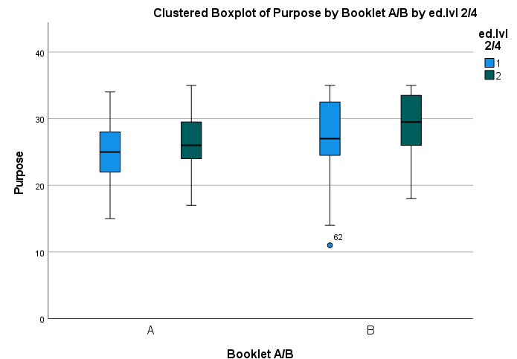
Figure A1
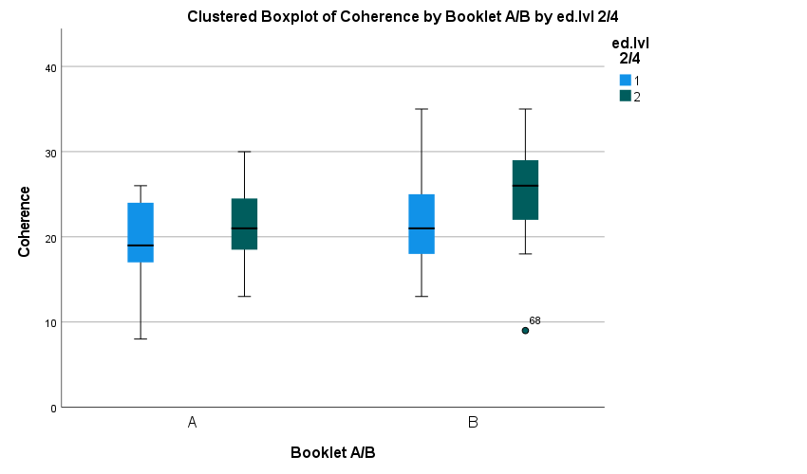

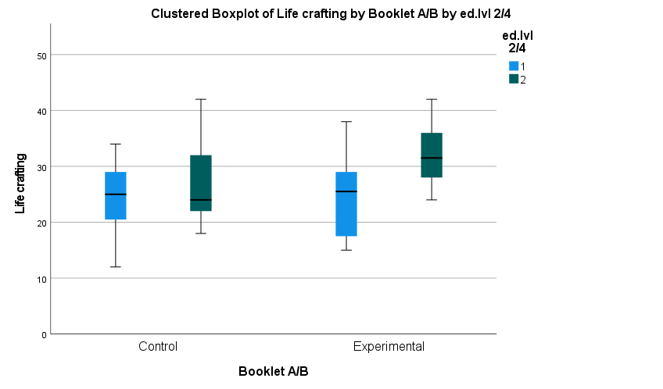
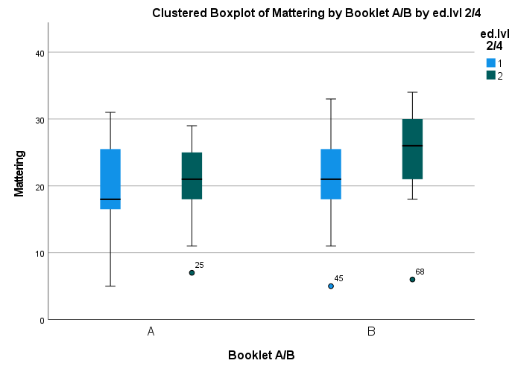

Appendix B

Information Sheet
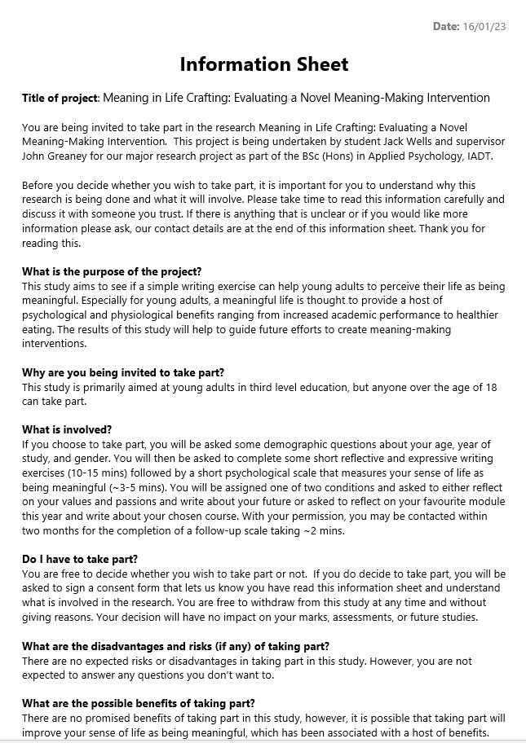
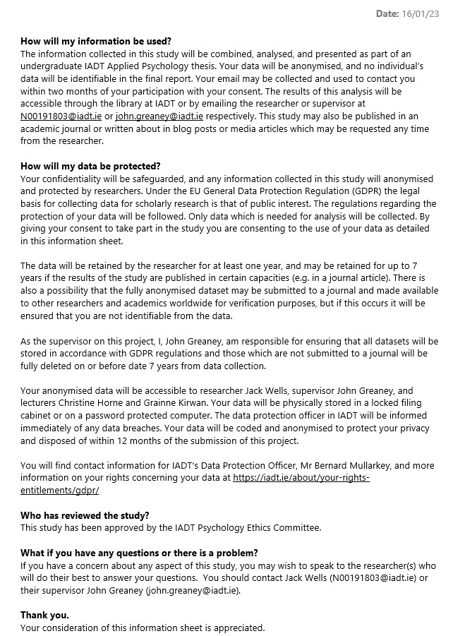

Appendix C

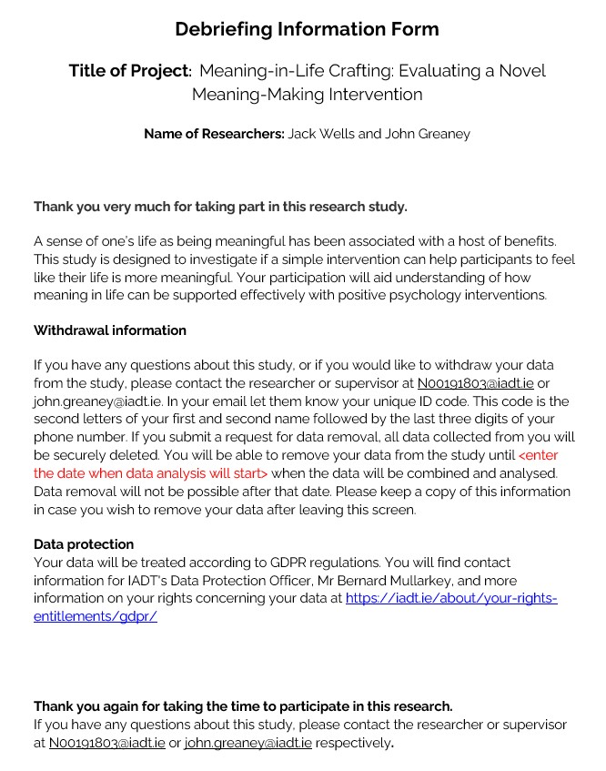
Debrief Sheet

Appendix D

PowerPoint Presentation Slides
Slide 1
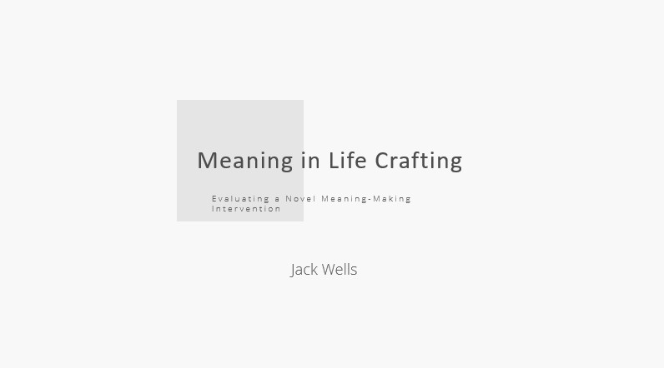


Slide 2

Slide 3
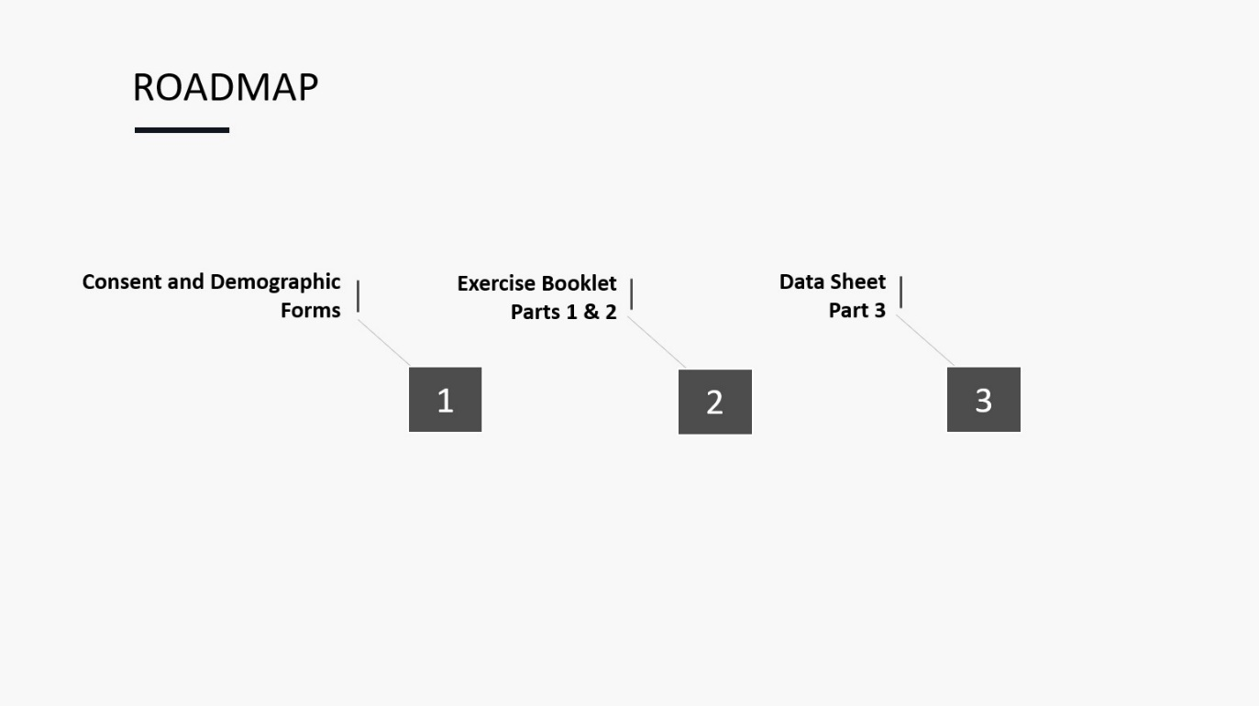

Slide 4
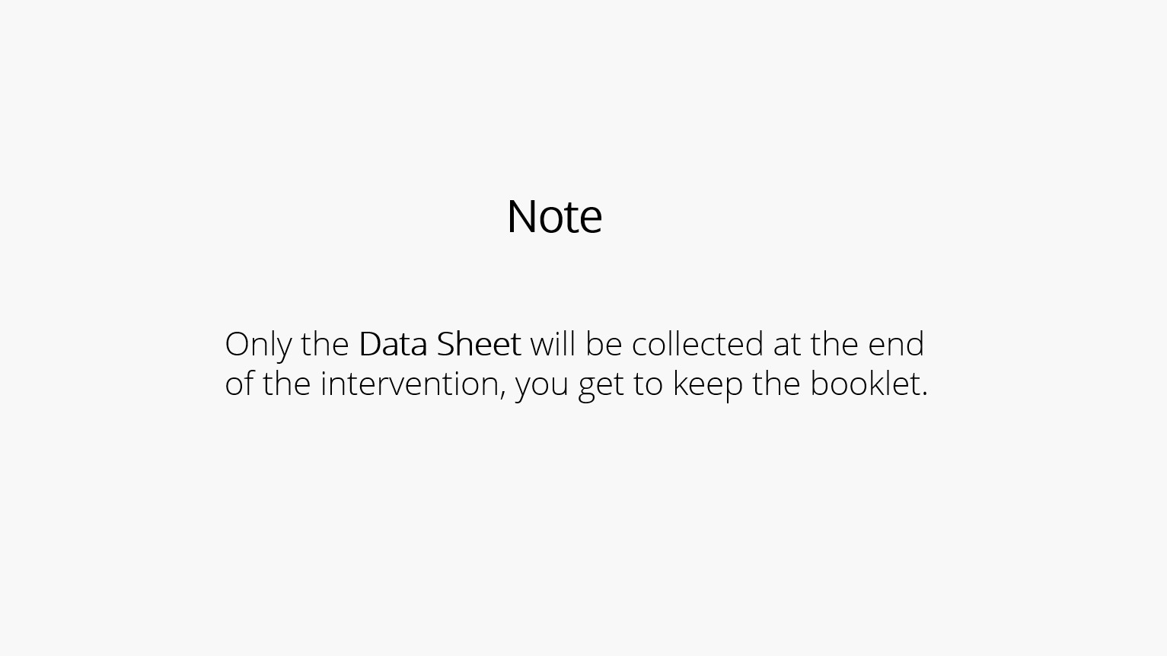

Slide 5
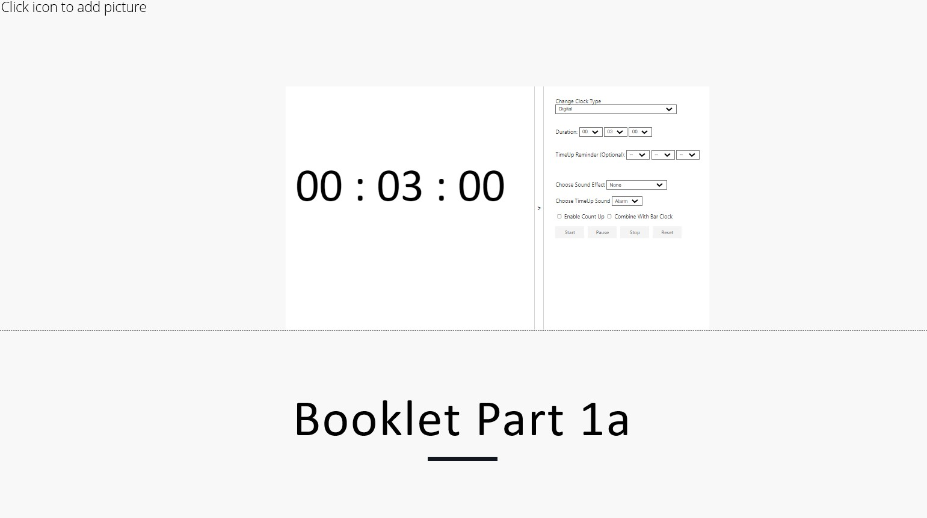

Slide 6
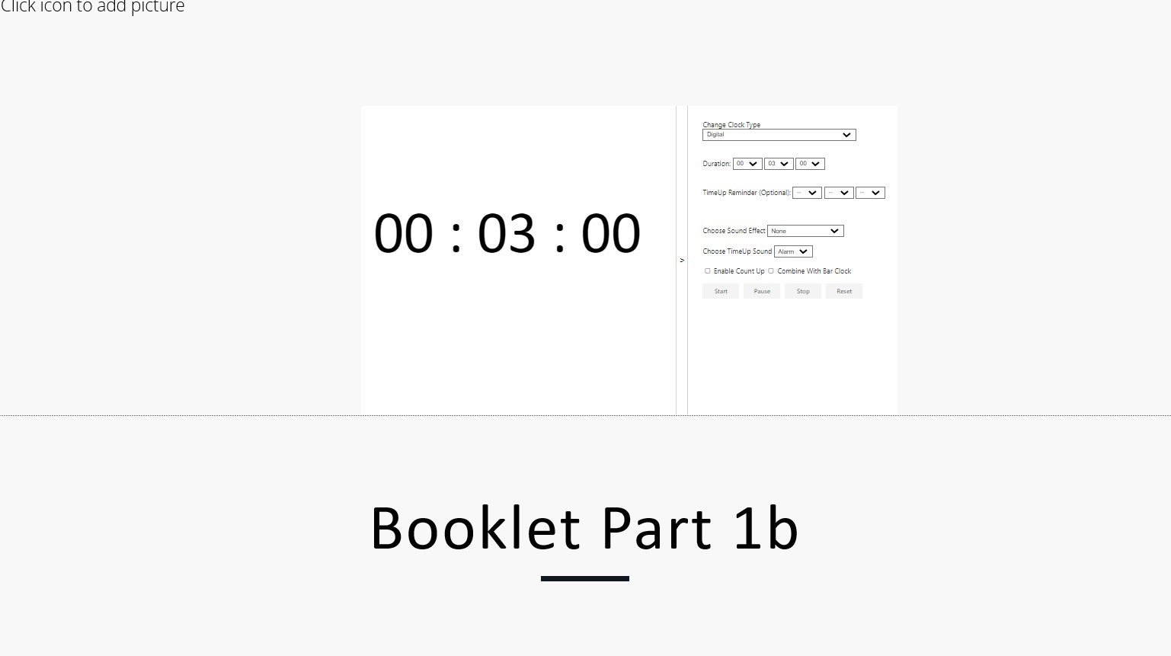

Slide 7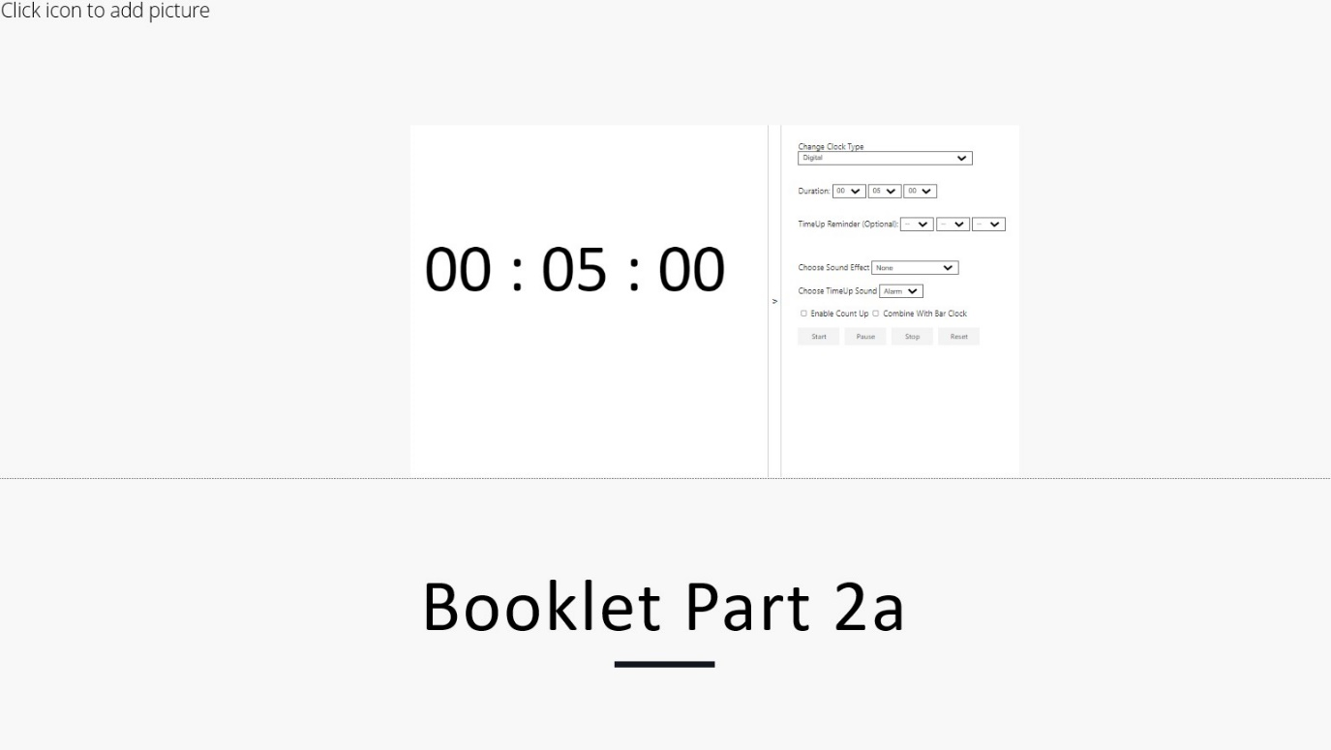

Slide 8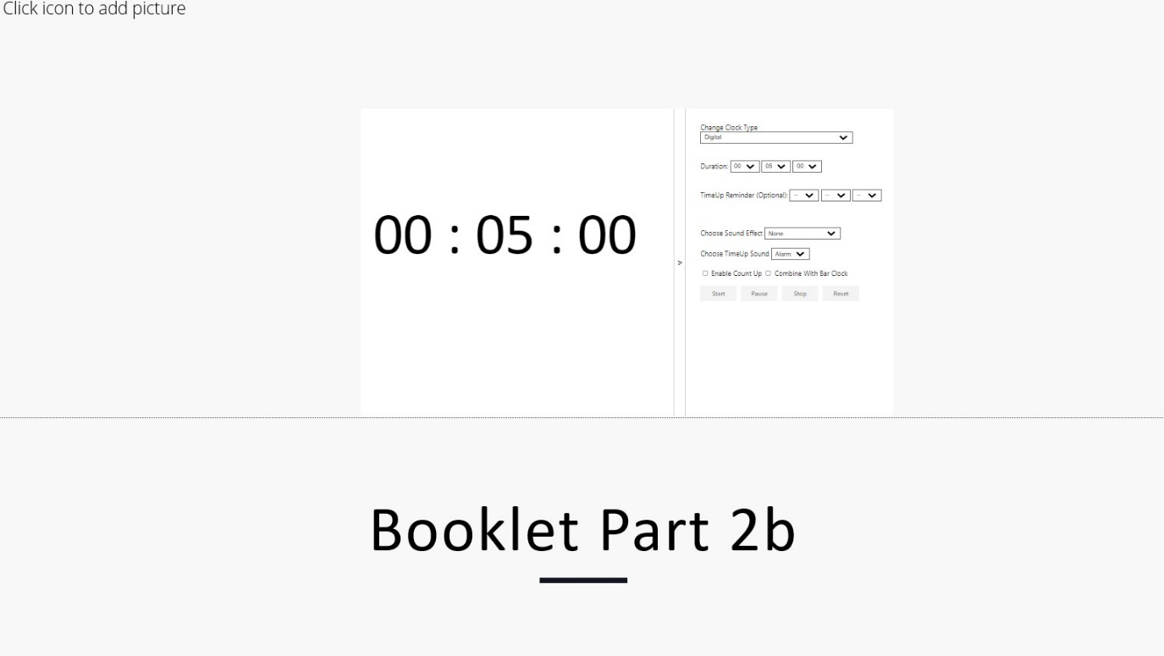

Slide 9

Slide 10

Appendix E

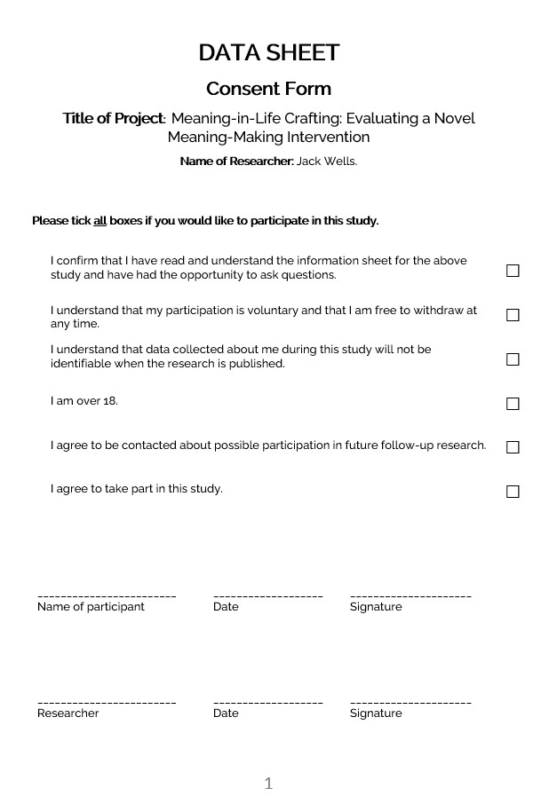
Data Sheet

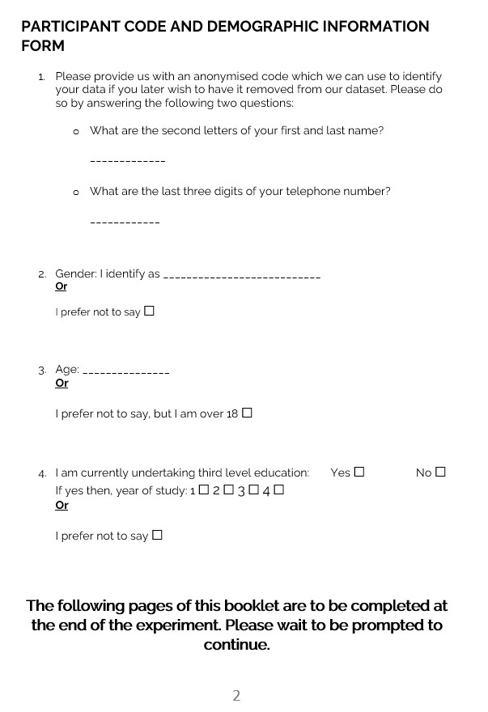

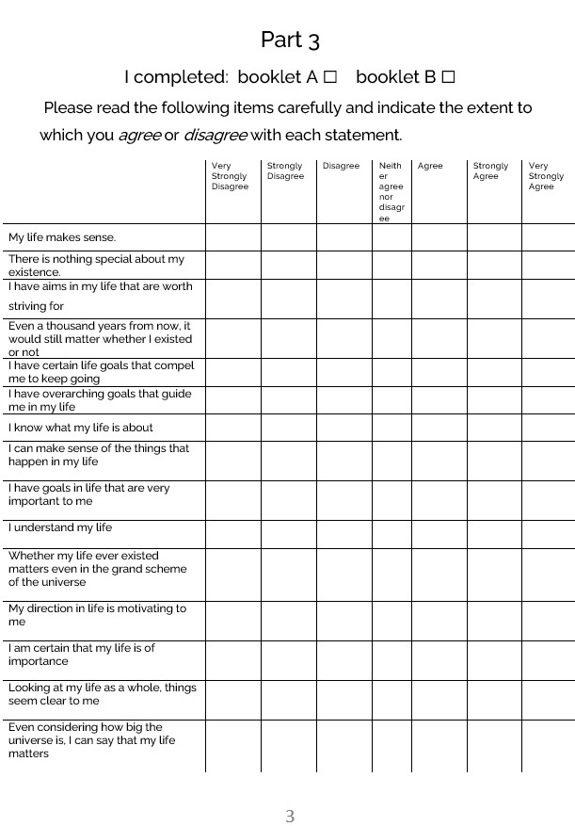

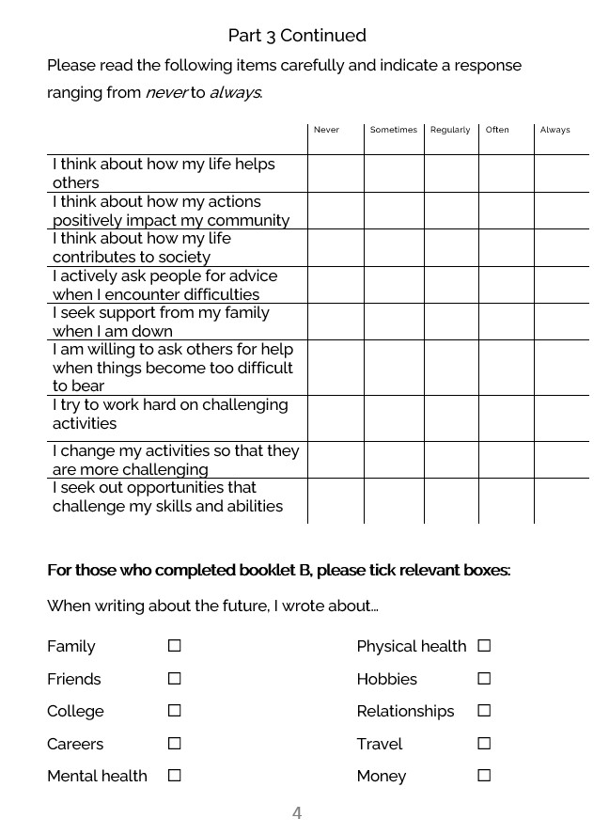

Appendix F

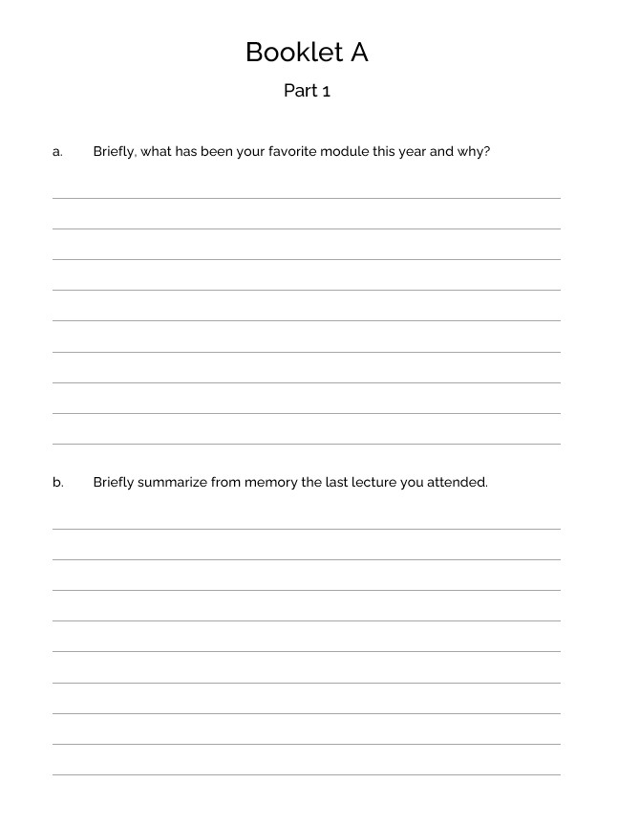
Booklet A



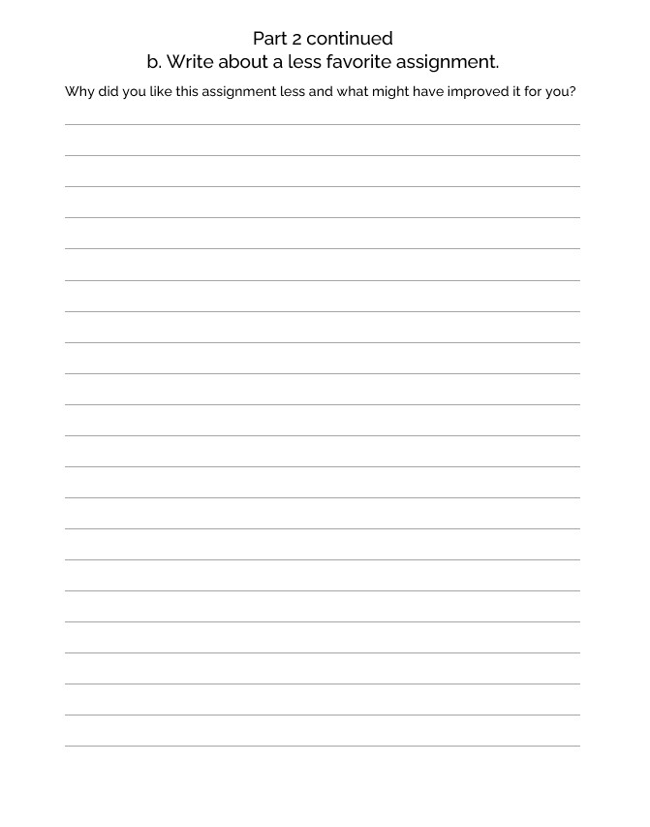

Appendix G

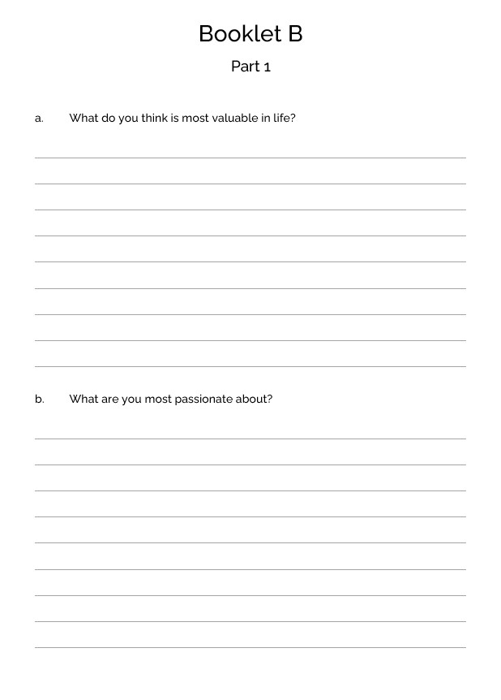
Booklet B

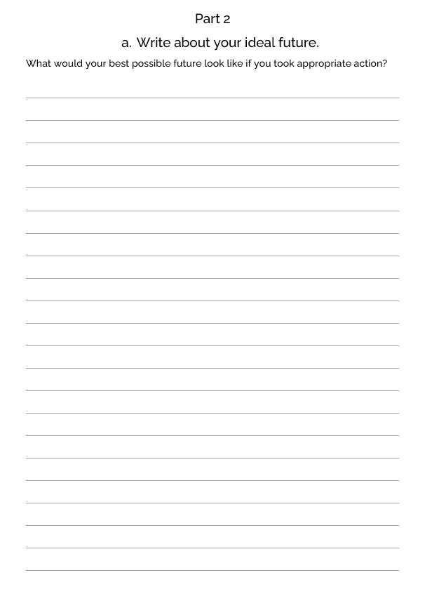

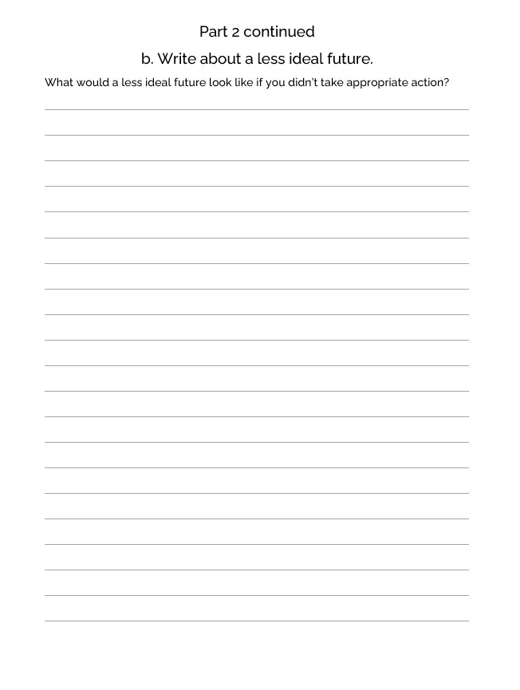

Appendix H

The Multidimensional Existential Meaning Scale
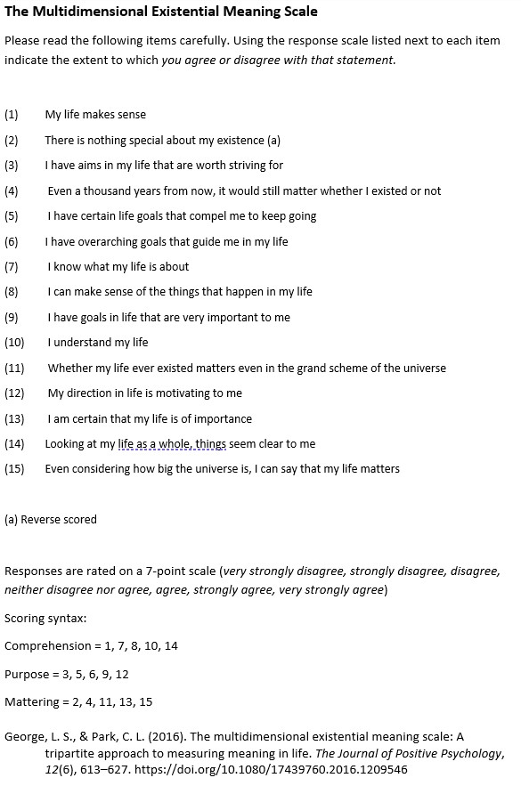

Appendix I

The Life Crafting Scale
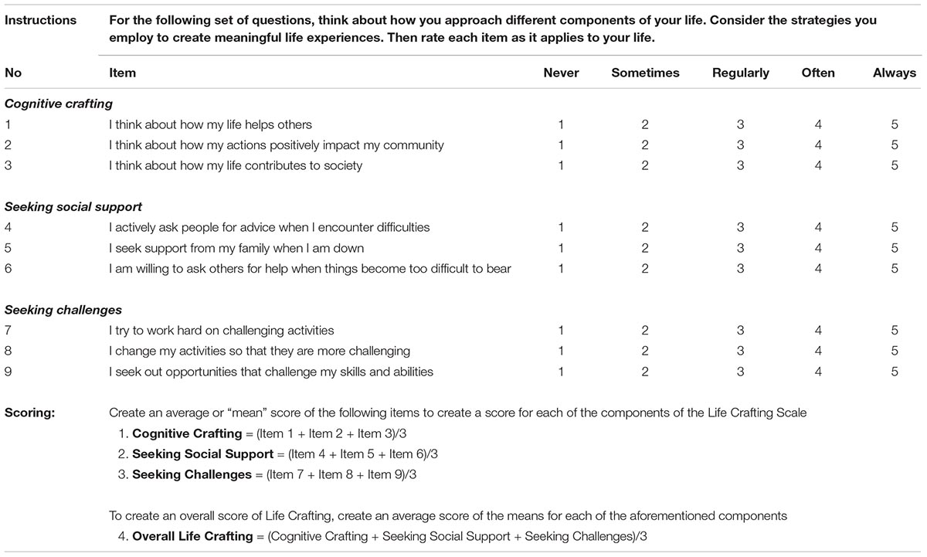

Chen, S., van der Meij, L., van Zyl, L. E., & Demerouti, E. (2022). The Life Crafting Scale: Development and validation of a multi-dimensional meaning-making measure. Frontiers in Psychology, 13. https://doi.org/10.3389/fpsyg.2022.795686

Appendix J

Participant UU225’s Large Influence in the Two-Way ANOVA
Participant UU225’s high score placed them just below the requirement for exclusion as an outlier. Below is a boxplot differentiating participant UU225 from the rest of the second-year experimental group.
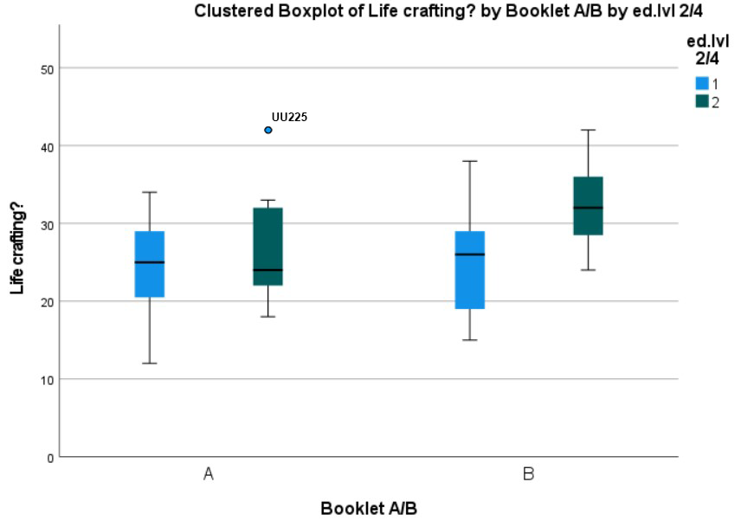
Below is a Two Way ANOVA Table from SPSS computing the influence of year of study and experimental grouping on life crafting scores showing a statistically significant interaction effect between year of study (ed.lvl24) and experimental grouping (BookletAB) with participant UU225 excluded.
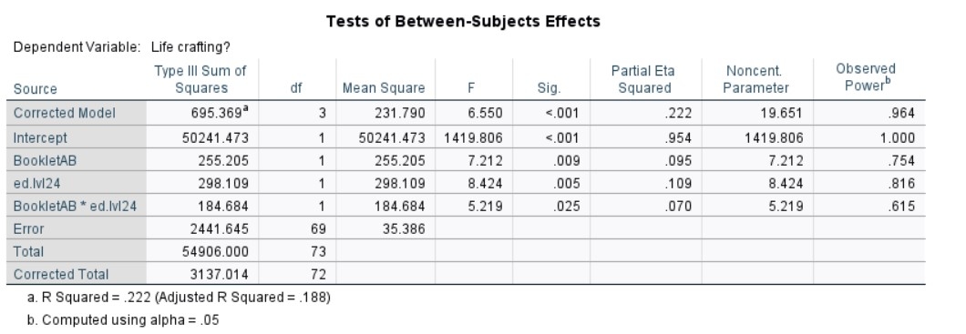

Appendix K

MANOVA Assumptions Testing Report
The assumption of multicollinearity of the dependent variables was not violated. In fact, each dependent variable correlated moderately with one another, reinforcing the validity of the analysis (Dattalo, 2013). Below is a table illustrating moderate correlation between each DV.
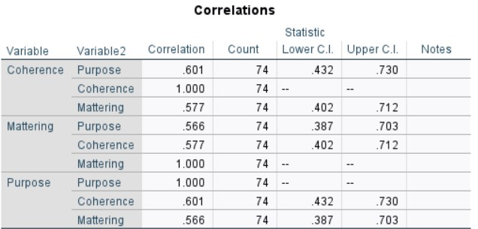
The assumption of linear relationship between DVs for each IV group was also not violated. Below Figure K1 displays scatterplot matrices illustrating a linear relationship between each DV for each IV group.
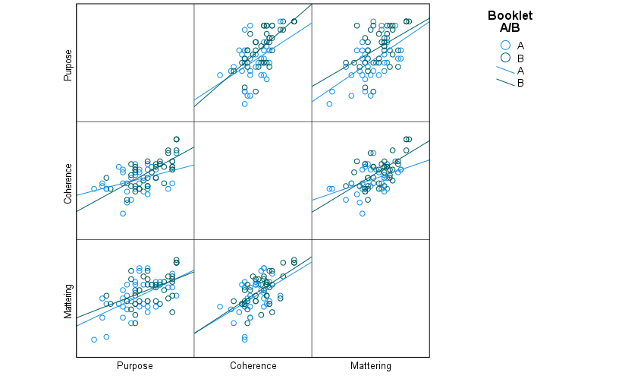
Figure K1

Dattalo, P. (2013). Basic Concepts and Assumptions. In Analysis of multiple dependent variables (pp. 1–22). essay, Oxford University Press.

The assumption of multivariate normality of the DVs was determined graphically and using the Shapiro-Wilk test of normality. This assumption was violated in one case: purpose scores in the experimental group were moderately negatively skewed (skewness = -.408, p = .388) and therefore abnormally distributed. Below is a population pyramid illustrating the skewness of purpose scores in the experimental group (green).
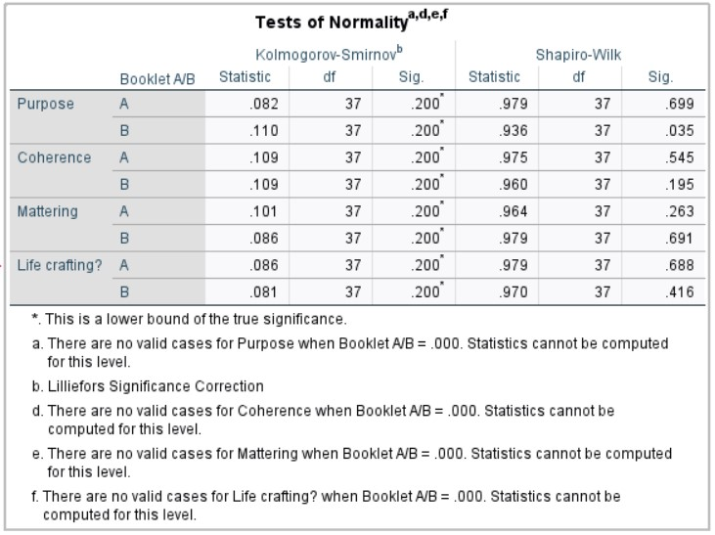
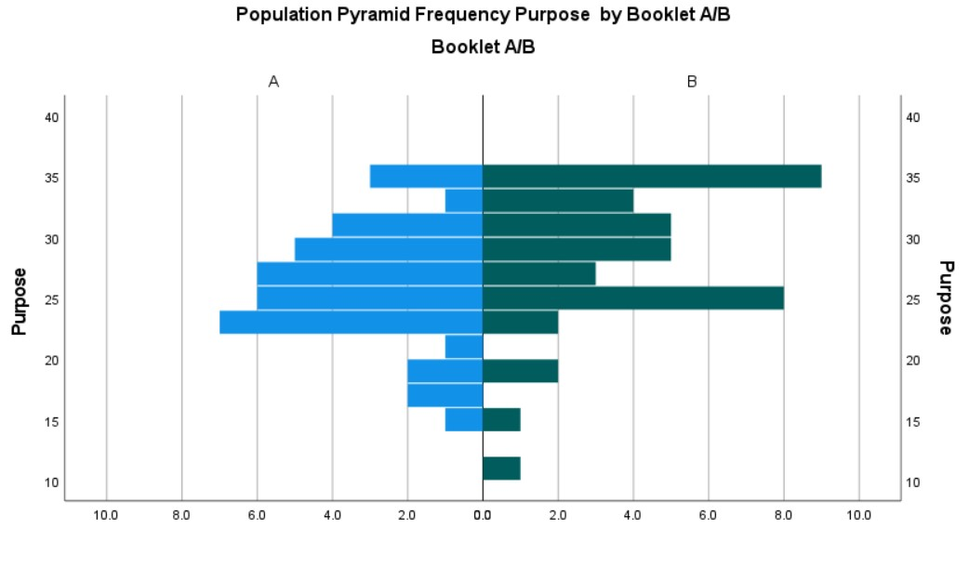This abnormality was numerically supported by Shapiro-Wilk testing, W(37)=.936, p=.035. Below is the SPSS output table for this normality test.

Levene’s test of equality of error variances was not violated for coherence scores; Levene’s Statistic(1,72)=.475, p=.515, or mattering scores; Levene’s Statistic(1,72)=.736, p=.114. However, this test was violated for purpose scores, Levene’s Statistic (1,72) <.001, p=.989.
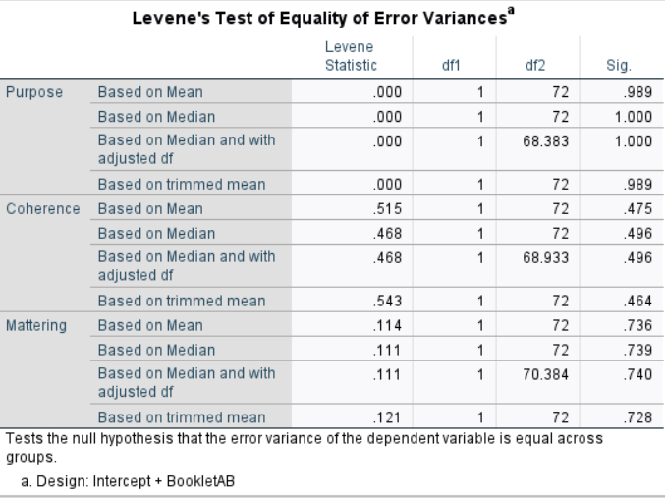
The cause of this violation was one participant in the second-year experimental group (UU225) scoring exceptionally high in purpose, but below the outlier threshold. Removing this participant, resolves this violation as well as the observed abnormality of the purpose group.
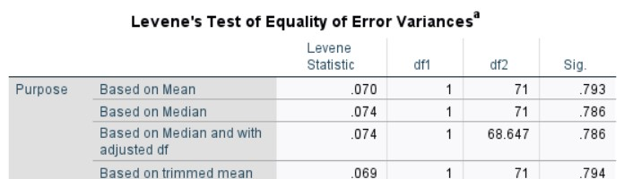
However, a significant between-subjects effect for purpose scores is present with this participant both in and out of the analysis (see overleaf) suggesting that their removal is unnecessary and that results are valid despite these minor assumption violations.

MANOVA Output with UU225 Removed.
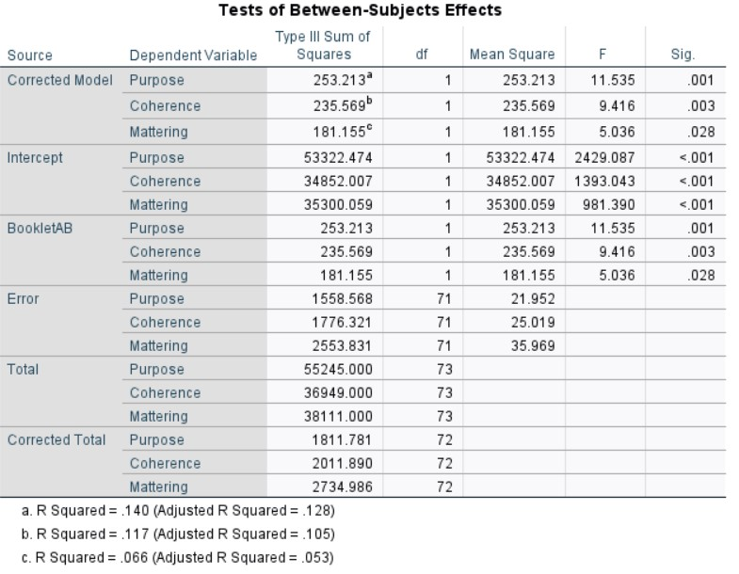
Based on the discussed aspects of the data it is highly likely that with a greater sample size no assumptions would have been violated.

Appendix L

ANOVA Assumptions Testing Report
No assumptions of this test were violated.
Shapiro-Wilk normality testing suggested that life-crafting scores were normally distributed for the control group, W(37)=.979, p=.688. The same was true for the experimental group, W(37)=.970, p=.416. Shapiro-Wilk normality testing suggested that life-crafting scores were normally also distributed for the second-year group, W(45)=.975, p=.436. The same was true for the fourth-year group, W(29)=.969, p=.522.
Levene’s test for equality of error variances suggested homogeneity of variance between groups, Levene Statistic(3,70)=.856, p=.468.

