Luke Coogan

Food, Design and Emotion:
An analysis of fake meat products through the lens of emotional design principles

Submitted to the Department of Technology and Psychology in candidacy for the Bachelor of Art (Hons) Interaction + User Experience Design
Faculty of Film, Art and Creative Technologies
2024

Declaration of Originality
This dissertation is submitted by the undersigned to the Institute of Art Design and Technology, Dun Laoghaire in partial fulfilment for the BA (Hons) in Interaction + User Experience Design. It is entirely the author’s own work, except where noted, and has not been submitted for an award from this or any other educational institution.
Signed:


Abstract

As society has become increasingly aware of the detrimental effects of animal-meat production, meat alternative products have seen a significant increase in popularity. Many of these meat alternatives are intentionally designed to mimic the characteristics, look and feel of animal-based meat products. However, as food making technology advances, we must critically evaluate the product and experience we are creating for these consumers. Why do these products look like meat? What effect does this mimicry have on us as consumers? What effects may it have in the future? To answer these questions, we must first understand how these products exist, identify the problems we are faced with now and identify opportunities that may arise in the future.

Table of Contents

Declaration of Originality 2
Abstract 3
List of Images 5
Chapter 1 – The Origins of Fake Meat 11

Chapter 2 – The Design of Fake Meat: Impossible Burger Case Study 23
Chapter 3 – The Future of Fake Meat 35
Conclusion 46
Works Consulted 49

List of Images

Fig. 1 All about Tofu. Cook for Your Life, https://www.cookforyourlife.org/blog/all-about-tofu/. Accessed 19 Nov. 2023.
Fig. 2 Protose Cutlets. Perspectives on History, https://www.historians.org/research-and-publications/perspectives-on-history/december-2020/protose-cutlets. Accessed 19 Nov. 2023.
Fig. 3 Protose Vegetable Meat. Vegetarian History, https://vegetarianhistory.blogspot.com/2010/06/welcome.html?fbclid=IwAR0_1e0lnjKdenJQ86fdwoOTl8zBm8CkJlfZhok0yjF_2iC1dggLkamDo58. Accessed 19 Dec. 2023.
Fig. 4 Fake meat is baked into Battle Creek’s history. Battle Creek Enquirer, https://eu.battlecreekenquirer.com/story/life/2019/10/04/fake-meat-battle-creek-kellogg-vegetarianism-seventh-day-adventist-protose/2301425001/. Accessed 10 Oct. 2023.
Fig. 5 “The Battle Creek Diet System”: A Pamphlet and Birth of the Fake Meat Industry. https://blogs.loc.gov/inside_adams/2020/02/battle-creek-diet-fake-meat/#:~:text=Protose%20held%20the%20lofty%20claim,flavor%20and%20composition.%E2%80%9D%20The%20rest. Accessed 10 Oct. 2023.
Fig. 6 History of Plant-based meat. Sudo Foods, https://sudofoods.com/blogs/articles/history-of-plant-based-meat#:~:text=2010s%20%2D%20Plant%2Dbased%20meat%20substitutes,available%20in%20supermarkets%20%26%20restaurants%20worldwide. Accessed 3 Oct. 2023.
Fig.7, 8 Denny Meat Free Range. Denny Meat Free, https://denny.ie/food/denny-meat-free-sausages/. Accessed 17 Oct. 2023.
Fig. 9 Impossible’s Heme Ingredient. HEME, HEALTH, AND THE PLANT-BASED DIET, https://impossiblefoods.com/blog/heme-health-the-essentials. Accessed 17 Oct. 2023.
Fig. 10 Dinetz, Bob. BobDinetzDesign, http://www.bobdinetzdesign.com/impossible-foods-1. Accessed 12 Sept. 2023.
Fig. 11 Dinetz, Bob. BobDinetzDesign, http://www.bobdinetzdesign.com/impossible-foods-1. Accessed 12 Sept. 2023.
Fig 12 Studio, Fisk. Beyond Meat Brand Refresh. Fisk Studio, https://fisk.studio/project/beyond-meat. Accessed 12 Sept. 2023.
Fig 13, 14 Impossible Foods Branding - West Venture Studio. West Venture Studio, https://west.ventures/work/impossible-foods-branding. Accessed 12 Sept. 2023.
Fig. 15 Dinetz, Bob. BobDinetzDesign, http://www.bobdinetzdesign.com/impossible-foods-1. Accessed 12 Sept. 2023.
Fig.16, 17 Impossible Foods Branding - West Venture Studio. West Venture Studio, https://west.ventures/work/impossible-foods-branding. Accessed 12 Sept. 2023.
Fig. 18 “Impossible Foods Puts Their Meat-Free Patties Font on Center.” The Dieline, https://thedieline.com/blog/2021/1/14/-impossible-foods. Accessed 12 Sept. 2023.
Fig. 19 “Impossible Foods Puts Their Meat-Free Patties Font on Center.” The Dieline, https://thedieline.com/blog/2021/1/14/-impossible-foods. Accessed 12 Sept. 2023.
Fig. 20 “Burgers.” Tofurky, 14 Dec. 2022, tofurky.com/what-we-make/burger/plant-based-burger/. Accessed 12 Sept. 2023.
Fig. 21 Mark Post unveiling first cultivated burger. https://www.peta.org/living/food/whats-store-future-food-spoiler-vegan/. Accessed 7 Nov. 2023.
Fig. 22 Good Meat Cultivated Chicken. https://www.goodmeat.co/butchery. Accessed 7 Nov. 2023.
Fig. 23 Upside Foods. https://upsidefoods.com/food. Accessed 7 Nov. 2023.
Fig. 24 Juicy Marbles. https://juicymarbles.com/. Accessed 7 Nov. 2023.
Fig. 25 Butcher Striploin Steak. https://butcher.ie/shop/beef/2-x-12oz-wagyu-striploin-steak/. Accessed 7 Nov. 2023.
Fig.26, 27 Lara Hanlon Entomo Project. https://www.larahanlondesign.com/entomo. Accessed 7 Nov. 2023.
Fig 28, 29 Neo Fruits. https://designawards.core77.com/speculative-design/84449/Neo-Fruit. Accessed 7 Nov. 2023.
Fig. 30 Neo Fruits. https://designawards.core77.com/speculative-design/84449/Neo-Fruit. Accessed 7 Nov. 2023.

Introduction

Food is something that unites us all. Irrespective of who or where we are, food plays a role in everyone’s lives. In a world where people are often disconnected from not only each other, but nature itself, food is a window into the natural world and our role within it. Food tells stories, holds memories, brings people together and helps us form connections with each other. In this way, food is deeply emotional. By critically evaluating food products we have interacted with previously, interact with now, and may possibly interact with in the future, it may be possible to design food which not only sustains us, but empowers us.

As of 2024, the world is at a critical point in its food history. Research continues to show the adverse effects current animal agriculture practices have on the environment. Following the release of the EAT-Lancet report in 2019, there has been a global call-to-action to meet UN sustainability development goals in this area. The report outlines that to achieve these goals by 2050, fruit, vegetable, nut and legume consumption will need to double, and consumption of red meat must be reduced by 50%. This call for sustainable food sources has been one of the contributing factors to the rising popularity of alternative meats.

As our understanding of the adverse effects that animal agriculture has on the environment deepens, we also continue to make leaps of progress in respect to food technologies. As we enter this new age of both progress and uncertainty, it is pivotal that we analyse, understand, and furthermore challenge the ways in which we design our food. What might this future of food look like in 50 years? What should it look like? Could we create new products which address the problems that we already have? Could we create products which build on new opportunities?

In this dissertation, I explore the design of alternative meats which seek to replicate the characteristics, look and feel of animal-based meat products, known to consumers as fake meats. Beginning with alternatives which primarily consisted of wheat gluten, to precision fermentation, which isolates specific proteins from plant material, and looking forward to the developments of cultivated meat, animal-meat which is grown from cell cultures. The technology around these products continues to grow and thus we are presented with unprecedented possibilities for the capabilities of our foods. To effectively capitalize on these opportunities, it is critical to comprehensively analyse and understand current problems, goals and opportunities to allow for meaningful design solutions.

I will be examining the design of fake meats through the lens of emotional design principles which have been outlined by Don Norman, in his book “Emotional Design”. Norman identifies three levels of emotional design which interconnect with each other. These levels consist of Visceral Design, Behavioural Design and Reflective Design. Visceral design concerns itself with how the product appears to the user. It focuses on superficial qualities, such as how beautiful or appealing the product is. Behavioural design concerns itself with how effective, or usable the product is. This level is focused on functionality. Lastly there is Reflective Design, which is the level at which we reflect on the product in a wider context. How might others perceive me with the product? What stories might I tell? These three levels make up Emotional Design and can be deeply influential in a consumer's evaluation of a desirable or undesirable product. Through this exploration, I hope to gain a deep understanding of these products and our interactions with them, to allow myself and other designers to theorize and speculate how we might design foods that are more than just sustainable, but that we love.

In Chapter One, The Origin of Fake Meat, I examine early examples of fake meats. In this chapter, I analyse advertisements of the first mass-marketed alternative protein, Protose. Through this analysis, I identify persuasive psychological principles used to incentivize consumers to interact with these products and explore the emotional relationship (or lack thereof) that is formed with the product. This examination provides me with insights into the tools which early fake meat brands used, some of which remain present today. This allows me to draw both comparisons and contrasts to how these products are later portrayed to consumers, providing context for current fake meat products.

In Chapter Two, The Design of Fake Meat, I use the popular plant-based meat alternative brand, Impossible Foods, as a lens through which to view the wider industry. This case study provides insights into how the design of fake meat has changed over time and furthermore how consumers’ interactions with these products have changed. By contrasting their current design approach with their previous, I identify varying target audiences for their messaging, coinciding with their shift towards a larger demographic. This analysis looks to the emotional design principles which have been implemented by the alternative meat industry and evaluates the efficacy and the ethical implications of these applications.

Chapter Three, The Future of Fake Meat, analyses upcoming food technology, cultivated meat, and speculative design food projects. By analysing the presentation of these products and examining sources on consumer perception, I identify current problems the novel technology is facing and may face in the future. Looking through the lens of speculative design projects, I go on to theorize how some of the difficulties cultivated meat currently faces may be addressed going forward. I critically evaluate the opportunities and obstacles for novel technology and theorise how these speculative outcomes may meaningfully contribute to the future of fake meat through acknowledging and challenging our collective biases and assumptions.

In order to speculate about the future of fake meats, I must first understand the history of these foods. To do this, I examine early examples of plant and fungal based products which have been advertised to consumers as substitutes for animal-based meat. Through this analysis, I aim to understand our previous interactions with these products to provide context as to how people interact with these products now and how they may interact with them in the future.

Chapter 1: The Origins of Fake Meat

Meat alternatives are products which seek to substitute themselves as a source of protein in people's diets. Due to increasing levels of acceptance that animal agriculture is one of the largest contributors to recent environmental degradation and increasing concerns for personal well-being and animal welfare, meat alternatives have seen an explosion of popularity within the last 10 years. In the meat alternative market, plant-based meat alternatives make up 99% of these products as of 2021, with the remaining 1% consisting of options such as cultivated meats and insect-proteins. These other protein sources are still in development and research and thus have not yet been commercialized to the extent of plant-based products.
Plant-based proteins are not new to us, however. They first began to appear in 206 BC, when Mahayana monks in China developed an alternative to meat through soybean curds. This was a flexible option which was used in many meals and became what we now know as tofu. Later, Buddhist Monks in China would develop Mian Jin , a protein derived from wheat gluten and in the 17th century, tempeh became another plant-based substitute for animal-based meats.
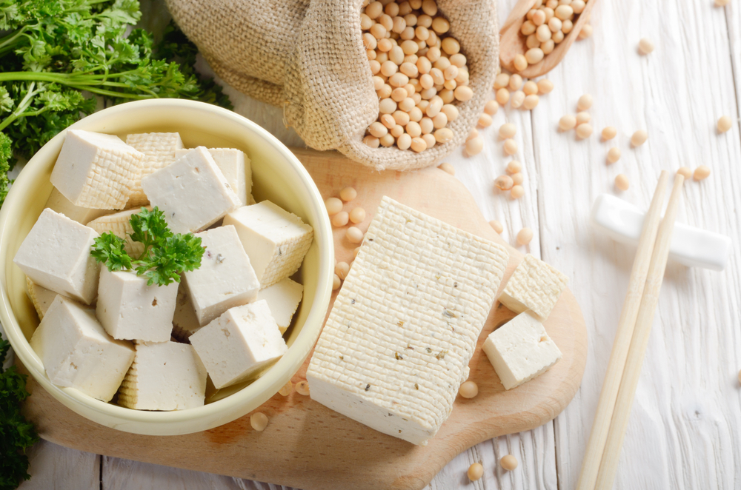
Fig. 1 All about Tofu. Cook for Your Life, https://www.cookforyourlife.org/blog/all-about-tofu/. Accessed 19 Nov. 2023.
Notably, these early plant-based alternatives were not trying to imitate the feeling, taste or sensation of meat products during this time. They were derived from high-protein materials and added to meals as their own component. This is an important distinction to make, as although early plant-based proteins such as tofu and tempeh qualify as meat alternatives, they are not fake meats.
Plant-based foods at this time were recognised for their own merits such as nutritional value, low cost and ease of access and were not intentionally created to replicate the experience of eating meat. In modern day, while tofu and tempeh are still eaten by consumers, many plant-based alternatives are created with the intention to replicate the experience of eating meat.
Fake meats are a sub-category of meat-alternative, which are designed to substitute for animal-based proteins. These products are often designed with the intention of mimicking the flavour, texture, taste and even behaviour of animal-based meat products. As more consumers turn to plant-based products in search of sustainable protein sources, these fake meats have become increasingly popular. Their similarity to animal-meat based products offer meat-eating consumers a familiar experience, while also aligning with their ethical motivations. This development would start in the 20th century, where we can observe one of the first examples of fake meat: Protose. (see Fig. 2)
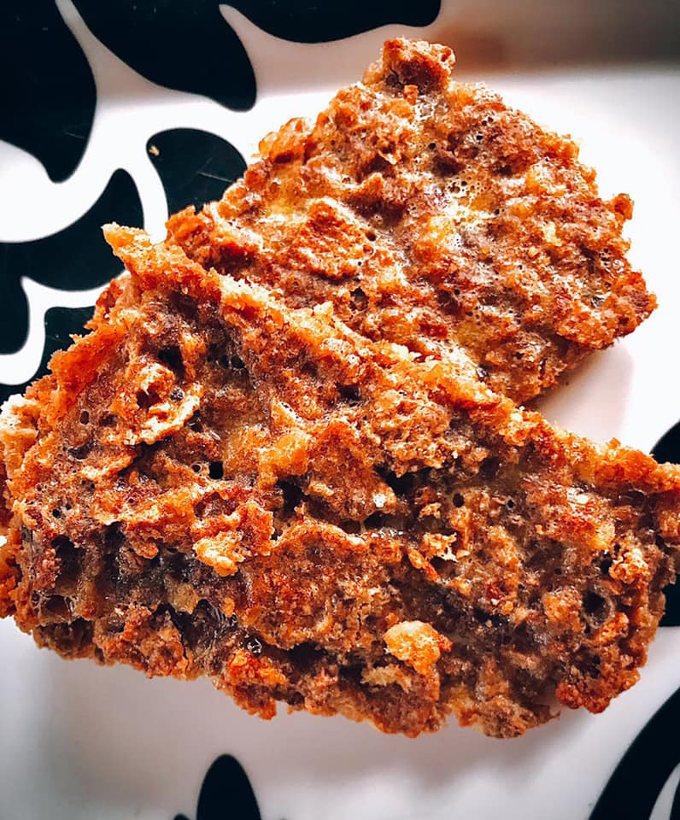
Fig. 2 Protose Cutlets. Perspectives on History, https://www.historians.org/research-and-publications/perspectives-on-history/december-2020/protose-cutlets. Accessed 19 Nov. 2023.
Protose is a plant-based protein consisting of peanut butter, mashed beans, cornstarch, onion, sage, salt and water. The meat alternative was developed by John Harvey Kellogg and was the first plant-based alternative ever to be mass-marketed. Kellogg was the director of the popular health resort Battle Creek Medical Surgical Sanatorium in Michigan, which experimented with several unusual treatments for its guests. Kellogg’s religious beliefs held that by abstaining from pleasure, people would be less likely to indulge in what they deemed immoral activities. These beliefs were held in conjunction with his hypothesis that eating meat resulted in less physical strength and that meat harboured harmful bacteria. These ideals extended to and were exemplified in the design of their food products, as although they were advertised as imitations to consumers, the ingredients used, and flavour palettes shared few similarities to meat products.
Advertisements at the time hinged on comparisons to animal-based products. Here, we can see the first use of terms such as “steak” that are generally used to describe meat products to be applied to products which are derived from plants (See Fig.4). The product was marketed as looking, smelling and tasting like meat (although these statements were contested). This was a novel concept to consumers, a turning point in the development for plant-based meat products, and one that we can still see in the market today.
While Protose may be one of the earliest examples of fake meats, there are key differences. In modern day, the taste and texture of the product is a vital factor in consumer perception and thus is highly prioritised by brands; however, Protose intentionally deprives the consumer of these pleasurable sensations while simultaneously claiming to possess them. While this is an unethical approach, it is evident that Kellogg’s understood the influence that imitation and comparison can have on a consumer, one that remains present today.
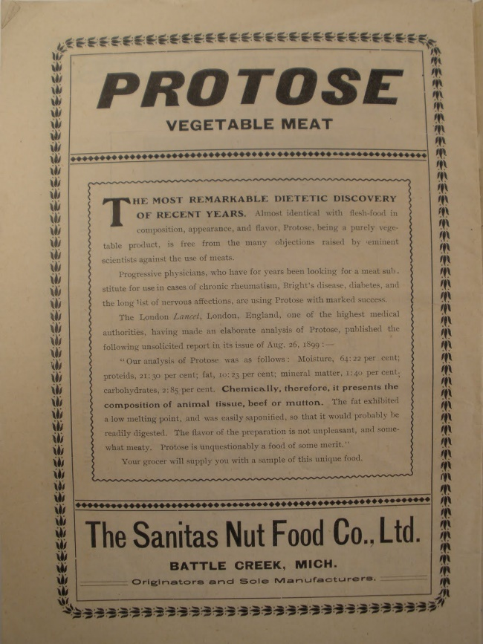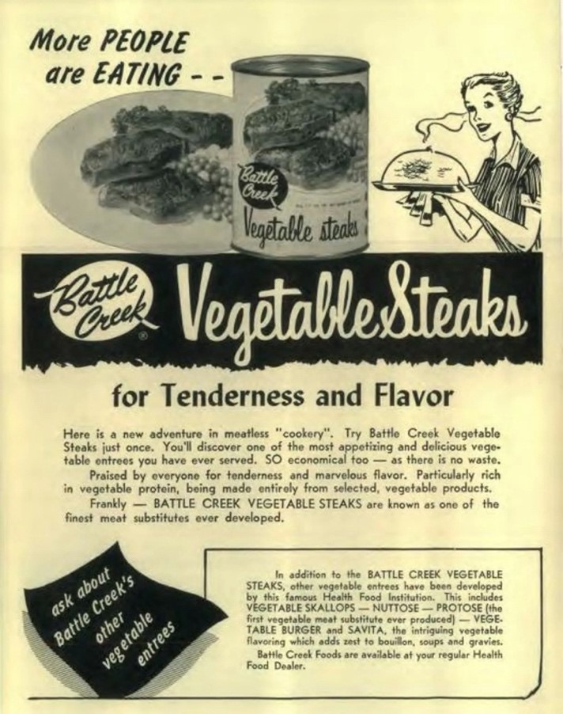
Fig,3 Protose Vegetable Meat. Vegetarian History, https://vegetarianhistory.blogspot.com/2010/06/welcome.html?fbclid=IwAR0_1e0lnjKdenJQ86fdwoOTl8zBm8CkJlfZhok0yjF_2iC1dggLkamDo58. Accessed 19 Dec. 2023.
Fig. 4 Fake meat is baked into Battle Creek’s history. Battle Creek Enquirer, https://eu.battlecreekenquirer.com/story/life/2019/10/04/fake-meat-battle-creek-kellogg-vegetarianism-seventh-day-adventist-protose/2301425001/. Accessed 10 Oct. 2023.

Fig.3 presents an advertisement for Protose circulated to consumers in 1908. The composition is entirely text-based and places large emphasis on the practicality of the product. It draws comparison to meat products, a novel practice at the time, even going as far as to state the supposed chemical composition of their product as being similar to that of a meat counterpart. This is an example of behavioural design principles at play, the product is portrayed as a perfectly usable and appropriate substitute for a meat product. However, at this point the remaining levels of emotional design are not present. The advertisement lacks imagery and a clear narrative for the consumer and thus cannot satisfy the criteria for visceral or reflective design. Fig.4 displays a Battle Creek vegetable steak advertisement from 1959, the advertisement uses the terminology “meat-substitute” to entice consumers, continuing to draw comparison to animal-based products. This example also includes similar persuasive arguments which state the viability of the product; however, it is now accompanied by imagery.
Close inspection of the imagery reveals the advertisement uses the same imagery of vegetable steaks twice, on the packaging of the can and on the plate. This may be interpreted as the advertisement being particularly cautious about how the food is presented to consumers.
In the book Influence: The psychology of persuasion Robert Cialdini identifies six factors which influence a user’s decision-making process. These principles are reciprocity, social proof, liking, scarcity, authority and commitment and consistency. Cialdini establishes that these principles can be used to nudge users to take specific actions. For example, if a user were to receive an item first, they feel indebted and are more likely to “return the favour”. If a user associates a product with someone that they like, they are more likely to purchase it, and if a user believes that there is a limited availability of a product, they are more likely to engage with it to avoid “missing out”. These principles are commonly implemented when trying to persuade consumers to choose their product over a competitor, and Battle Creek was no different.
The psychological principle of social proof is that consumers are more likely to choose something if they believe others to also be choosing it. This is due to an innate desire for human beings to feel they have behaved correctly and to be accepted as part of a group. This principle has also been shown to be more effective on individuals who are unsure of themselves.
In these advertisements, this is seen using phrases such as “Praised by everyone for tenderness and marvelous flavour” and “MORE people are EATING”. Who are the people? Who is the product being praised by? There is no evidence to support these claims, however they are a pivotal component in this piece of marketing. In this way, Protose is like modern-day plant-based food products, which place a large emphasis on perceived taste and appearance. There are key differences, however, as these advertisements are primarily text-based and aim to persuade the consumer through discursive language and argument as opposed to visual communication or emotional influence.

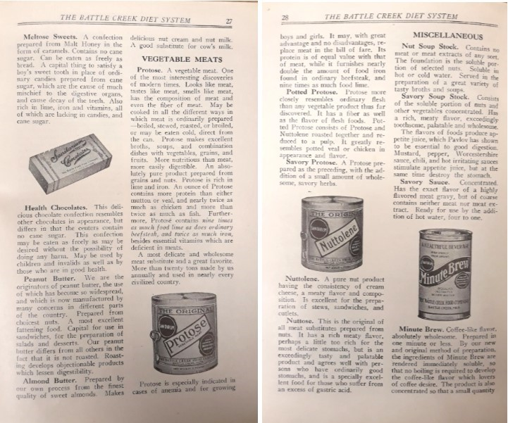
Fig.5 “The Battle Creek Diet System”: A Pamphlet and Birth of the Fake Meat Industry. https://blogs.loc.gov/inside_adams/2020/02/battle-creek-diet-fake-meat/#:~:text=Protose%20held%20the%20lofty%20claim,flavor%20and%20composition.%E2%80%9D%20The%20rest. Accessed 10 Oct. 2023.
Fig.5 shows a pamphlet advertising several of Battle Creek’s products. This pamphlet is also largely text-based and does not include any images of the physical food products. However, it does opt to display four different products in their containers. The imagery used is intriguing, as the composition focuses on the canned product, rather than the food itself. This is in stark contrast to food advertising today, which often places strong emphasis on the visceral elements of the product. The inclusion of the packaged product in tandem with the exclusion of the physical food product suggests the food product may have been visually unappealing to consumers during this period and thus worth excluding from advertisements. Notably, the text describing each product is heavily embellished. The pamphlet reads “Looks like meat, tastes like meat, smells like meat, has the composition of meat and even the fiber of meat” and “It may with great advantage and no disadvantages, replace meat in the bill of fare” in reference to Protose.

Protose received criticisms from consumers due to the lower sensory appeal of the product. It consisted of peanuts and wheat gluten and did not successfully imitate the meaty flavours which were promised to consumers. In this instance, the plant-based ingredients did not have the ability to replicate the savoury and umami flavours associated with meat products. The production of these products coincided with the Great Depression, which led to a decline in the number of Battle Creek sanatorium’s patients. However, Protose would remain in production for some time, until production ceased in 2000. While Protose may have faced difficulties due to the limitations of food technology during this period, it remains an intriguing case study for fake meats today. Although the physical food product was lacking in many areas, the product was still successful amongst smaller groups who were seemingly impacted by their ethic-driven and persuasive messaging.
The effects of Kellogg’s design were felt throughout the plant-based meat industry for years to come with brands such as Quorn and Tofurkey which continued to mimic meat products for consumers. These brands were held in much higher regard by consumers and offered a palatable alternative to those who did not want to eat animal-based products. The point of difference of these products was our growing capabilities in food making technologies. This allowed for the food technology industry to introduce new forms of plant-based meats, notably myco-protein and soy-proteins. These proteins were notable steps in the progression towards developing plant-based substitutes that replicate meat, however, it wasn’t until the 2010s that the alternative market saw a significant increase in popularity. To understand this, we must also look at social trends around this time.

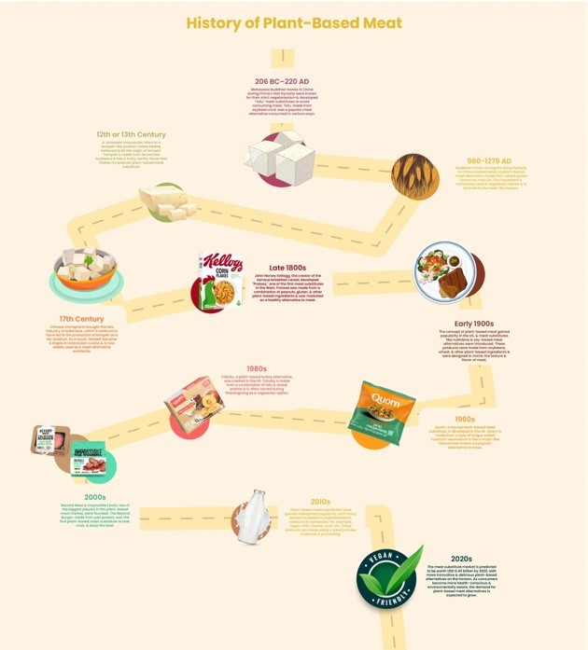
Fig. 6 History of Plant-based meat. Sudo Foods, https://sudofoods.com/blogs/articles/history-of-plant-based-meat#:~:text=2010s%20%2D%20Plant%2Dbased%20meat%20substitutes,available%20in%20supermarkets%20%26%20restaurants%20worldwide. Accessed 3 Oct. 2023.
Veganism and vegetarianism as consumer movements were gaining traction during this period, especially among younger demographics. While these movements are not new, the popularity of these alternative diets have spiked in recent years. This increase in what was previously a relatively small market share and overall increased interest in alternatives to meat, due to land and water consumption, has been responded to by business, and the supply of vegan and vegetarian products has risen, with many popular brands now offering meat alternatives to capitalize on this opportunity. The increased market options led to saturation and to brands competing for consumers. This competition has encouraged innovation and refinement of soy-based meats, with brands eager to make the fake meat which tastes the most real. In Fig. 7 and 8, we can observe Denny & Sons, a popular Irish meat brand, adopting this new technology.
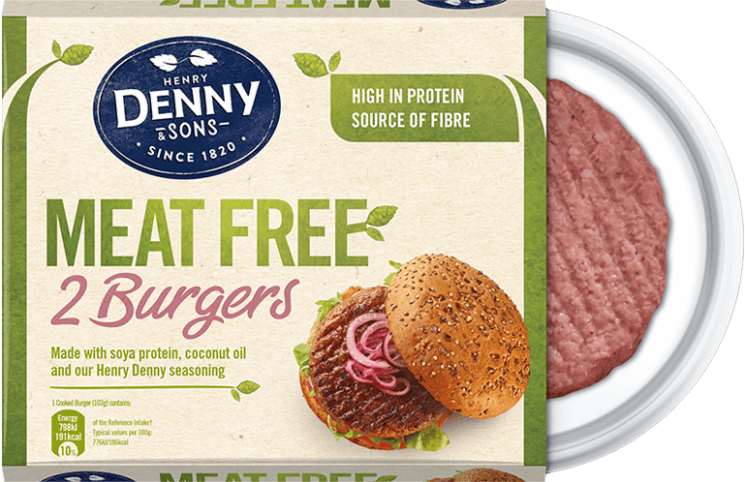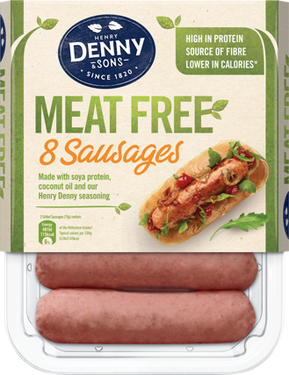
Fig.7,8 Denny Meat Free Range. Denny Meat Free, https://denny.ie/food/denny-meat-free-sausages/. Accessed 17 Oct. 2023.

To meat-eating consumers, these early plant-based brands did not achieve their goal, and thus faced considerable criticism for their lack of sensory appeal and unappealing texture. However, this changed with the release of the Beyond and Impossible products. These brands shifted the paradigm of plant-based meat, from a product which was aimed solely at non-meat eaters, to a product which was aimed at everyone, while specifically tailoring to the preferences of meat-eaters. These products used a method known as precision fermentation to create their products. By isolating specific plant-based proteins structurally similar to proteins found in animals, they can replicate the umami taste that is derived from meat products. This is the latest development which has taken hold of the plant-based meat industry; however, it has faced criticisms from consumers due to nutritional concerns.

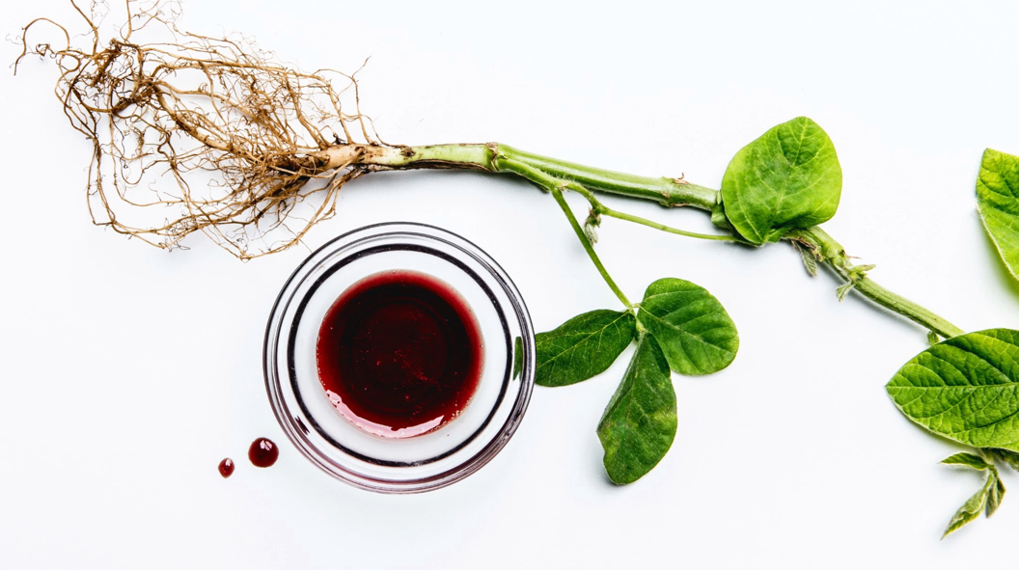
Fig. 9 Impossible’s Heme Ingredient. HEME, HEALTH, AND THE PLANT-BASED DIET, https://impossiblefoods.com/blog/heme-health-the-essentials. Accessed 17 Oct. 2023.

These modern plant-based products fall into a category known as ultra-processed foods. Ultra-processed foods are defined as containing five or more ingredients, preservatives, sweeteners, artificial flavours or colouring. These foods are traditionally higher in saturated fats, salt and sugar and thus require more consideration when constructing a balanced diet. While these products have successfully widened the market to consumers who do typically eat meat, the implications of changing our collective diets towards these foods must also be considered. Are the benefits gained by this environmental consciousness coming at the cost of consumer nutrition? These are questions which we must ask ourselves as consumers and importantly, modern meat alternative food brands.

The prominence of these brands persists today, as plant-based technology takes a shift towards precision fermentation to produce plant-based foods. As consumers search for more sustainable protein sources, the validity of plant-based products has come to be judged based on their replication of animal-based meats, rather than as a standalone food.
The earliest example of this narrative being marketed to consumers is Protose, but it has remained consistent to consumers since. Over the last century, new ways of thinking have emerged, changing not only the way that food is eaten, but what that food is. It begs the question, in a world where we can design and create our own food, what do we design?
To understand plant-based meat products that attract consumers today, I have identified Impossible Foods, one of the leading brands in the plant based-market, as a case study into the current climate of plant-based meat alternative products. This examination offers a lens through which I can investigate the wider design of plant-based meat products and consumer behaviour, and is the focus of the next chapter.

Chapter 2: The Design of Fake Meat: Impossible Burger Case Study

Impossible Foods Inc. is a company founded in 2011 which manufactures plant-based meat alternatives. The company is best known for their signature product, the Impossible Burger, which launched in 2016. Impossible is one of the fastest-growing companies in the market, with a $7 billion valuation in November 2021. They are one of the leading companies in food innovation and put a strong emphasis on the importance of sustainable food practices. Due to the popularity of Impossible Foods, it is likely to be one of the first PBMA brands which consumers will commonly interact with around the world.
According to Rebeckah Moses, Head of Impact at Impossible Foods, the company’s mission is to decrease the general population’s reliance on animal-based meat products through influencing our current value systems. In practice, this translates to making plant-based foods an attractive alternative to consumers who currently don’t engage in sustainable dietary habits. However, behaviour change in relation to food can be a difficult task, due to a variety of motivational barriers. Studies show that consumers generally regard plant-based alternatives as having lower sensory attributes in comparison to meat products.
Impossible is among many popular PBMA brands to present their meat products as appearing and behaving in a similar way to animal-based products. Notably, this is in direct contrast to PBMA products which were popularized in many regions such as seitan and tofu. The Impossible Burger owes this mimicry to the ingredient heme. Heme is the protein soy leghemoglobin derived from soy roots and provides the umami taste frequently found in meat products. The heme protein is also responsible for the product's similar behaviour to animal-based products. The Impossible Burger has been recognized as a plant-based meat alternative that “bleeds”, similar to its animal-based counterpart. This effort to make their products not only look and taste, but also behave like animal-based meat products has shown to be more appealing to consumers who usually don’t consume plant-based products.
Impossible Foods engineers their food through precision fermentation. As mentioned in Chapter 1, precision fermentation is the process of isolating specific (usually plant-based) proteins to replicate an umami taste, which would traditionally be experienced when eating animal-based products. This method is becoming popular in the PBMA industry, as more companies seek to appeal to a wider consumer base. However, as these new meat alternatives strive to further emulate the experience of a meat-eater, how does this affect their vegan and vegetarian consumers? These new developments in PBMA products aimed towards meat-eating consumers may alienate vegan and vegetarian consumers who are not looking for food which replicates meat. It leads us to ask new questions, such as, are we moving toward a future in which plant-based meat products and vegetarian products occupy different markets? If precision fermentation is using protein originally derived from animals, can we call it vegan? These food innovation solutions from PBMA companies may require us to reconsider the definitions of veganism and vegetarianism within our lifetime, as plant-based may not be synonymous with vegan.

Impossible Foods have identified their target audience as people who consume meat products. However, to fully understand the context in which Impossible Foods operates, we must also understand how the consumer views their product. Plant-based meat alternatives have been around for centuries and while society has become increasingly aware of the undesirable environmental effects of meat consumption, plant-based meats are not widely accepted as an alternative. Vegans, vegetarians and pescatarians make up a small portion of consumers and while meat-eating consumers are becoming more conscious of the environmental impact of their dietary choices, this has not been reflected in changes to their eating habits. This understanding of the market appears to be reflected in Impossible Foods’ visual branding. Impossible Foods’ original branding, from Bob Dinetz Design, displays messages which appeal to the consumers’ ethics. (see Fig.10, 11) We see phrases such as “Less Water. Less Land. Same Meaty Flavor” and “Big Flavor. Tiny Footprint.” as key pieces to draw in the attention of viewers. Notable also is the choice of colour palette exhibited, these messages are depicted in forest green tones, alluding to the nature and environment that the consumer is impacting when choosing their product. This is a popular branding tactic among environmentally focused brands. (see Fig. 12)
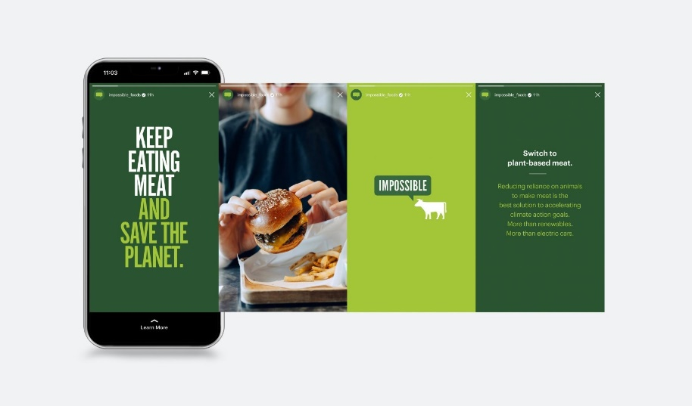
Fig. 10 Dinetz, Bob. BobDinetzDesign, http://www.bobdinetzdesign.com/impossible-foods-1. Accessed 12 Sept. 2023.
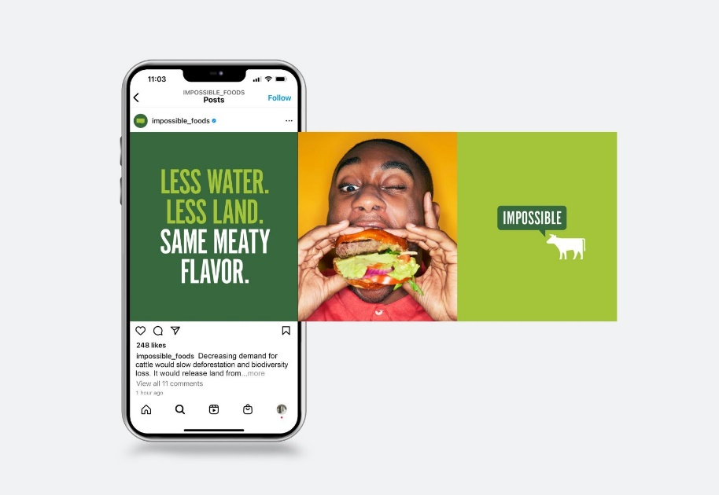
Fig. 11 Dinetz, Bob. BobDinetzDesign, http://www.bobdinetzdesign.com/impossible-foods-1. Accessed 12 Sept. 2023.
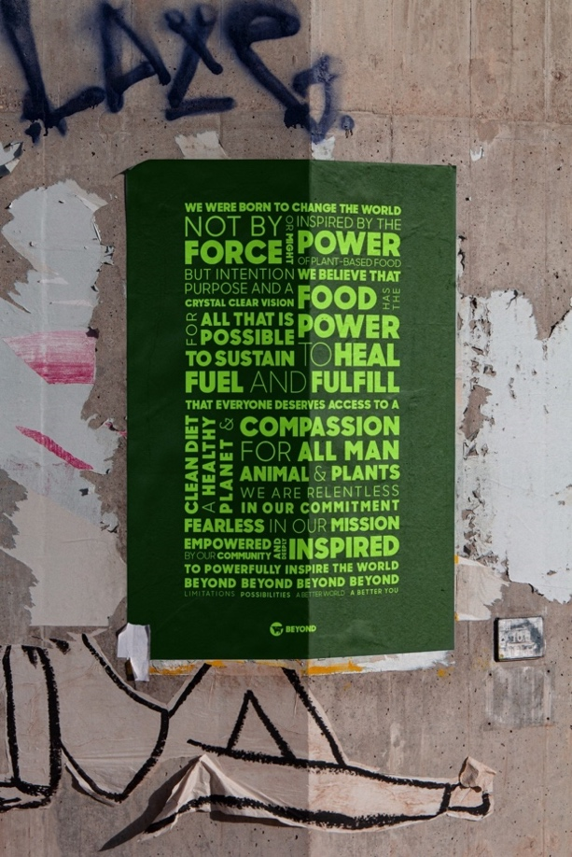
Fig 12. Studio, Fisk. Beyond Meat Brand Refresh. Fisk Studio, https://fisk.studio/project/beyond-meat. Accessed 12 Sept. 2023.
Impossible Foods’ current branding is designed by West Ventures (see Fig 13, 14). West Venture’s goal was to propel Impossible’s products to a larger audience. They cite working with chefs into their process while acknowledging that they are specifically targeting people within the age ranges of 25-40 who are passionate about food. This aligns with demographic research which suggests that people within this age range are also more likely to eat new foods. While Impossible’s initial visual communication strategy focused on appealing to the consumers ethical obligation to accept a more sustainable alternative, West’s solution was to focus on making the food look appealing, with a focus on meat-eaters. They note ‘“we shifted the focus from the vegetarian meat industry, with sales just north of $550 million, toward the $88 billion beef industry.”
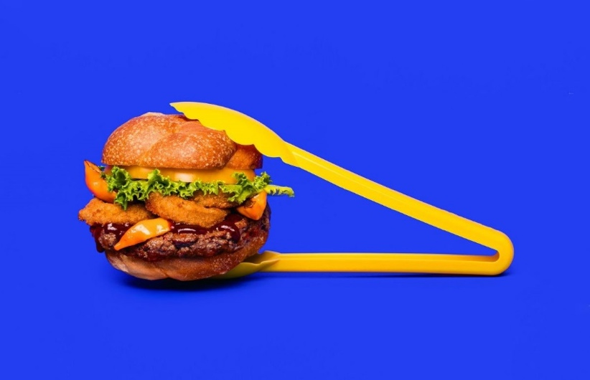
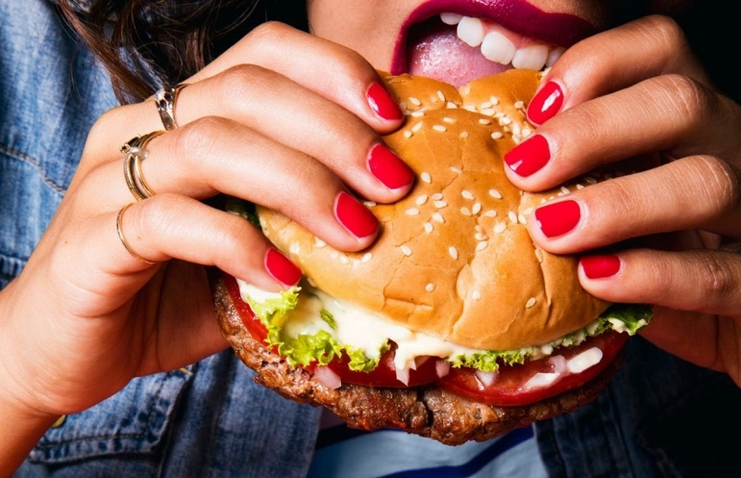
Fig 13, 14 Impossible Foods Branding - West Venture Studio. West Venture Studio, https://west.ventures/work/impossible-foods-branding. Accessed 12 Sept. 2023.
To re-examine the visual branding designed by Bob Dinetz through the lens of Norman’s emotional design principles, I hypothesise that their initial design delivers on the merits of both behavioural and reflective design principles. “Without Compromise” is the slogan which Impossible Foods championed during this period (see Fig.15), this is to state that their consumers are capable of both enjoying their favourite foods and meals, without compromising on their moral values.
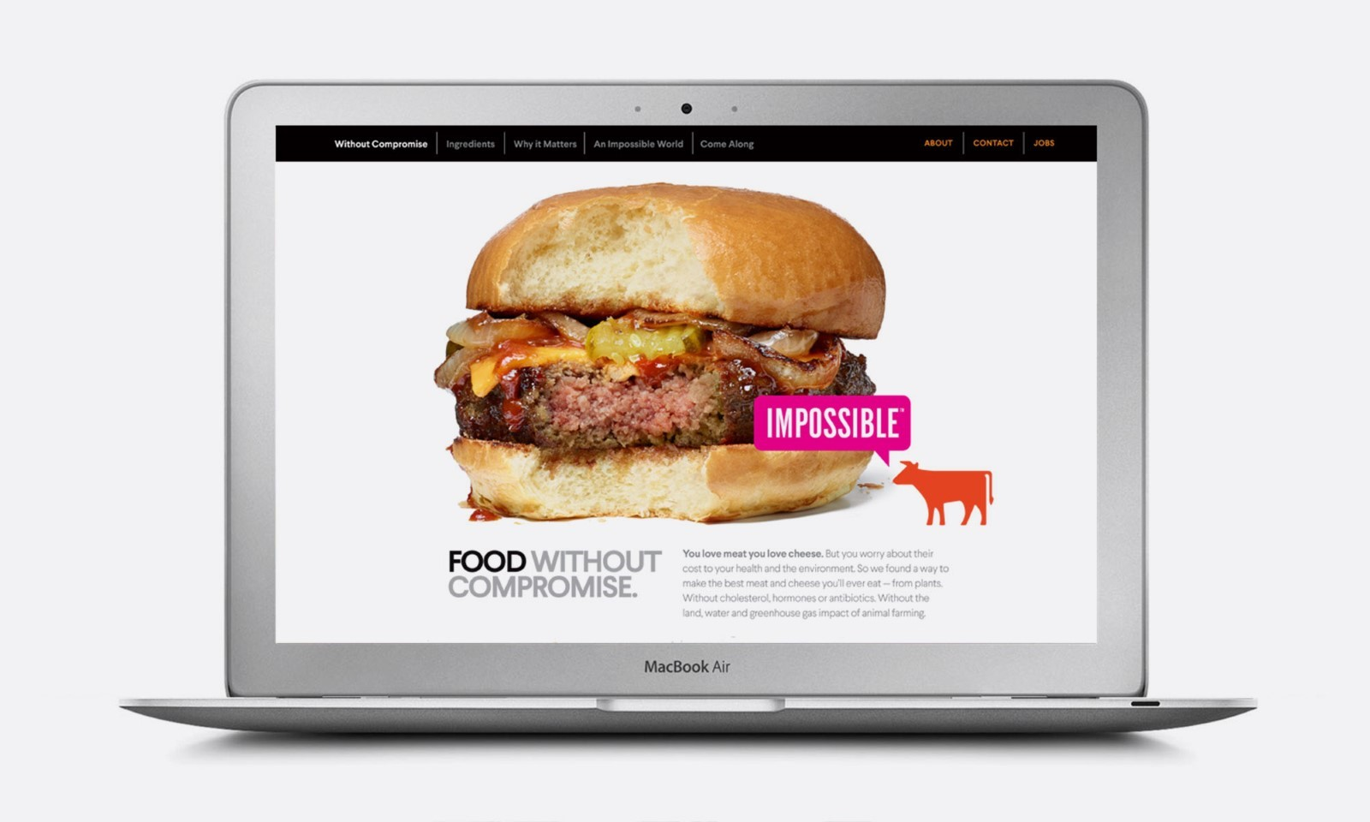
Fig. 15 Dinetz, Bob. BobDinetzDesign, http://www.bobdinetzdesign.com/impossible-foods-1. Accessed 12 Sept. 2023.

In this aspect, Impossible Foods offer their consumers a functional, practical replacement for their current protein sources. This is an example of behavioural design. However, what is the appeal of this new substitute? It may, in theory, meet their needs, but why should a consumer change their diet? In Dinetz’s work, the appeal to people’s ethics is through education, informing the consumer why their product is more ethically sound than competitors (see Fig.10). This is an effort to influence consumer behaviour through challenging their beliefs, and furthermore if those beliefs align with their current actions and habits. This questions whether a consumers' current dietary choices are reflective of how they view themselves within a wider context and further, how others may view them. Consequently, this design successfully fulfils the criteria for reflective design.
Through this analysis, I have determined that there is a strong emphasis on motivating the consumer to try Impossible Foods using behavioural and reflective design. However, it is noteworthy that the third level of emotional design, visceral design, is not prioritized at this point.
A shortcoming of Dinetz’s approach is that it no longer addresses the needs of the target audience. Recent studies have indicated that the motivational barriers preventing meat-eating consumers from switching to plant-based alternatives is, in fact, not ignorance of the environmental impact that their choices have, but instead rooted in the perceived lower sensory attractiveness of plant-based foods and neophobia. Meat-eating consumers also view plant-based alternatives as more ethically sound than their counterparts. This is a clear deviation from the expected audience that these ethically driven messages were designed for.
West Venture was Impossible Foods’ next step in their branding strategy and visual marketing. West worked on brand strategy, digital design, brand messaging, brand platform, brand identity and creative production for Impossible. An analysis of West’s design for Impossible Foods products, reveals key differences to Dinetz’s. Notably, there is now a lack of persuasive messages appealing to the ethics of the consumer (see Fig 16, 17). Instead, the focus is on the physical product. The compositions now consist of vibrantly coloured backgrounds with stills of the plant-based meat substitutes, feature no ethical messaging, and have shifted the focus on to food photography. In the visuals West Ventures’ presents on their website of their work with Impossible, there is nothing to indicate that these products are plant-based (see Fig 16, 17). West Ventures has instead focused on the visceral design level of emotional design, and appealed to the consumers’ sense of familiarity with animal-based products to create a product with a higher sense of perceived sensory attractiveness and a reduced level of food neophobia. This is an approach which aligns with recent studies of the market and is predicted to become a trend across many plant-based meat alternative products.
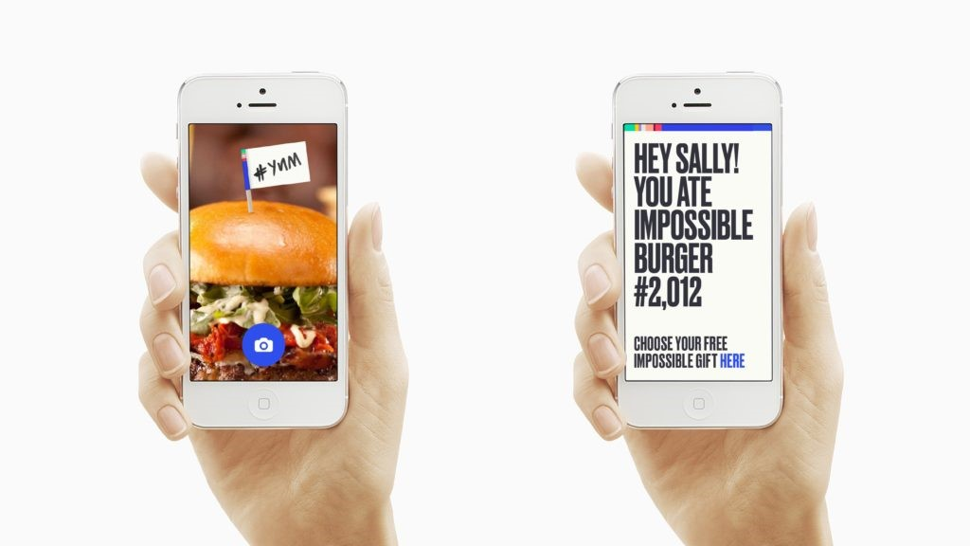
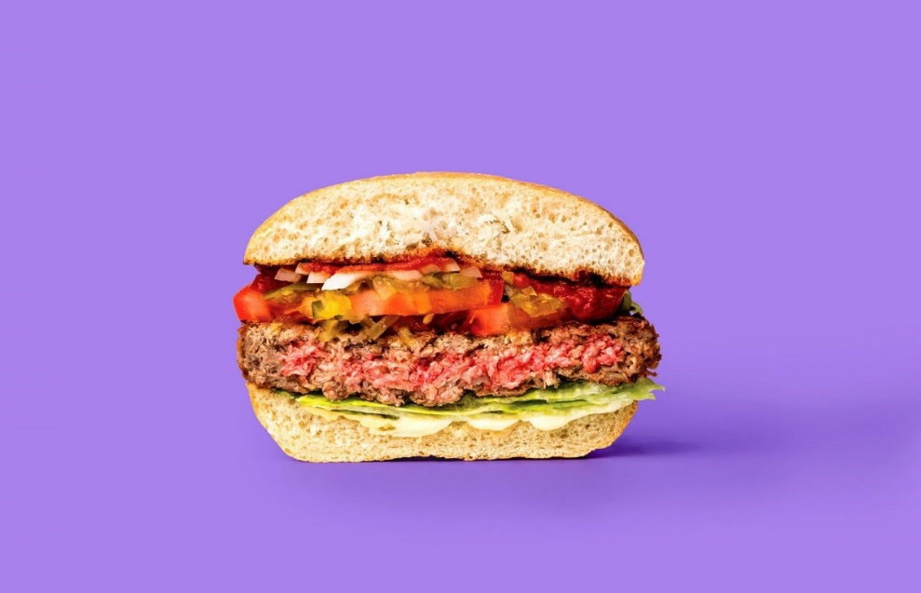
Fig.16, 17 Impossible Foods Branding - West Venture Studio. West Venture Studio, https://west.ventures/work/impossible-foods-branding. Accessed 12 Sept. 2023.
This change in marketing strategy is also reflected in Impossible Foods’ food packaging. Impossible Foods was awarded third place in The Dieline Awards in 2021. In the blog, the packaging design is quoted as “Impossible Burger patties come in a package that puts the patties front and center, and showcases how indistinguishable our product is from a regular beef burger.” Notably, they also mention that the Impossible Burger may be found in the meat aisle in grocery stores, further acknowledging their target audience and the increased focus of visceral design.
The packaging consists of a vacuum skin wrap that puts the product itself on display as the first element a consumer will notice. This is in line with how similar animal-based meat products are presented to consumers and is a bold statement by the brand. This decision creates a direct comparison to animal-based meat brands, which displays a level of confidence in the plant-based burger; seemingly inviting comparison. The hierarchy of information presented is firstly the brand name, Impossible, secondly the product type, burger patties, and lastly, how the product is made, from plants. (see Fig. 18) This is reflective of Impossible prioritising creating and growing brand recognition amongst their consumers. While the company is at the forefront of plant-based meat products, it is important to the brand that their consumers know they are eating an Impossible burger, not just a plant-based burger.

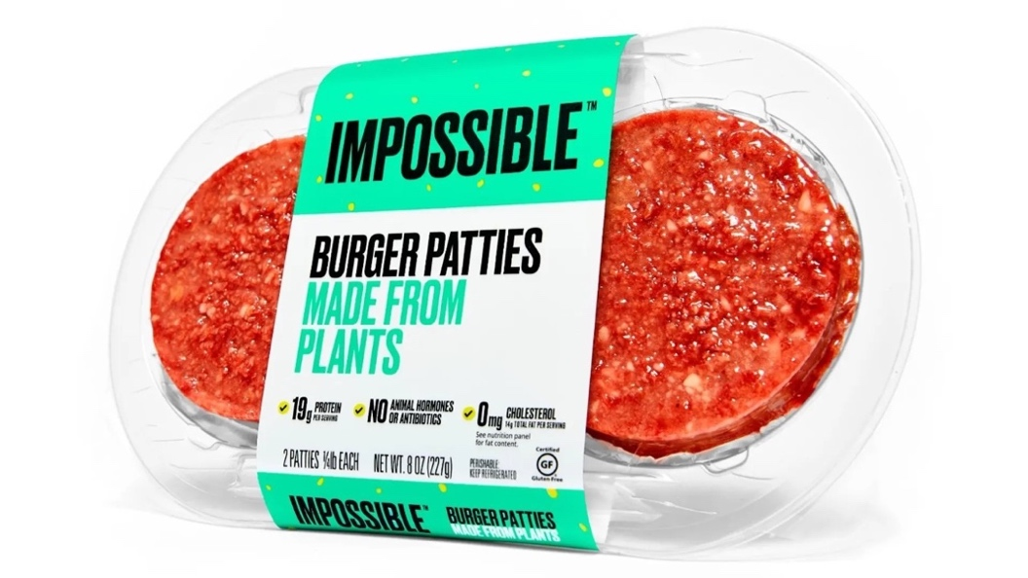
Fig. 18 “Impossible Foods Puts Their Meat-Free Patties Font on Center.” The Dieline, https://thedieline.com/blog/2021/1/14/-impossible-foods. Accessed 12 Sept. 2023.
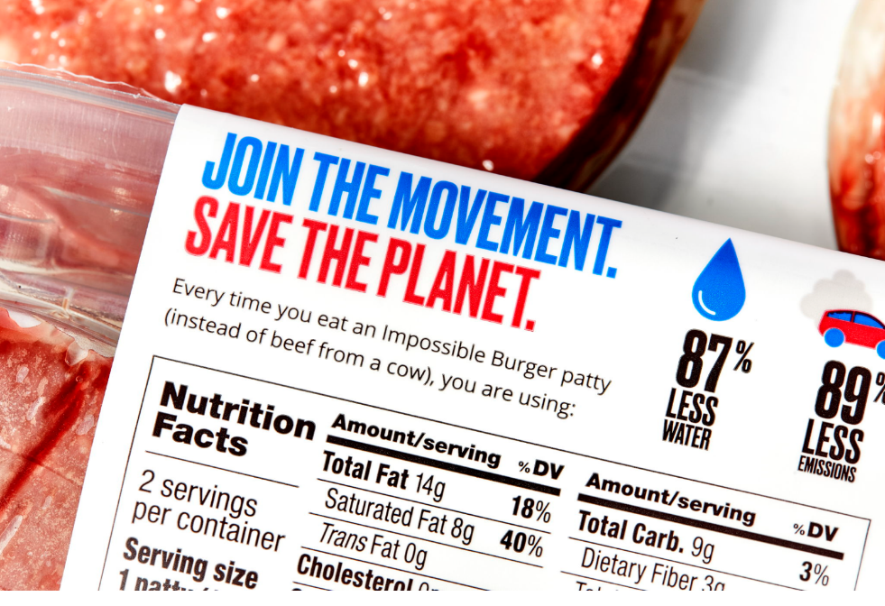
Fig. 19 “Impossible Foods Puts Their Meat-Free Patties Font on Center.” The Dieline, https://thedieline.com/blog/2021/1/14/-impossible-foods. Accessed 12 Sept. 2023.

The packaging features the environmental benefits of choosing their plant-based alternatives on the back of the product, rather than the front (see Fig.19). This is a deviation from Impossible’s earlier approach, instead of appealing to all consumers’ ethics, now only the consumers who initially picked up their burger and want to know more will read the information listing the sustainability benefits. This is in direct contrast to some other plant-based companies who place higher importance on their messaging and less on the physical product (see Fig. 20). However, it is possible that these companies have varying target audiences.

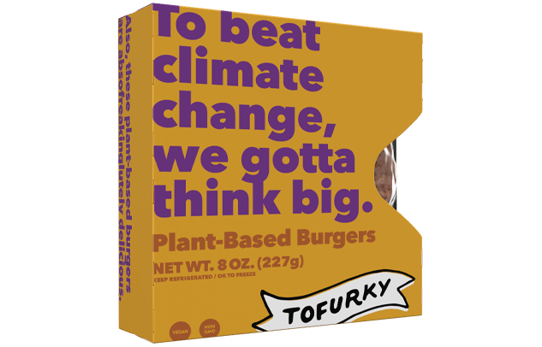
Fig. 20 “Burgers.” Tofurky, 14 Dec. 2022, tofurky.com/what-we-make/burger/plant-based-burger/. Accessed 12 Sept. 2023.

Impossible’s packaging is another example of this new approach emphasizing visual design principles. While the plant-based company places high importance on the sustainability of its food and the environmental benefits of switching to their product, this is not the message which they use to attract consumers.
While Impossible’s methods of delivery have proven to be effective in increasing engagement with meat-eating consumers , the concept of us, as consumers, being more effectively influenced by factors such as perceived taste, beauty and colour rather than our ethical values is a frightening one. Impossible Foods’ mission to reduce biodiversity loss, reduce greenhouse gas emissions and water usage is a righteous one; but what if it wasn’t? Despite the criticisms of Dinetz’s approach, his work is grounded in the assumption that if meat-eating consumers were aware of the impact their choices have on the environment, then they would change their behaviour. This is an empathetic outlook, as in practice, consumers are generally not guided by moral compasses, but instead by psychological barriers to change.

Impossible Foods’ implementation of novel food technologies has been one of the key drivers of the company’s success in recent years. However, as technology continues to evolve, how could our food develop and change? With the power to create and design our own meat from the ground up, how can we design it to be better? To answer these questions, the next chapter explores one of the latest developments in the world of alternative proteins: cultivated meat.

Chapter 3: The Future of Fake Meat

Cultivated meat, also known as cultured meat or lab-grown meat, is grown artificially through the use of animal cells. This sets cultivated meat apart from other substitutes such as plant-based meat, as it does not need to imitate the flavours and behaviours of animal-meat products. This is an appealing concept to many, as a production process without the slaughter of live animals may significantly reduce biodiversity loss and eutrophication to our environment, while also allowing meat-eating consumers to continue to enjoy their products without consumer guilt, behaviour change or compromise.
Cultivated meat currently takes up a marginal market share in the alternative protein market, however it is projected to grow, because of its lower land-use and greenhouse gas emissions. These factors, in tandem with emerging technology surrounding the cultivated meat market, make it an appealing baseline to further speculate on the future of fake meats.
However, the response to cultivated meat thus far has been mixed. While there is acknowledgement of the potential that this fake meat demonstrates, there are obstacles to these potential benefits. Many consumers recognise that alternatives to animal-based meat are beneficial on a societal level, however, they experience more difficulty in recognising these benefits on a personal level.

Cultivated meat made its first appearance in 2013, when scientist Mark Post unveiled the product at a media event in London (See Fig. 21). The burger was tasted by food author Josh Schonwald and researcher Hanni Rutzler and received positive feedback, with both participants stating that the burger tasted and felt like typical animal meat. In 2015, the first companies producing cultivated meat were founded and funding continued to be invested in this novel form of protein production.
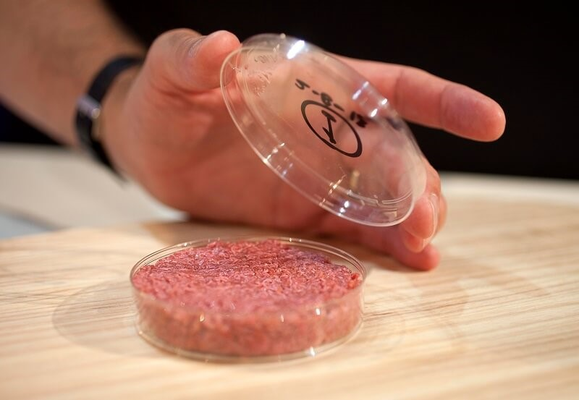
Fig. 21 Mark Post unveiling first cultivated burger. https://www.peta.org/living/food/whats-store-future-food-spoiler-vegan/. Accessed 7 Nov. 2023.
Cultivated meat was still far from everyday consumption, however. Post’s initial burger had cost $325,000 to produce and the resources that cultivated meat required made it difficult to effectively scale.
In 2022, the Journal of Agriculture and Food Research conducted a study which examined the cost efficiency of the large-scale production of cultivated meat. The results concluded that the current high-cost production methods pose a significant challenge for the alternative protein in replacing animal-meat production; however, this is expected to decrease in coming years as the industry grows and cultivation technologies become more efficient.
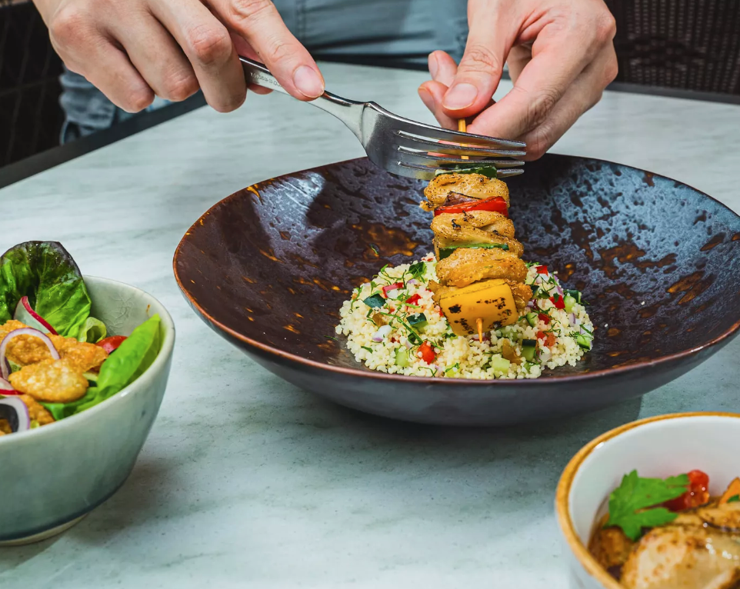Fig. 22 Good Meat Cultivated Chicken. https://www.goodmeat.co/butchery. Accessed 7 Nov. 2023.
As of 2020, Eat Just, also known as GOOD meat, became the first company to receive approval to sell their cultivated meat products to consumers. The products went on sale in restaurant 1880 in Singapore. This is an exciting landmark in the world of alternative proteins and brings forward questions about the future ahead, however it is critical to also understand the current problems which we are facing with alternative protein sources such as cultivated meat.
Cultivated meat has received criticism from many consumers. As cultivated meat is a novel food, consumer perception plays a vital role in how successful the product is received or understood. This is problematic for cultivated meat as it currently has strong associations with being fake, unnatural and even disgusting. These associations may stem from neophobia surrounding food, as we have already established that people can struggle with accepting new foods, however there may be more to this fear. In 2022, The Journal of Environmental Psychology published a study examining 1587 participants' level of disgust towards cultivated meat. The study estimated that 35% of meat-eaters and 55% of vegetarians find synthetic meat “unnatural”. If these results are representative, they pose a substantial problem, especially given that meat-eaters make up such a large percentage of the population. However, the study sought to measure what percentage of each group found the novel meat disgusting, rather than if they found it disgusting. While these findings are still valuable as research, the questions being asked are grounded in what they previously assume consumers to associate cultivated meat with and thus leave little room for new findings about consumer associations. The journal also suggests that this problem is encountered due to the product’s lack of meat-origins for meat-eaters, regardless of it behaving as such. In contrast, vegetarians were averse to the product due to its similarity to animal-based products. This is an interesting observation, however, as studies also indicate that most vegetarians do not consume meat for ethical reasons. This is an unexpected outcome, as many would presume that meat that doesn’t come from an animal would be ideal for vegetarian and vegan consumption.
To meat-eaters, the naming conventions currently implemented by cultivated meat companies may be a contributing factor to this belief. Studies have demonstrated that consumers are averse to terms such as “lab-grown” due to associations of the unnatural. This is an undesirable association as it may lead to the consumers considering the food to be highly processed, which is closely associated with being unhealthy, which is typically viewed as a negative characteristic. While the term cultivated meat has been received more positively, it may be possible that further iteration could lead to more positive associations in the future. For example, products such as cheese and milk are produced through fermentation processes and yet are not perceived to be unnatural by the public. The key to this issue may be through careful examination of consumers understanding of the product and iterating based on this research.
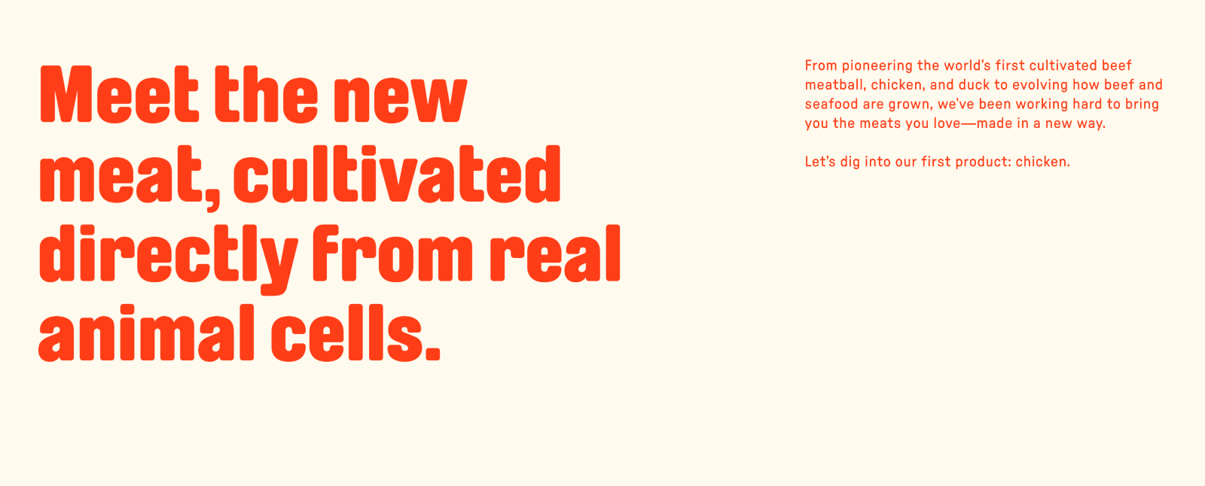
Fig. 23 Upside Foods. https://upsidefoods.com/food. Accessed 7 Nov. 2023.

While cultivated meat may be an innovative solution to some of the environmental issues that we currently face, these products still need to be enticing to consumers. This perception of “unnaturalness” may be due to how cultivated meat is currently portrayed to consumers. Terminology such as “synthetic” and “cell-based” are commonly used within the world of cultivated meat and carry strong connotations (see Fig.23). This can make it more difficult for consumers who are unfamiliar with the products. When we see animal-based meat products advertised to us through food photography, we often see a strong focus on appealing to our senses. The photography is used to make the food seem beautiful and flavourful. This is an important consideration to make, as when we are working with products which can't be experienced by the consumer prior to purchasing, it is imperative to find other ways to communicate this experience.
In modern food advertising, this is typically done through the implementation of visceral design principles. However, in the case of cultivated meat, it is common to see imagery focusing more on the food technology of the product. As this is currently an emerging technology, it is understandable why such an emphasis is currently being placed on the production of cultivated meat as opposed to the appearance of meat. However, based on research about plant-based alternative meats, I suggest that for synthetic meat to appear as a viable replacement for animal-based meat in consumers' diets, there must be consideration given to its visual treatment.
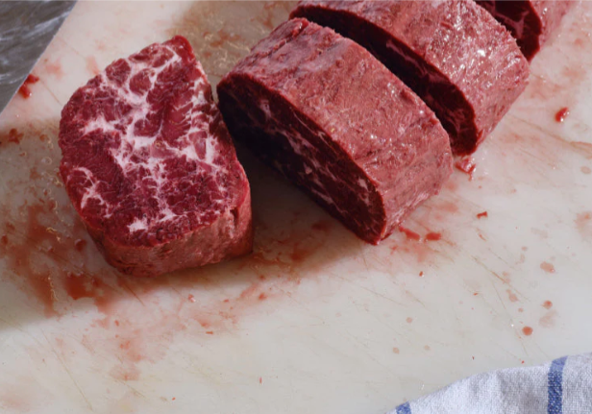
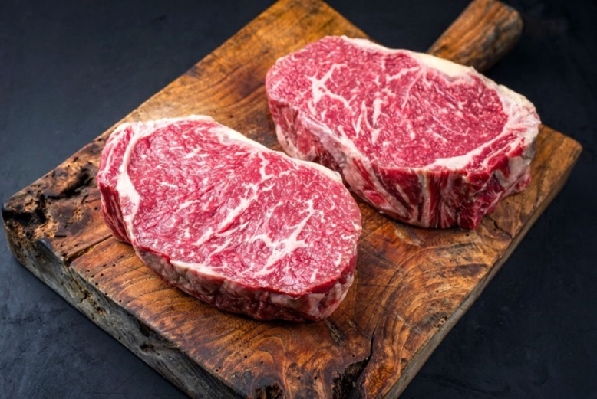
Fig. 24 Juicy Marbles. https://juicymarbles.com/. Accessed 7 Nov. 2023.
Fig.25 Butcher Striploin Steak. https://butcher.ie/shop/beef/2-x-12oz-wagyu-striploin-steak/. Accessed 7 Nov. 2023.
For example, Juicy Marbles is a plant-based meat alternative brand praised for its likeness to animal-based meats. The subject is photographed and displayed to consumers in a similar fashion to that of conventional meats (See Fig. 24, 25). This treatment is received positively by meat-eating consumers as they no longer criticize the source of the food due to its visual similarity to meat, despite the lack of an animal source from the plant-based product. Through design, we can make products more appealing to consumers. One way that this can be achieved is through visual communication. For example, in Lara Hanlon’s Entomo project, insects were an unfamiliar protein source that was unappetizing to consumers. However, by acknowledging the factors that triggered disgust in consumers and through precise visual treatment, these insects could appear delicious. (See Fig. 26, 27)
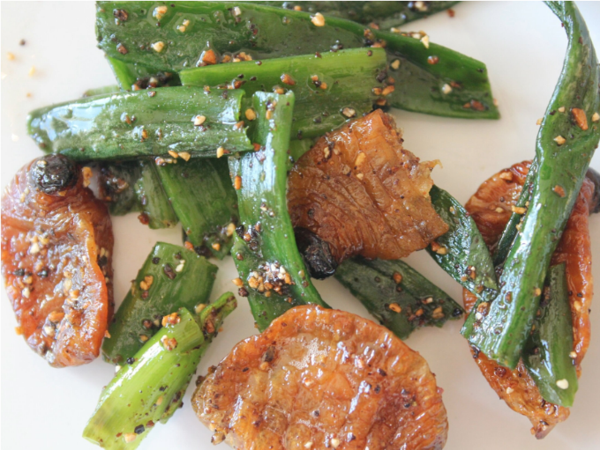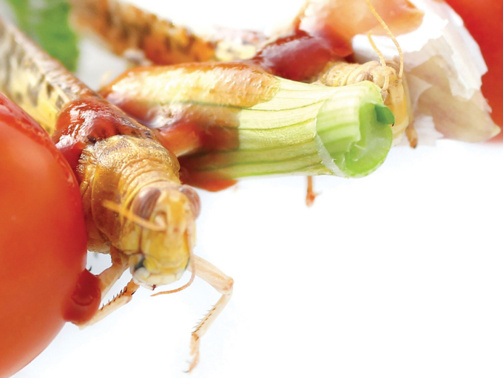
Fig.26, 27 Lara Hanlon Entomo Project. https://www.larahanlondesign.com/entomo. Accessed 7 Nov. 2023.

Faced with a similar problem, Hanlon identified that insects were a viable protein source for consumption. However, research has indicated that many western consumers are averse to eating insects, despite the nutritional benefits. Through analysing existing food product branding and advertising, the project created a sense of familiarity to consumers, reducing food neophobia. This was achieved through manipulating the food subject through food photography, creating a likeness to existing foods and by creating meals with insects as an ingredient, while not being the sole focus.
Notably, this is a similar approach to West Venture’s Impossible Foods rebrand. Existing plant-based meat products lacked perceived sensory value, which was addressed through subtle but intentional visual communication, giving us a basis in reality for this speculative project.
Could a similar treatment make cultivated meat more palatable to consumers? By addressing this issue through adapting the way we present these products to consumers, the problem of consumer perception can be alleviated in the short term. However, the problem of visualisation may persist as food develops and changes over time. For example, if animal-based meats were to become less popular than meat-free alternatives in the future, the shape and feel that these products take may be different than that of conventional meats. Is this something that we will have to cater for? Will the design of our foods always be influenced and determined by our food neophobia?
In the project Neo Fruits, Meydan Levy speculates a future in which we can design our food in a new way. The project proposes a future in which we print our food using 3D printing. The food is printed flat and can then change form later through the addition of a nutrient-rich liquid. This project offers several new elements to food design. The first one of which is convenience. Due to the fruits being printed as flat, compressed objects, they are easier to transport and store for consumers. The consumers can decide when the fruit is ripe and enjoy it at their own leisure. The project also considers nutrition in its design, with the fruits being composed of a blend of nutrients which can be chosen pre-emptively by the user.
The objects are novel objects and as such, do not have predetermined flavours or textures nor are they perceived to. This is used to the products advantage, as the designer has used this opportunity to create new flavours from existing materials. This avoids comparison to existing foods and cements the product as new and different to the consumer. (See Fig.28, 29)

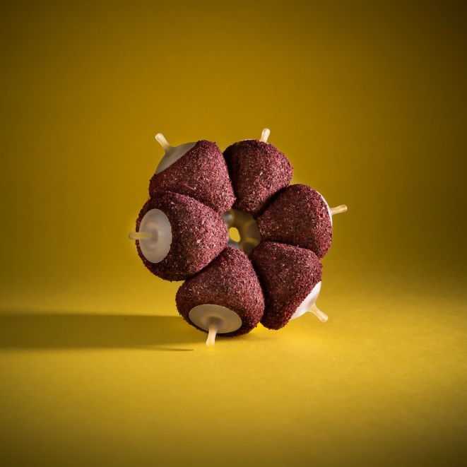
Fig 28 ,29 Neo Fruits. https://designawards.core77.com/speculative-design/84449/Neo-Fruit. Accessed 7 Nov. 2023.
Importantly, Neo Fruits considers experience. The experience of eating food is a factor considered when choosing a food, both consciously and unconsciously: how “crunchy” or “juicy” a food is, how much of a mess it will make, how quickly we can cook the food. We consider these factors as consumers, and this leads to design opportunities as new technological processes emerge. By foregoing the expectations which consumers have of a fruit product, the designer has shaped this food in a way that benefits the consumer in multiple ways. The fruit is packed full of beneficial nutrients, is easily transported and is highly malleable in flavour; however, it also places importance on the physical sensation of eating. By mimicking objects such as “bones”, “pods” and “leaves”, the designer has opened the possibilities to speculate and research what a good eating experience is for a consumer and how we can provide not only a nutritional one, but a fulfilling one. (See Fig. 30)
Fig. 30 Neo Fruits. https://designawards.core77.com/speculative-design/84449/Neo-Fruit. Accessed 7 Nov. 2023.

With cultivated meat on the horizon, there is a future in which hypothetical 3D printed foods are available in local supermarkets. However, I believe there is a significant opportunity for future fake meats to consider factors outside barriers to consumer consumption when designing their products. When designing for a user, it is just as important to understand and address their goals as well as their frustrations. It has been established in this case that consumers struggle with eating foods that they are unfamiliar with, however I believe that it is also possible to use this opportunity to act towards the consumers shared goals.
Could the concept of synthetic foods be taken further and provide all the nutrients that consumers need in a single food product? Instead of emulating the taste of an animal-based meat product, could new tastes and flavours be created that are more appealing to people? If consumers are no longer confined by the pre-determined shapes of food, what shape and form should this food take? Can the eating experience be enriched for the consumer? Could there be a world in which these new foods are accepted not just as imitations, but as an independent food?
Although the food industry currently faces significant challenges, it is also approaching a period which is rife with opportunities for innovative design. While searching for solutions to make food options sustainable, it is also imperative to consider solutions in which food futures can be made more enjoyable or fulfilling. These speculative design projects are opportunities for designers and researchers to analyse whether the futures in which these products exist may be a positive one and furthermore question how they may be brought to reality. However, the extent to which this opportunity is used is in the consumer’s hands. By defying and challenging the psychological barriers that we face and through challenging our innate assumptions about the food we eat, we are directly contributing to a future in which meat could mean more than just food.

Conclusion

Fake meat experienced a surge in popularity during a difficult period for many people globally. The environmental cost of food agricultural production demanded a solution from the food industry. While far from perfect, fake meat is a positive innovation in this area, allowing consumers to both have a dietary choice that aligns with their ethical beliefs, while also contributing to fewer greenhouse gas emissions. In this way, modern plant-based brands have contributed significantly to normalising environmentally conscious food choices, particularly among meat-eating consumers. However, it is crucial to build upon these successes, particularly as food making technologies continue to advance, in order to create better food and better experiences for people.
The impact alternative foods have on us as consumers is not limited to environmental impact. Throughout this dissertation I have examined each fake meat product through the lens of Norman’s emotional design principles. These principles are built on the fundamental understanding that people feel emotion in their day-to-day lives with every product that they interact with, both consciously and unconsciously. By acknowledging this and approaching the subject from the perspective of gaining an understanding of how these products interact with consumer emotions, I have observed a shortcoming in the design of these products.
These products are all designed from the perspective of the person making the product. There is a strong emphasis on the advertisement and treatment of the product due to how critical these elements are to consumer perception, which in turn lead to sales. However, if the primary focus of these products is to simply sell them, then we are depriving real people of experiences which are potentially far more fulfilling and meaningful. If the goal of a fake meat product is to make a consumer feel as though they are choosing a healthier product, rather than being a healthier product, then these fake meat products are fundamentally failing consumers. The primary focus must be on delivering a quality, holistic experience to the consumer. It is possible to take these lessons that we have already learned from early fake meat brands such as Protose and use them to make products which deliver meaningful experiences to people.
These speculative projects offer valuable insights to designers and industry. While their striking form and unusual subject matter appears initially appealing to viewers, there is more to learn here than the power of visual communication alone. What makes these speculative design projects stand out to me, as a designer, is the empathetic approach which each designer has taken to the project. In Lara Hanlon’s Entomo project, on a base level there is an acknowledgement and understanding of both the current food systems relationship with the environment and of many consumers’ food neophobia fears. The project challenges consumer’s feelings about this novel food source by applying familiar visual treatment and rational argument, however it is truly the approach which makes projects such as this valuable to future designers and industry. Hanlon considers the person who would be eating the food. To create this project which challenges the assumptions, feelings and fears of a person, the designer first has to understand those feelings themselves. This is the element lacking in fake meat products. It is not solely lack of nutritional value, nor solely ineffective visual communication; it is a lack of understanding of the emotions that the people eating the food may feel.
The Neo Fruits project exercises a similar understanding of the user. Through applying the design process to a food product, it is possible to understand, empathize and design solutions for food problems which seem either unsolvable, or have not yet been challenged. This project displays beautiful shapes and forms which consumers are likely to be unfamiliar with, however the product also provides an experience which consumers are largely unfamiliar with in the realm of food products, particularly fake meats. There is a strong emphasis placed on the experience of eating the product. Allowing the user to pack the food to be portable, and for the user to choose their own flavour profile, as well as their desired nutritional value, is a level of personalization yet to be seen in meat products but is a common feature sought after in many other products’ fields.
I believe that the most important element that these speculative projects have gained is not through their permission to use playful forms and present unconventional ideas, but through their ability to apply a rigorous, creative and empathetic approach without criticism. These designers have displayed a comprehensive and complex understanding of human emotion and the feelings that are interconnected with foods. Through the application of Norman’s emotional design principles, it is possible to create these meaningful experiences. However, achieving these results may require a shift in motivation from fake meat brands and industry. As fake meat looks to replace and substitute foods which have been part of people’s lives, it is important to acknowledge that these products were not only part of people’s diets. These products were family favourites, were a grandparent’s secret recipe, or perhaps even a guilty pleasure; these are the stories that these products have previously held for people. While well-intentioned, when looking to provide a substitute for these foods, it is important to provide products which allow these people to tell new stories.
In her book, “Lick It”, eating designer Marije Vogelzang notes “We cannot experience food without emotions”. Throughout my research and analysis of fake meats, these words have resonated with me. As we encounter problems, roadblocks and new hurdles in the future for our designs to overcome, it is imperative that we never lose sight of the implicit emotional qualities that food holds for us all. Food holds stories, emotions and memories of loved ones for people all over the world. We owe it to them to provide the most rich and meaningful experience that we can.

Works Consulted

“‘Gigantic’ Power of Meat Industry Blocking Green Alternatives, Study Finds.” The Guardian, Guardian News and Media, 18 Aug. 2023, www.theguardian.com/environment/2023/aug/18/gigantic-power-of-meat-industry-blocking-green-alternatives-study-finds#:~:text=The%20analysis%20of%20lobbying%2C%20subsidies,800%20times%20more%20public%20funding.
“2 x 12 Oz Wagyu Striploin Steak.” Butcher.Ie, butcher.ie/shop/beef/2-x-12oz-wagyu-striploin-steak/. Accessed 1 Dec. 2023.
“About Impossible Foods.” About Impossible Foods, impossiblefoods.com/company. Accessed 1 Dec. 2023.
“About.” UC Berkeley Alternative Meats Lab, 25 Apr. 2022, altmeatlab.berkeley.edu/about/.
“As Youth Anger over Climate Change Mounts, Protests Spread around The ...” Washington Post, www.washingtonpost.com/world/2019/01/25/global-wave-protests-is-underway-anger-mounts-among-those-wholl-have-live-with-global-warming/. Accessed 1 Dec. 2023.
“Bluu Seafood.” BLUU SEAFOOD, bluu.bio/. Accessed 1 Dec. 2023.
“Burgers.” Tofurky, 14 Dec. 2022, tofurky.com/what-we-make/burger/plant-based-burger/.
“Cultivated Meat: Cell Culture Medium Costs: Analysis: GFI.” The Good Food Institute, 1 Feb. 2023, gfi.org/resource/analyzing-cell-culture-medium-costs/.
“Culture Re-View: When Greta Thunberg Led the Biggest Climate Protest.” Euronews, www.euronews.com/culture/2023/09/20/culture-re-view-when-greta-thunberg-led-the-biggest-climate-protest-in-history. Accessed 1 Dec. 2023.
“Entomo.” ☟, www.larahanlondesign.com/entomo. Accessed 1 Dec. 2023.
“Envisioning and Designing a Planet-Centric Future.” Frog, Part of Capgemini Invent, 28 Nov. 2023, www.frog.co/designmind/envisioning-and-designing-a-planet-centric-future.
“Evidence for Meat-Eating by Early Humans.” Nature News, Nature Publishing Group, www.nature.com/scitable/knowledge/library/evidence-for-meat-eating-by-early-humans-103874273/. Accessed 1 Dec. 2023.
“Faked Meat.” Marije Vogelzang, 31 Aug. 2023, www.marijevogelzang.nl/past-projects/faked-meat/.
“FAQ.” GOOD Meat, www.goodmeat.co/faq. Accessed 1 Dec. 2023.
“FAQ.” SCiFi Foods, scififoods.com/faq. Accessed 1 Dec. 2023.
“FDA Proposal: Plant-Based Beverages Can Still Be Labeled ‘Milk.’” CBS News, CBS Interactive, 24 Feb. 2023, www.cbsnews.com/news/plant-based-milk-fda-proposal-oat-almond-soy/.
“Food & Eating Design - Food & Eating Design Lab.” Delft Design Labs, 26 May 2020, delftdesignlabs.org/food-design/.
“Food UX.” Foodux, 25 July 2022, www.foodux.org/.
“Green Claims.” Environment, environment.ec.europa.eu/topics/circular-economy/green-claims_en. Accessed 1 Dec. 2023.
“Heme + the Science behind ImpossibleTM.” Heme + The Science Behind ImpossibleTM, impossiblefoods.com/heme. Accessed 1 Dec. 2023.
“History of the Environmental Movement.” Encyclopædia Britannica, Encyclopædia Britannica, inc., www.britannica.com/topic/environmentalism/History-of-the-environmental-movement. Accessed 1 Dec. 2023.
“How Food Labels Can Help Tackle Climate Change.” The Independent, Independent Digital News and Media, 22 Jan. 2023, www.independent.co.uk/climate-change/news/climate-change-food-labels-b2266957.html?utm_source=pocket_reader.
“Juicy MarblesTM Prime Plant Meats.” Juicy Marbles US, juicymarbles.com/. Accessed 1 Dec. 2023.
“Neo Fruit. - by Meydan Levy. / Core77 Design Awards.” Core77, designawards.core77.com/speculative-design/84449/Neo-Fruit. Accessed 1 Dec. 2023.
“Novel Food: Get People to Imagine Experiencing It and Engage Them - Food & Eating Design Lab.” Delft Design Labs, 25 Apr. 2019, delftdesignlabs.org/projects/novel-food-get-people-to-imagine-experiencing-it-and-engage-them/.
“Plant Bones.” Marije Vogelzang, www.marijevogelzang.nl/past-projects/plant-bones/. Accessed 1 Dec. 2023.
“Plant-Based Food.” Plant-Based Food - an Overview | ScienceDirect Topics, www.sciencedirect.com/topics/agricultural-and-biological-sciences/plant-based-food#:~:text=Plant%2Dbased%20foods%20are%20generally,ingredients%20such%20as%20oleaginous%20seed%E2%80%93. Accessed 1 Dec. 2023.
“Precision Fermentation Simply Explained.” Single Use Support, www.susupport.com/knowledge/fermentation/precision-fermentation#:~:text=Precision%20fermentation%20is%20a%20more,and%20bred%20in%20small%20factories. Accessed 1 Dec. 2023.
“Report: Impossible Foods Business Breakdown & Founding Story.” Contrary Research, research.contrary.com/reports/impossible-foods?head=%3B%3Bvaluation. Accessed 1 Dec. 2023.
“Resilience Mural Project by Greg Fisk.” Greg Fisk, 17 Nov. 2022, fisk.studio/project/beyond-meat.
“School Pupils Call for Radical Climate Action in UK-Wide Strike.” The Guardian, Guardian News and Media, 15 Feb. 2019, www.theguardian.com/environment/2019/feb/15/uk-climate-change-strike-school-pupils-children-environment-protest.
“Small Actions for Big Change.” Impossible Foods: Meat Made from Plants, impossiblefoods.com/blog/small-actions-for-big-change. Accessed 1 Dec. 2023.
“The Future of Meat: The Rise in Plant Based Meat Substitutes.” Unilever Food Solutions US, 20 Apr. 2022, www.unileverfoodsolutions.us/chef-inspiration/plant-based-eating/trends/meat-alternatives.html.
“The Now: What Is Lab-Grown Meat?” GCFGlobal.Org, GCFGlobal Learning, edu.gcfglobal.org/en/thenow/what-is-labgrown-meat/1/#. Accessed 1 Dec. 2023.
“The Paris Agreement .” Unfccc.Int, unfccc.int/process-and-meetings/the-paris-agreement. Accessed 1 Dec. 2023.
“The Quorn Revolution: The Rise of Ultra-Processed Fake Meat.” The Guardian, Guardian News and Media, 12 Feb. 2018, www.theguardian.com/lifeandstyle/2018/feb/12/quorn-revolution-rise-ultra-processed-fake-meat#:~:text=in%20its%20portfolio.-,Quorn%20has%20built%20up%20a%20range%20of%20more%20than%20100,equivalents%20use%20potato%20protein%20instead.
“The Science of Cultivated Meat: GFI.” The Good Food Institute, 5 July 2023, gfi.org/science/the-science-of-cultivated-meat/.
“The Science of Fermentation (2023): GFI.” The Good Food Institute, 17 Jan. 2023, gfi.org/science/the-science-of-fermentation/#:~:text=Precision%20fermentation%20can%20produce%20enzymes,and%20Impossible%20Foods’%20heme%20protein.
“There’s No Stopping the Rise of Plant-Based Meat.” ProVeg Corporate, 14 Oct. 2022, corporate.proveg.com/article/the-rise-of-plant-based-meat/.
“Umami Bioworks.” Umami Bioworks, 6 Nov. 2023, umamibioworks.com/.
“Upside Foods.” UPSIDE Foods, upsidefoods.com/food. Accessed 1 Dec. 2023.
“What Is Plant-Based Meat?” The Good Food Institute, 30 Nov. 2023, gfi.org/plant-based/#:~:text=This%20%E2%80%9Cbiomimicry%E2%80%9D%20approach%20began%20in,in%20mainstream%20fast%2Dfood%20outlets.
“What’s in Store for the Future of Food? (Spoiler: It’s Vegan).” PETA, 30 Nov. 2022, www.peta.org/living/food/whats-store-future-food-spoiler-vegan/.
Addis, Michela, et al. “Food experience design to prevent unintended consequences and improve well-being.” Journal of Service Research, vol. 25, no. 1, 2021, pp. 143–159, https://doi.org/10.1177/10946705211057593.
Addis, Michela, et al. “Food experience design to prevent unintended consequences and improve well-being.” Journal of Service Research, vol. 25, no. 1, 2021, pp. 143–159, https://doi.org/10.1177/10946705211057593.
Alae-Carew, Carmelia, et al. “The role of plant-based alternative foods in sustainable and healthy food systems: Consumption trends in the UK.” Science of The Total Environment, vol. 807, 2022, p. 151041, https://doi.org/10.1016/j.scitotenv.2021.151041.
Aleksandrowicz, Lukasz, et al. “The impacts of dietary change on greenhouse gas emissions, land use, water use, and Health: A Systematic Review.” PLOS ONE, vol. 11, no. 11, 2016, https://doi.org/10.1371/journal.pone.0165797.
Alfaro, Danilo. “What Is Tofurky and How Is It Prepared?” The Spruce Eats, The Spruce Eats, 8 Mar. 2021, www.thespruceeats.com/what-is-tofurky-3376823.
Arora, Shubhangi, et al. “Comprehensive review on the role of plant protein as a possible meat analogue: Framing the future of meat.” ACS Omega, vol. 8, no. 26, 2023, pp. 23305–23319, https://doi.org/10.1021/acsomega.3c01373.
Bittman, Mark. Animal, Vegetable, Junk: A History of Food, from Sustainable to Suicidal. Harvest, 2022.
Boereboom, Anouk, et al. “Identifying consumer groups and their characteristics based on their willingness to engage with cultured meat: A comparison of four European countries.” Foods, vol. 11, no. 2, 2022, p. 197, https://doi.org/10.3390/foods11020197.
Boler, D.D., and D.R. Woerner. “What is meat? A perspective from the American Meat Science Association.” Animal Frontiers, vol. 7, no. 4, 2017, pp. 8–11, https://doi.org/10.2527/af.2017.0436.
Borthwick, Madeleine, et al. “From human-centred to life-centred design: Considering environmental and ethical concerns in the design of interactive products.” Journal of Responsible Technology, vol. 10, 2022, p. 100032, https://doi.org/10.1016/j.jrt.2022.100032.
Boukid, Fatma, et al. “Fermentation for designing innovative plant-based meat and dairy alternatives.” Foods, vol. 12, no. 5, 2023, p. 1005, https://doi.org/10.3390/foods12051005.
Bret Leary, R., et al. “Leading the way: Motivating environmental action through perceived marketplace influence.” Journal of Business Research, vol. 79, 2017, pp. 79–89, https://doi.org/10.1016/j.jbusres.2017.05.028.
Broadwater, Ben. “Impossible Foods IPO: Plant-Based Food Giant Eyes 2022 Listing.” Investment U, 14 July 2023, investmentu.com/impossible-foods-ipo/#:~:text=Impossible%20Foods%20has%20raised%20%242.1,Foods%20a%20%247%20billion%20valuation.
Brooks, Natasha. “Chart Shows What the World’s Land Is Used for ... and It Explains Exactly Why so Many People Are Going Hungry.” One Green Planet, One Green Planet, 19 Aug. 2023, www.onegreenplanet.org/news/chart-shows-worlds-land-used/.
Buckley, Nick. “Fake Meat Is Baked into Battle Creek’s History.” Battle Creek Enquirer, Battle Creek Enquirer, 7 Oct. 2019, eu.battlecreekenquirer.com/story/life/2019/10/04/fake-meat-battle-creek-kellogg-vegetarianism-seventh-day-adventist-protose/2301425001/.
Buxton, Amy. “I Tried Juicy Marbles’ Vegan Filet Mignon Steak. Here’s Why I Can Never Eat It Again.” Green Queen, 22 Dec. 2022, www.greenqueen.com.hk/juicy-marbles-vegan-filet-mignon-review/#:~:text=The%20steaks%20looked%2C%20smelled%2C%20and,that%20had%20been%20cooked%20reverently.
Calma, Justine. “Impossible Foods Clears Legal Battle over the Ingredient That Makes Its Meat ‘Bleed.’” The Verge, The Verge, 3 May 2021, www.theverge.com/2021/5/3/22418036/impossible-foods-legal-battle-key-ingredient-heme-fda.
Cerpina, Zane, and Stahl Stenslie. The Anthropocene Cookbook: Recipes and Opportunities for Future Catastrophes. The MIT Press, 2022.
Chai, Bingli Clark, et al. “Which Diet has the least environmental impact on our planet? A systematic review of vegan, vegetarian and omnivorous diets.” Sustainability, vol. 11, no. 15, 2019, p. 4110, https://doi.org/10.3390/su11154110.
Cherry, Elizabeth. “Veganism as a cultural movement: A relational approach.” Social Movement Studies, vol. 5, no. 2, 2006, pp. 155–170, https://doi.org/10.1080/14742830600807543.
Chi, Mathilde Do. “10 Labeling Learnings: A Regulatory Expert’s Guide for Plant-Based Brands Going Global.” Green Queen, 25 Sept. 2023, www.greenqueen.com.hk/10-labeling-learnings-a-regulatory-experts-guide-for-plant-based-brands-going-global/.
Clay, Jonathan, director. Breaking Boundaries: The Science of Our Planet. Silverback Films, Indikate Productions, 2021, www.Netflix.com. Accessed 1 Dec. 2023.
Climate Nexus. “Animal Agriculture’s Impact on Climate Change.” Climate Nexus, 13 Nov. 2019, climatenexus.org/climate-issues/food/animal-agricultures-impact-on-climate-change/.
Connolly, Matt. “Timeline: A Short and Sweet History of Fake Meat.” Mother Jones, 4 Dec. 2013, www.motherjones.com/environment/2013/12/history-fake-meat/.
Cowie, Robert H., et al. “The sixth mass extinction: Fact, fiction or speculation?” Biological Reviews, vol. 97, no. 2, 2022, pp. 640–663, https://doi.org/10.1111/brv.12816.
Dalton, Russell J. “Waxing or waning? the changing patterns of environmental activism.” Environmental Politics, vol. 24, no. 4, 2015, pp. 530–552, https://doi.org/10.1080/09644016.2015.1023576.
De Boer, Joop, and Harry Aiking. “How meat reduction differs from other personal climate actions: Distinct concerns and cultural barriers among EU consumers.” Food Quality and Preference, vol. 101, 2022, p. 104646, https://doi.org/10.1016/j.foodqual.2022.104646.
Dhiviyarajan, Shan. “The 3 Levels of Product Design.” Medium, Medium, 16 Aug. 2018, medium.com/@uxshan/the-3-levels-of-product-design-75a7c48e0aca.
Does Lab-Grown Meat Need a Rebrand? One Expert Came up with 400 ..., www.fastcompany.com/90945132/lab-grown-meat-needs-a-rebrand-one-expert-came-up-with-400-different-options. Accessed 1 Dec. 2023.
Dupare, B. & Billore, s.D. & Joshi, Om & Husain, S.M.. (2008). Origin, domestication, introduction, and success of soybean in India. Asian Agri-History. 12. 179-195.
Eit Food | Eit Food, www.eitfood.eu/media/documents/Uni_Hohenheim_Whitepaper_16zu9.pdf. Accessed 1 Dec. 2023.
Environment, UN. “Greta Thunberg.” UNEP, www.unep.org/blogs/2019-09/climate-leadership-inspires/greta-thunberg#:~:text=She%20has%20inspired%20many%20school,dedicate%20ourselves%20to%20positive%20change. Accessed 1 Dec. 2023.
Epp, Melanie. “EU Parliament Decides Fate of ‘Veggie Meat.’” Pig Progress, 30 Apr. 2021, www.pigprogress.net/home/eu-parliament-decides-fate-of-veggie-meat/.
European Commission, Directorate-General for Environment, Circular economy – New criteria to enable sustainable choices and protect consumers and companies from greenwashing, Publications Office of the European Union, 2023, https://data.europa.eu/doi/10.2779/826535 Accessed 1 Dec. 2023.
Fake Meats: How Sustainable Are They? - Knowable Magazine, knowablemagazine.org/article/food-environment/2022/how-sustainable-are-fake-meats. Accessed 1 Dec. 2023.
Fellet, Melissae. “A fresh take on fake meat.” ACS Central Science, vol. 1, no. 7, 2015, pp. 347–349, https://doi.org/10.1021/acscentsci.5b00307.
Foodnavigator-Usa.com. “‘a Gamechanger for Flavor in Meat Alternatives...’ Motif FoodWorks to Launch Heme-Binding Protein Delivering ‘Flavor and Aroma of Real Meat.’” Foodnavigator, www.foodnavigator-usa.com/Article/2021/09/17/Motif-FoodWorks-to-launch-myoglobin-a-yeast-derived-heme-binding-protein-delivering-the-flavor-and-aroma-of-real-meat. Accessed 1 Dec. 2023.
FRANKEN, BERNHARD. Hybrid Food Retail: Staging the Super Market for the Experience Economy. FRAME Publishers, 2019.
Fullagar, Simone. “Nature, performing.” International Encyclopedia of Human Geography, 2009, pp. 305–308, https://doi.org/10.1016/b978-0-08-102295-5.10017-4.
Garrison, Greg L., et al. “How much will large-scale production of cell-cultured meat cost?” Journal of Agriculture and Food Research, vol. 10, 2022, p. 100358, https://doi.org/10.1016/j.jafr.2022.100358.
Gilchrist, Karen. “This Multibillion-Dollar Company Is Selling Lab-Grown Chicken in a World-First.” CNBC, CNBC, 1 Mar. 2021, www.cnbc.com/2021/03/01/eat-just-good-meat-sells-lab-grown-cultured-chicken-in-world-first.html.
Greta Thunberg on the State of the Climate Movement - The Washington Post, www.washingtonpost.com/magazine/2021/12/27/greta-thunberg-state-climate-movement-roots-her-power-an-activist/. Accessed 1 Dec. 2023.
Hayes, Terry Ann, "The potential for misleading visual communication on food packaging" (2009). Thesis. Rochester Institute of Technology. Accessed from https://scholarworks.rit.edu/theses/4228. Accessed 1 Dec. 2023.
Hoek, Annet C., et al. “Replacement of meat by meat substitutes. A survey on person- and product-related factors in consumer acceptance.” Appetite, vol. 56, no. 3, 2011, pp. 662–673, https://doi.org/10.1016/j.appet.2011.02.001.
Is Your Packaging Sustainable? – Impossible Foods, faq.impossiblefoods.com/hc/en-us/articles/1500011123822-Is-your-packaging-sustainable-. Accessed 1 Dec. 2023.
Jahn, Steffen, et al. “Plant-based meat alternatives: Motivational adoption barriers and solutions.” Sustainability, vol. 13, no. 23, 2021, p. 13271, https://doi.org/10.3390/su132313271.
Jennifer Hahn |7 December 2019 Leave a comment. “Meydan Levy Creates 4d-Printed Artificial Fruit Filled with Nutrients.” Dezeen, 7 Dec. 2019, www.dezeen.com/2019/12/07/meydan-levy-neo-fruit-4d-print-design/.
Jung, Jieun, et al. “When a girl awakened the world: A user and social message analysis of Greta Thunberg.” Sustainability, vol. 12, no. 7, 2020, p. 2707, https://doi.org/10.3390/su12072707.
Kunst, Jonas R., and Sigrid M. Hohle. “Meat eaters by dissociation: How we present, prepare and talk about meat increases willingness to eat meat by reducing empathy and disgust.” Appetite, vol. 105, 2016, pp. 758–774, https://doi.org/10.1016/j.appet.2016.07.009.
Larson, Ronald B., and Jessica M. Farac. “Profiling green consumers.” Social Marketing Quarterly, vol. 25, no. 4, 2019, pp. 275–290, https://doi.org/10.1177/1524500419882391.
Lee, Hyun Jung, et al. “Status of meat alternatives and their potential role in the future meat market — a review.” Asian-Australasian Journal of Animal Sciences, vol. 33, no. 10, 2020, pp. 1533–1543, https://doi.org/10.5713/ajas.20.0419.
Lewis, Simon L., and Mark A. Maslin. “Defining the anthropocene.” Nature, vol. 519, no. 7542, 2015, pp. 171–180, https://doi.org/10.1038/nature14258.
Liceaga, Andrea M. “Edible insects, a valuable protein source from ancient to modern times.” Emerging Sources and Applications of Alternative Proteins, 2022, pp. 129–152, https://doi.org/10.1016/bs.afnr.2022.04.002.
Living, Vegan Food and. “What Is Seitan? Complete Guide to This Healthy Vegan Meat Alternative.” Vegan Food & Living, 2 Aug. 2023, www.veganfoodandliving.com/features/what-is-seitan/.
Machovina, Brian, et al. “Biodiversity conservation: The key is reducing meat consumption.” Science of The Total Environment, vol. 536, 2015, pp. 419–431, https://doi.org/10.1016/j.scitotenv.2015.07.022.
Maeder, Brenda, et al. “Meatless Happiness – Alternative Proteins on the Rise.” EY, EY, 14 Mar. 2023, www.ey.com/en_gl/strategy/how-alternative-proteins-are-reshaping-meat-industries#:~:text=America%20and%20Asia.-,High%20growth%20rates%20in%20the%20plant%2Dbased%20meat%20segment%20are,personal%20health%20and%20well%2Dbeing.
Maeder, Brenda, et al. “Meatless Happiness – Alternative Proteins on the Rise.” EY, EY, 14 Mar. 2023, www.ey.com/en_gl/strategy/how-alternative-proteins-are-reshaping-meat-industries#:~:text=America%20and%20Asia.-,High%20growth%20rates%20in%20the%20plant%2Dbased%20meat%20segment%20are,personal%20health%20and%20well%2Dbeing.
Magazine, Smithsonian. “We’re Entering a New Age of Meatless Meat Today. but We’ve Been Here Before.” Smithsonian.Com, Smithsonian Institution, 25 Apr. 2019, www.smithsonianmag.com/arts-culture/turn-century-meatless-meat-180972042/.
Magazine, Smithsonian. “We’re Entering a New Age of Meatless Meat Today. but We’ve Been Here Before.” Smithsonian.Com, Smithsonian Institution, 25 Apr. 2019, www.smithsonianmag.com/arts-culture/turn-century-meatless-meat-180972042/.
Marsh, Nick. “Why Singapore Is the Only Place in the World Selling Lab-Grown Meat.” BBC News, BBC, 8 June 2023, www.bbc.com/news/business-65784505.
McClements, David Julian. “Ultraprocessed plant‐based foods: Designing the next generation of healthy and sustainable alternatives to animal‐based foods.” Comprehensive Reviews in Food Science and Food Safety, vol. 22, no. 5, 2023, pp. 3531–3559, https://doi.org/10.1111/1541-4337.13204.
McClements, David Julian. “Ultraprocessed plant‐based foods: Designing the next generation of healthy and sustainable alternatives to animal‐based foods.” Comprehensive Reviews in Food Science and Food Safety, vol. 22, no. 5, 2023, pp. 3531–3559, https://doi.org/10.1111/1541-4337.13204.
Michail, Niamh. “The Naked Truth: Processed Food Is Perceived as Unhealthier.” Foodnavigator.Com, William Reed Ltd, 4 Aug. 2016, www.foodnavigator.com/Article/2016/08/04/The-naked-truth-Processed-food-is-perceived-as-unhealthier.
Michel, Fabienne, Antti Knaapila, et al. “A multi-national comparison of meat eaters’ attitudes and expectations for burgers containing beef, pea or algae protein.” Food Quality and Preference, vol. 91, 2021, p. 104195, https://doi.org/10.1016/j.foodqual.2021.104195.
Michel, Fabienne, Christina Hartmann, et al. “Consumers’ associations, perceptions and acceptance of meat and plant-based meat alternatives.” Food Quality and Preference, vol. 87, 2021, p. 104063, https://doi.org/10.1016/j.foodqual.2020.104063.
Mishler, Jennifer. “How Many Cows Are Killed Each Year?” Sentient Media, 15 Feb. 2023, sentientmedia.org/how-many-cows-are-killed/#:~:text=According%20to%20the%20most%20recent,cattle%20were%20slaughtered%20in%202020.
Mittelstaedt, John D., et al. “Sustainability as Megatrend.” Journal of Macromarketing, vol. 34, no. 3, 2014, pp. 253–264, https://doi.org/10.1177/0276146713520551.
Mouritsen, Ole G., et al. “Flavour of fermented fish, insect, game, and pea sauces: Garum revisited.” International Journal of Gastronomy and Food Science, vol. 9, 2017, pp. 16–28, https://doi.org/10.1016/j.ijgfs.2017.05.002.
Mridul, Anay. “Meat & Dairy Lobby Blocking the Rise of Alt-Protein, Says Study.” Green Queen, 17 Nov. 2023, www.greenqueen.com.hk/meat-dairy-lobby-power-influence-policy-plant-based-cultivated-alt-proteins/.
Nield, David. “Many People Seem Disgusted by the Thought of Eating Cultured Meat.” ScienceAlert, 17 Jan. 2022, www.sciencealert.com/many-people-seem-disgusted-by-the-thought-of-eating-cultured-meat.
O’Mara, F.P. “The significance of livestock as a contributor to global greenhouse gas emissions today and in the near future.” Animal Feed Science and Technology, vol. 166–167, 2011, pp. 7–15, https://doi.org/10.1016/j.anifeedsci.2011.04.074.
Pakseresht, Ashkan, et al. “Review of factors affecting consumer acceptance of cultured meat.” Appetite, vol. 170, 2022, p. 105829, https://doi.org/10.1016/j.appet.2021.105829.
Petti, Alessandra, et al. Vegetarianism and Veganism: Not Only Benefits but Also Gaps. A Review, https://doi.org/DOI:10.23751/pn.v19i3.5229.
Poore, J., and T. Nemecek. “Reducing Food’s environmental impacts through producers and consumers.” Science, vol. 360, no. 6392, 2018, pp. 987–992, https://doi.org/10.1126/science.aaq0216.
Qualtrics// November 24. “How Impossible Is Driving the Meatless Revolution.” Qualtrics, 7 Dec. 2022, www.qualtrics.com/blog/impossible-driving-meatless-revolution/#:~:text=Impossible%20Foods’%20advertising%20%E2%80%94%20which%20it,wider%2C%20meat%2Deating%20masses.
Reynolds, Matt. “Insiders Reveal Major Problems at Lab-Grown-Meat Startup Upside Foods.” Wired, Conde Nast, 15 Sept. 2023, www.wired.com/story/upside-foods-lab-grown-chicken/.
Richardson, Katherine, et al. “Earth beyond six of nine planetary boundaries.” Science Advances, vol. 9, no. 37, 2023, https://doi.org/10.1126/sciadv.adh2458.
Ritchie, Hannah. “Half of the World’s Habitable Land Is Used for Agriculture.” Our World in Data, 11 Nov. 2019, ourworldindata.org/global-land-for-agriculture.
Robicelli, Allison. “Is Plant-Based Meat Better for the Environment?” Reader’s Digest, Reader’s Digest, 13 Nov. 2022, www.rd.com/article/plant-based-meats/.
Rosenfeld, Daniel L., and A. Janet Tomiyama. “Would you eat a burger made in a Petri dish? why people feel disgusted by cultured meat.” Journal of Environmental Psychology, vol. 80, 2022, p. 101758, https://doi.org/10.1016/j.jenvp.2022.101758.
Rubio, Natalie R., et al. “Plant-based and cell-based approaches to meat production.” Nature Communications, vol. 11, no. 1, 2020, https://doi.org/10.1038/s41467-020-20061-y.
Ruby, Matthew B., and Steven J. Heine. “Meat, morals, and masculinity.” Appetite, vol. 56, no. 2, 2011, pp. 447–450, https://doi.org/10.1016/j.appet.2011.01.018.
S.T. Wang, Edward. “The influence of visual packaging design on perceived food product quality, value, and brand preference.” International Journal of Retail &amp; Distribution Management, vol. 41, no. 10, 2013, pp. 805–816, https://doi.org/10.1108/ijrdm-12-2012-0113.
Sabherwal, Anandita, et al. “The Greta Thunberg effect: Familiarity with Greta Thunberg predicts intentions to engage in climate activism in the United States.” Journal of Applied Social Psychology, vol. 51, no. 4, 2021, pp. 321–333, https://doi.org/10.1111/jasp.12737.
Saladino, Dan. Eating to Extinction: The World’s Rarest Foods and Why We Need to Save Them. Picador, Farrar, Straus and Giroux, 2023.
Says:, Cynthia Williams, et al. “3 Reasons Vegans Happily Eat ‘Fake’ Meat: Do They Lack Integrity?” The Minimalist Vegan, 9 Aug. 2023, theminimalistvegan.com/why-do-vegans-eat-fake-meat/.
Schenker, By: Marc, et al. “How to Use Cialdini’s 7 Principles of Persuasion to Boost Conversions.” CXL, 26 Nov. 2023, cxl.com/blog/cialdinis-principles-persuasion/#h-3-social-proof-there-s-nothing-like-feeling-validated-based-on-what-others-are-doing.
Schmidt, Charlotte Vinther, and Ole G. Mouritsen. “The solution to sustainable eating is not a one-way street.” Frontiers in Psychology, vol. 11, 2020, https://doi.org/10.3389/fpsyg.2020.00531.
Schmidt, Julie & Blumentritt, Tracie. (2007). From Intentions to Actions: The Role of Environmental Awareness on College Students.
Scott, Evon, et al. “Why environmentalists eat meat.” PLOS ONE, vol. 14, no. 7, 2019, https://doi.org/10.1371/journal.pone.0219607.
Sexton, Alexandra E, et al. “Vegan food geographies and the rise of big veganism.” Progress in Human Geography, vol. 46, no. 2, 2022, pp. 605–628, https://doi.org/10.1177/03091325211051021.
Shurtleff, William, and Akiko Aoyagi. The Book of Tempeh. Harper & Row, 1979.
Siegrist, Michael, and Christina Hartmann. “Impact of sustainability perception on consumption of organic meat and meat substitutes.” Appetite, vol. 132, 2019, pp. 196–202, https://doi.org/10.1016/j.appet.2018.09.016.
Smil, Vaclav. “Should Humans Eat Meat? [Excerpt].” Scientific American, 24 Mar. 2023, www.scientificamerican.com/article/should-humans-eat-meat-excerpt/.
Spence, Charles, and George Van Doorn. “Visual communication via the design of food and beverage packaging.” Cognitive Research: Principles and Implications, vol. 7, no. 1, 2022, https://doi.org/10.1186/s41235-022-00391-9.
Splitter, Jenny. “Lightlife Calls on Impossible and beyond to Make Cleaner Plant-Based Food.” Forbes, Forbes Magazine, 27 Aug. 2020, www.forbes.com/sites/jennysplitter/2020/08/25/lightlife-letter-impossible-beyond/.
Stanford, Craig B. The Hunting Apes: Meat Eating and the Origins of Human Behavior. Princeton University Press, 2001.
Steffen, Will, et al. “Planetary boundaries: Guiding human development on a changing planet.” Science, vol. 347, no. 6223, 2015, https://doi.org/10.1126/science.1259855.
Stephens, William O. “Fake Meat.” Department of Philosophy, Creighton University Archive, philarchive.org/archive/STEFM-6. Accessed 1 Dec. 2023.
Stoll-Kleemann, Susanne, and Tim O’Riordan. “The sustainability challenges of our meat and dairy diets.” Environment: Science and Policy for Sustainable Development, vol. 57, no. 3, 2015, pp. 34–48, https://doi.org/10.1080/00139157.2015.1025644.
Terrell, Ellen. “‘the Battle Creek Diet System’: A Pamphlet and Birth of the Fake Meat Industry: Inside Adams.” The Library of Congress, 19 Feb. 2020, blogs.loc.gov/inside_adams/2020/02/battle-creek-diet-fake-meat/#:~:text=Protose%20held%20the%20lofty%20claim,flavor%20and%20composition.%E2%80%9D%20The%20rest.
The Big Problem with Plant-Based Meat: The ‘Meat’ Part, www.washingtonpost.com/climate-solutions/2023/01/19/plant-based-meat-failing/. Accessed 1 Dec. 2023.
Tironi, Martin, et al. “Problematizing human-centred design: Notes on planet- oriented design.” DIID, vol. 01, no. 77, 2022, https://doi.org/10.30682/diid7722c.
Toor, Amar. “World’s First Lab-Grown Burger Unveiled at Public Tasting.” The Verge, The Verge, 5 Aug. 2013, www.theverge.com/2013/8/5/4589744/cultured-beef-burger-public-tasting-mark-post-sergey-brin.
Torelli, Riccardo, et al. “Greenwashing and Environmental Communication: Effects on stakeholders’ perceptions.” Business Strategy and the Environment, vol. 29, no. 2, 2019, pp. 407–421, https://doi.org/10.1002/bse.2373.
Verbeke, Wim, et al. “‘would you eat cultured meat?’: Consumers’ reactions and attitude formation in Belgium, Portugal and the United Kingdom.” Meat Science, vol. 102, 2015, pp. 49–58, https://doi.org/10.1016/j.meatsci.2014.11.013.
Washington, Haydn, et al. “Why Ecocentrism Is the Key Pathway to Sustainability.” Www.Ecologicalcitizen.Net, https://scholarlypublications.universiteitleiden.nl/access/item%3A2901740/view. Accessed 1 Dec. 2023.
Webb, E.C., and E.M. Webb. “Ethics of meat production and its relation to perceived meat quality.” New Aspects of Meat Quality, 2017, pp. 629–647, https://doi.org/10.1016/b978-0-08-100593-4.00026-6.
Weisbrod, Katelyn. “Big Meat and Dairy Companies Have Spent Millions Lobbying against Climate Action, a New Study Finds.” Inside Climate News, 21 Apr. 2021, insideclimatenews.org/news/02042021/meat-dairy-lobby-climate-action/.
What Is Soy Leghemoglobin, or Heme? – Impossible Foods, faq.impossiblefoods.com/hc/en-us/articles/360019100553-What-is-soy-leghemoglobin-or-heme-. Accessed 1 Dec. 2023.
White, Lynn. “The Historical Roots of Our Ecologic Crisis.” Science, vol. 155, no. 3767, 1967, pp. 1203–07. JSTOR, http://www.jstor.org/stable/1720120. Accessed 1 Dec. 2023.
Why Many Ultra-Processed Foods Are so Unhealthy - the Washington Post, www.washingtonpost.com/wellness/2023/06/27/ultra-processed-foods-predigested-health-risks/. Accessed 1 Dec. 2023.
Willett, Walter, et al. “Food in the anthropocene: The eat–lancet commission on healthy diets from sustainable food systems.” The Lancet, vol. 393, no. 10170, 2019, pp. 447–492, https://doi.org/10.1016/s0140-6736(18)31788-4.
Williams, Adrian C, and Lisa J Hill. “Meat and nicotinamide: A causal role in human evolution, history, and Demographics.” International Journal of Tryptophan Research, vol. 10, 2017, p. 117864691770466, https://doi.org/10.1177/1178646917704661.
Wilson, Bee. The Trouble with Fake Meat | Food | the Guardian - Meat-up Ffire, www.meatupffire.com/wp-content/uploads/2019/01/The-trouble-with-fake-meat-Food-The-Guardian.pdf. Accessed 1 Dec. 2023.
World Leaders in Research-Based User Experience. “Social Proof in the User Experience.” Nielsen Norman Group, www.nngroup.com/articles/social-proof-ux/. Accessed 1 Dec. 2023.
Wrenn, Corey Lee. “The Vegan Society and Social Movement Professionalization, 1944–2017.” Food and Foodways, vol. 27, no. 3, 2019, pp. 190–210, https://doi.org/10.1080/07409710.2019.1646484.
Yu, Douglas. “Eat Just to Scale up Cultured Meat Production on Gaining New Regulatory Approval in Singapore.” Forbes, Forbes Magazine, 20 Jan. 2023, www.forbes.com/sites/douglasyu/2023/01/18/eat-just-to-scale-up-cultured-meat-production-on-gaining-new-regulatory-approval-in-singapore/.

Norman, Donald A. Emotional Design: Why We Love (or Hate) Everyday Things. BasicBooks, 2005.
Alae-Carew, Carmelia, et al. “The role of plant-based alternative foods in sustainable and healthy food systems: Consumption trends in the UK.” Science of The Total Environment, vol. 807, 2022, p. 151041, https://doi.org/10.1016/j.scitotenv.2021.151041.
“Plant-Based Meat: Resource Guide (2021).” The Good Food Institute, 16 June 2023, gfi.org/plant-based/.
Maeder, Brenda, et al. “Meatless Happiness – Alternative Proteins on the Rise.” Meatless Happiness – Alternative Proteins on the Rise | EY Denmark, EY, 14 Mar. 2023, www.ey.com/en_dk/strategy/how-alternative-proteins-are-reshaping-meat-industries.
Shurtleff, William, and Akiko Aoyagi. History of tofu and tofu products (965 CE to 2013). Soyinfo Center, 2013.
Living, Vegan Food and. “What Is Seitan? Complete Guide to This Healthy Vegan Meat Alternative.” Vegan Food & Living, 2 Aug. 2023, www.veganfoodandliving.com/features/what-is-seitan/.
Shurtleff, William, and Akiko Aoyagi. History of tempeh and tempeh products (1815-2011): Extensively annotated bibliography and sourcebook. Soyinfo center, 2011.
Piper, Kelsey. “The Rise of Meatless Meat, Explained.” Vox, 28 May 2019, www.vox.com/2019/5/28/18626859/meatless-meat-explained-vegan-impossible-burger.
Magazine, Smithsonian. “We’re Entering a New Age of Meatless Meat Today. but We’ve Been Here Before.” Smithsonian.Com, Smithsonian Institution, 25 Apr. 2019, www.smithsonianmag.com/arts-culture/turn-century-meatless-meat-180972042/. Terrell, Ellen. “‘The Battle Creek Diet System’: A Pamphlet and Birth of the Fake Meat Industry.” Library of Congress Blogs, https://blogs.loc.gov/inside_adams/2020/02/battle-creek-diet-fake-meat/. Accessed 19 Nov. 2023.
Terrell, Ellen. “‘The Battle Creek Diet System’: A Pamphlet and Birth of the Fake Meat Industry.” Library of Congress Blogs, https://blogs.loc.gov/inside_adams/2020/02/battle-creek-diet-fake-meat/. Accessed 19 Nov. 2023.
Magazine, Smithsonian. “We’re Entering a New Age of Meatless Meat Today. but We’ve Been Here Before.” Smithsonian.Com, Smithsonian Institution, 25 Apr. 2019, www.smithsonianmag.com/arts-culture/turn-century-meatless-meat-180972042/.
Buckley, Nick. “Fake Meat Is Baked into Battle Creek’s History.” Battle Creek Enquirer, Battle Creek Enquirer, 7 Oct. 2019, eu.battlecreekenquirer.com/story/life/2019/10/04/fake-meat-battle-creek-kellogg-vegetarianism-seventh-day-adventist-protose/2301425001/.
Michel, Fabienne, et al. “Consumers’ associations, perceptions and acceptance of meat and plant-based meat alternatives.” Food Quality and Preference, vol. 87, 2021, p. 104063, https://doi.org/10.1016/j.foodqual.2020.104063.
Cialdini, Robert B. Influence: The Psychology of Persuasion. HarperCollins, 2007.
World Leaders in Research-Based User Experience. “Social Proof in the User Experience.” Nielsen Norman Group, www.nngroup.com/articles/social-proof-ux/. Accessed 19 Nov. 2023.
Schenker, By: Marc, et al. “How to Use Cialdini’s 7 Principles of Persuasion to Boost Conversions.” CXL, 9 Nov. 2023, cxl.com/blog/cialdinis-principles-persuasion/#h-3-social-proof-there-s-nothing-like-feeling-validated-based-on-what-others-are-doing.
Terrell, Ellen. “‘The Battle Creek Diet System’: A Pamphlet and Birth of the Fake Meat Industry.” Library of Congress Blogs, https://blogs.loc.gov/inside_adams/2020/02/battle-creek-diet-fake-meat/. Accessed 19 Nov. 2023.
Alfaro, Danilo. “What Is Tofurky and How Is It Prepared?” The Spruce Eats, The Spruce Eats, 8 Mar. 2021, www.thespruceeats.com/what-is-tofurky-3376823. Connolly, Matt. “Timeline: A Short and Sweet History of Fake Meat.” Mother Jones, 4 Dec. 2013, www.motherjones.com/environment/2013/12/history-fake-meat/.
Waddell, Written by: Edward. “Quorn Research Shows Increasing Demand for Plant-Based Food.” Craftguildofchefs.Org, 27 Oct. 2022, craftguildofchefs.org/news/quorn-research-shows-increasing-demand-plant-based-food.
Finnigan, Tim JA, et al. “Mycoprotein: The future of nutritious nonmeat protein, a symposium review.” Current Developments in Nutrition, vol. 3, no. 6, 2019, https://doi.org/10.1093/cdn/nzz021.
Dean, David, et al. “Understanding key factors influencing consumers’ willingness to try, buy, and pay a price premium for Mycoproteins.” Nutrients, vol. 14, no. 16, 2022, p. 3292, https://doi.org/10.3390/nu14163292.
An Estimate of the Number of Vegetarians in the World www.researchgate.net/publication/254412281_An_Estimate_of_the_Number_of_Vegetarians_in_the_World. Accessed 16 Oct. 2023.
Maeder, Brenda, et al. “Meatless Happiness – Alternative Proteins on the Rise.” Meatless Happiness – Alternative Proteins on the Rise | EY Denmark, EY, 14 Mar. 2023, www.ey.com/en_dk/strategy/how-alternative-proteins-are-reshaping-meat-industries.
“How Impossible Is Driving the Meatless Revolution.” Qualtrics, 7 Dec. 2022, www.qualtrics.com/blog/impossible-driving-meatless-revolution/#:~:text=Impossible%20Foods’%20advertising%20%E2%80%94%20which%20it,wider%2C%20meat%2Deating%20masses.
“The Science of Fermentation (2023): GFI.” The Good Food Institute, 17 Jan. 2023, gfi.org/science/the-science-of-fermentation/#:~:text=Precision%20fermentation%20can%20produce%20enzymes,and%20Impossible%20Foods’%20heme%20protein.
McClements, David Julian. “Ultraprocessed plant‐based foods: Designing the next generation of healthy and sustainable alternatives to animal‐based foods.” Comprehensive Reviews in Food Science and Food Safety, vol. 22, no. 5, 2023, pp. 3531–3559, https://doi.org/10.1111/1541-4337.13204.
“Ultra-Processed Foods: How Bad Are They for Your Health?” BHF, British Heart Foundation, www.bhf.org.uk/informationsupport/heart-matters-magazine/nutrition/ultra-processed-foods. Accessed 16 Oct. 2023.
McClements, David Julian. “Ultraprocessed plant‐based foods: Designing the next generation of healthy and sustainable alternatives to animal‐based foods.” Comprehensive Reviews in Food Science and Food Safety, vol. 22, no. 5, 2023, pp. 3531–3559, https://doi.org/10.1111/1541-4337.13204.
“Company Overview - Impossible Foods.” Company Overview - Impossible Foods, impossiblefoods.com/company/overview. Accessed 4 Sept. 2023.
“About Impossible Foods.” About Impossible Foods, impossiblefoods.com/company. Accessed 4 Sept. 2023.
Broadwater, Ben. “Impossible Foods IPO: Plant-Based Food Giant Eyes 2022 Listing.” Investment U, 14 July 2023, investmentu.com/impossible-foods-ipo/.
“Impossible Foods: Sustainable Food for a Better Planet.” Impossible Foods | Sustainable Food for a Better Planet, impossiblefoods.com/sustainable-food. Accessed 4 Sept. 2023.
“Small Actions for Big Change.” Impossible Foods: Meat Made from Plants, impossiblefoods.com/blog/small-actions-for-big-change. Accessed 4 Sept. 2023.
Jahn, Steffen, et al. “Plant-based meat alternatives: Motivational adoption barriers and solutions.” Sustainability, vol. 13, no. 23, 2021, p. 13271, https://doi.org/10.3390/su132313271.
Michel, Fabienne, et al. “A multi-national comparison of meat eaters’ attitudes and expectations for burgers containing beef, pea or algae protein.” Food Quality and Preference, vol. 91, 2021, p. 104195, https://doi.org/10.1016/j.foodqual.2021.104195.
Lee, Hyun Jung, et al. “Status of meat alternatives and their potential role in the future meat market — a review.” Asian-Australasian Journal of Animal Sciences, vol. 33, no. 10, 2020, pp. 1533–1543, https://doi.org/10.5713/ajas.20.0419.
Impossible Foods, faq.impossiblefoods.com/hc/en-us. Accessed 4 Sept. 2023.
Devenyns, Jessi. “Impossible Burger’s ‘bleeding’ Ingredient Gets FDA Approval.” Food Dive, 26 July 2018, www.fooddive.com/news/impossible-burgers-bleeding-ingredient-gets-fda-approval/528577/.
Michel, Fabienne, Christina Hartmann, et al. “Consumers’ associations, perceptions and acceptance of meat and plant-based meat alternatives.” Food Quality and Preference, vol. 87, 2021, p. 104063, https://doi.org/10.1016/j.foodqual.2020.104063.
Boukid, Fatma, et al. “Fermentation for designing innovative plant-based meat and dairy alternatives.” Foods, vol. 12, no. 5, 2023, p. 1005, https://doi.org/10.3390/foods12051005.
Foodnavigator-Usa.com. “‘a Gamechanger for Flavor in Meat Alternatives...’ Motif FoodWorks to Launch Heme-Binding Protein Delivering ‘Flavor and Aroma of Real Meat.’” Foodnavigator, www.foodnavigator-usa.com/Article/2021/09/17/Motif-FoodWorks-to-launch-myoglobin-a-yeast-derived-heme-binding-protein-delivering-the-flavor-and-aroma-of-real-meat. Accessed 4 Sept. 2023.
“Impossible Foods Branding - West Venture Studio.” West, 7 Apr. 2021, west.ventures/work/impossible-foods-branding.
Jahn, Steffen, et al. “Plant-based meat alternatives: Motivational adoption barriers and solutions.” Sustainability, vol. 13, no. 23, 2021, p. 13271, https://doi.org/10.3390/su132313271.
“Impossible.” Bob Dinetz Design, www.bobdinetzdesign.com/impossible-foods-1. Accessed 5 Sept. 2023.
“Resilience Mural Project by Greg Fisk.” Greg Fisk, 17 Nov. 2022, fisk.studio/project/beyond-meat.
“Impossible Foods Branding - West Venture Studio.” West, 7 Apr. 2021, west.ventures/work/impossible-foods-branding.
Siegrist, Michael, and Christina Hartmann. “Impact of sustainability perception on consumption of organic meat and meat substitutes.” Appetite, vol. 132, 2019, pp. 196–202, https://doi.org/10.1016/j.appet.2018.09.016.
“Impossible Foods Branding - West Venture Studio.” West, 7 Apr. 2021, west.ventures/work/impossible-foods-branding.
Jahn, Steffen, et al. “Plant-based meat alternatives: Motivational adoption barriers and solutions.” Sustainability, vol. 13, no. 23, 2021, p. 13271, https://doi.org/10.3390/su132313271.
Michel, Fabienne, Antti Knaapila, et al. “A multi-national comparison of meat eaters’ attitudes and expectations for burgers containing beef, pea or algae protein.” Food Quality and Preference, vol. 91, 2021, p. 104195, https://doi.org/10.1016/j.foodqual.2021.104195.
“Impossible Foods Branding - West Venture Studio.” West, 7 Apr. 2021, west.ventures/work/impossible-foods-branding.
Michel, Fabienne, Christina Hartmann, et al. “Consumers’ associations, perceptions and acceptance of meat and plant-based meat alternatives.” Food Quality and Preference, vol. 87, 2021, p. 104063, https://doi.org/10.1016/j.foodqual.2020.104063.
“Impossible Foods Puts Their Meat-Free Patties Font and Center.” Dieline, thedieline.com/blog/2021/1/14/-impossible-foods. Accessed 8 Sept. 2023.
Mphathi, Naledi. “Impossible Foods’ Success: A Behavioural Science Perspective.” BVA Nudge Consulting, 19 Mar. 2021, www.bvanudgeconsulting.com/impossible-foods-success-a-behavioural-science-perspective/.
Jahn, Steffen, et al. “Plant-based meat alternatives: Motivational adoption barriers and solutions.” Sustainability, vol. 13, no. 23, 2021, p. 13271, https://doi.org/10.3390/su132313271.
“The Now: What Is Lab-Grown Meat?” GCFGlobal.Org, GCFGlobal Learning, edu.gcfglobal.org/en/thenow/what-is-labgrown-meat/1/#. Accessed 6 Nov. 2023.
“The Science of Cultivated Meat: GFI.” The Good Food Institute, 5 July 2023, gfi.org/science/the-science-of-cultivated-meat/.
Verbeke, Wim, et al. “‘would you eat cultured meat?’: Consumers’ reactions and attitude formation in Belgium, Portugal and the United Kingdom.” Meat Science, vol. 102, 2015, pp. 49–58, https://doi.org/10.1016/j.meatsci.2014.11.013.
Toor, Amar. “World’s First Lab-Grown Burger Unveiled at Public Tasting.” The Verge, The Verge, 5 Aug. 2013, www.theverge.com/2013/8/5/4589744/cultured-beef-burger-public-tasting-mark-post-sergey-brin.
“Launch of the World’s First Cultured Meat Hamburger (August 5, 2013).” YouTube, YouTube, 13 Jan. 2018, https://www.youtube.com/watch?v=slslQLZL2EI&ab_channel=MosaMeat. Accessed 6 Nov. 2023.
“The Science of Cultivated Meat: GFI.” The Good Food Institute, 5 July 2023, gfi.org/science/the-science-of-cultivated-meat
Garrison, Greg L., et al. “How much will large-scale production of cell-cultured meat cost?” Journal of Agriculture and Food Research, vol. 10, 2022, p. 100358, https://doi.org/10.1016/j.jafr.2022.100358.
Gilchrist, Karen. “This Multibillion-Dollar Company Is Selling Lab-Grown Chicken in a World-First.” CNBC, CNBC, 1 Mar. 2021, www.cnbc.com/2021/03/01/eat-just-good-meat-sells-lab-grown-cultured-chicken-in-world-first.html.
Pakseresht, Ashkan, et al. “Review of factors affecting consumer acceptance of cultured meat.” Appetite, vol. 170, 2022, p. 105829, https://doi.org/10.1016/j.appet.2021.105829.
Jahn, Steffen, et al. “Plant-based meat alternatives: Motivational adoption barriers and solutions.” Sustainability, vol. 13, no. 23, 2021, p. 13271, https://doi.org/10.3390/su132313271.
Rosenfeld, Daniel L., and A. Janet Tomiyama. “Would you eat a burger made in a Petri dish? why people feel disgusted by cultured meat.” Journal of Environmental Psychology, vol. 80, 2022, p. 101758, https://doi.org/10.1016/j.jenvp.2022.101758.
Rosenfeld, Daniel L., and A. Janet Tomiyama. “Would you eat a burger made in a Petri dish? why people feel disgusted by cultured meat.” Journal of Environmental Psychology, vol. 80, 2022, p. 101758, https://doi.org/10.1016/j.jenvp.2022.101758.
Does Lab-Grown Meat Need a Rebrand? One Expert Came up with 400 ..., www.fastcompany.com/90945132/lab-grown-meat-needs-a-rebrand-one-expert-came-up-with-400-different-options. Accessed 6 Nov. 2023.
Norman, Donald A. Emotional Design: Why We Love (or Hate) Everyday Things. BasicBooks, 2005.
Jahn, Steffen, et al. “Plant-based meat alternatives: Motivational adoption barriers and solutions.” Sustainability, vol. 13, no. 23, 2021, p. 13271, https://doi.org/10.3390/su132313271. Michel, Fabienne, et al. “Consumers’ associations, perceptions and acceptance of meat and plant-based meat alternatives.” Food Quality and Preference, vol. 87, 2021, p. 104063, https://doi.org/10.1016/j.foodqual.2020.104063.
Buxton, Amy. “I Tried Juicy Marbles’ Vegan Filet Mignon Steak. Here’s Why I Can Never Eat It Again.” Green Queen, 22 Dec. 2022, www.greenqueen.com.hk/juicy-marbles-vegan-filet-mignon-review/#:~:text=The%20steaks%20looked%2C%20smelled%2C%20and,that%20had%20been%20cooked%20reverently.
“Entomo.” ☟, www.larahanlondesign.com/entomo. Accessed 6 Nov. 2023.
Liceaga, Andrea M. “Edible insects, a valuable protein source from ancient to modern times.” Emerging Sources and Applications of Alternative Proteins, 2022, pp. 129–152, https://doi.org/10.1016/bs.afnr.2022.04.002.
“Impossible Foods Branding - West Venture Studio.” West, 7 Apr. 2021, west.ventures/work/impossible-foods-branding.
“Neo Fruit. - by Meydan Levy. / Core77 Design Awards.” Core77, designawards.core77.com/speculative-design/84449/Neo-Fruit. Accessed 7 Nov. 2023.

